Pre-series Illia Thought Dump

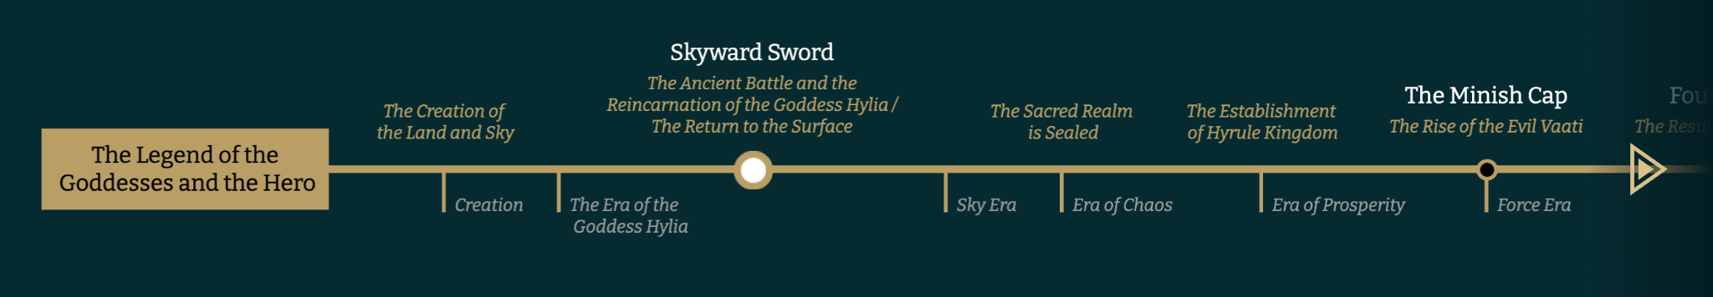
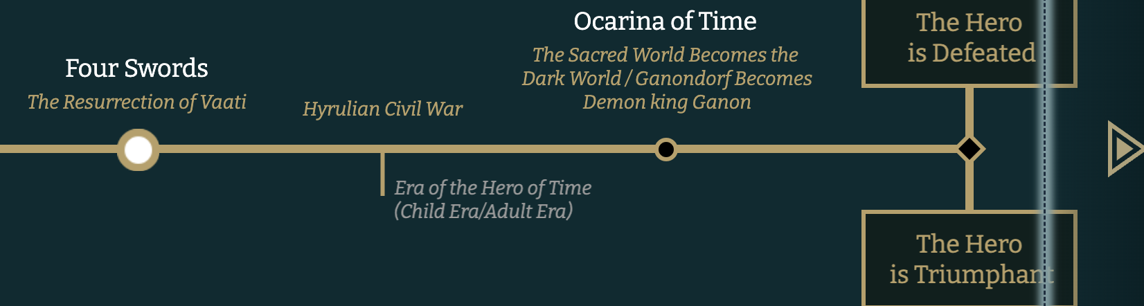

Womlon’s Kingdom
- He creates a wall of Jagged rock that grows throughout the books.
- His powers multiply.
- Jagged rock wall surrounds Illia
- When Womlon is banished to the sea, the elements paved the way.
- Elements
  - Fire - melts sand into glass
  - Water - ?
  - Air - creates opening or a swirling
  - Earth - creates cave
  - Light - ?
- The carried hiim and his followers
  - To the west
  - Like a giant ball & his army
- Why towards Illia?
- What is the connection?
- The life forces pulled
- Balance of Good and Evil
- Dark and LIght
- His Abode - Description
  - Lorem ipsum
- How is he able to battle Clal? In what form?
- Out at sea he meets him in the 7 stone place.
- Seeks crystals because they will give him the power to reach, breech, break through the magic wall of banishment
- “IF my kingdom touches Illian land, I am released”
- (Crystals grow)
- Womlon is not Spirit. He is stuck below the ocean.
- How does he meet Clal?
- People say they are beginning to see a dark figure out on the horizon of the ocean, or lights.
- Everytime a crystal is taken, the element that is upholding the virtue of that kingdom is removed and transferred to the stone in the Dawning of Time place…
  - And the people are released from that place and find home at Illia.
  - But how does that effect their world?
  - How does that effect Illia?
- Does Clal leave a dimension portal open in Mirrim and Nilthinon?
- Each Magicon is returned at same point either at end or at the end of each book.
  - Island sinks into ocean - dimensions
  - Island sails into air - dimension
  - “There’s nothing there people say.” Just snow.
  - City disappears
  - City covered by mountain
  - Illia has a heart
- 7 Stone - Portal
  - How to enter?
  - Touch the 7 stones in order, starting with any stone.
  - Floating stones.
  - Then whirlpool pulls under
- Same way Womlon came to abode.
- What does it look like?
- Crystals keep to kingdom, hidden.
- When removed, the magic begins to fade
- When Illia’s Crystal is removed, the last of the life force that banished Womlon is gone.
- He is freed to roam.
- He has power over all elements also.

A temples is set up somewhere

And a sister templin in the inner kingdoms

Felsawn, son of Ottomus: The Shephard (Wizard 2)
Creates the Phenominons
In the Plan that was given to Wizard 2 by his father, there is included a small idea on how to create a force strong enough to defeat “The Dark One Lurking.” All that his father wrote was:

(Make into a poem this phrase (possibly))

What a strength can bind
A weakness can find

He derives a plan of his own…he researches the books and scrolls that his father gave him. In it he finds the 5 weaknesses of “The Dark One”

They are elements: F’elements (meaning Five Elements.)

The F’elements are under development (i.e. De’F’element) lol

1. Fire
2. Song
3. Invisibility
4. Love
5. Beauty – (beauty is mostly in thins that may not appear beautiful on the outside. Beauty is purity, is clean, is goodness, is life, is respect.

Wizard 2 realizes that he must create a force that can reach and master each weakness all at once in a short period of time. He decides that the best way to do this is to mold all five into one. Because he is only the shepherd and by law cannot just give this created weapon to “The One” he decides to lure him to the weapon. But, if “The One” obtains the weapon too early, he will not be prepared to wield the weapon. This puts a damper on the plan as Wizard 2 wonders how this will work.

Alas, his plan is layed out before him in a dream, a vision. He must encapsulate each weakness and have “The One” collect them. The F’elements will be placed in a statue to be held there until all Five Elements are united. Then, the statue will melt away and create a sword with all five weakness elements forged into it. The F’elements will activate on “The One’s” command and this is what will happen.

- Fire will protrude from the blade.
- A song will echo from the sword along with a continuous humming.
- The wielder of the blade will become invisible at will
- The sword will be so beautiful that the Dark Lord will seek to obtain it.
- The five sided jewel in the middle of the hilt is from the heart of Cul Country and love will radiate from it

So, as was eluded to previously, The One must not obtain the sword in his heroic infancy. Therefore, Wizard 2 forms 5 phenominons in the course of Cul Country history. This will achieve a few important purposes.

- they will mark The One’s path for him, focal points.
- Because they are phenominons they will be great, being endeavored through no small means. Therefore, The One will have to undue each 1ighteous1 and in doing so, find the F’element within the Phenominon or Magicon. Basically, Wizard 2 will seal or hide the F’element within each Phenominon. This is a part of Cul Country that makes it extraordinarily unique.

Phenominons (Magicons)
- Beauty: (Felsawn moves the mountain during the night time.)
- (Song) Sky-Land: The rising of a land mass taken from Cul Country that is more of a myth then of a legend, which makes it almost impossible to find. Upon its earth high above Cul is a F’elemnt. The white dragon aids here. A song is always heard when upon this land mass. The sword that it helps create always has a hum about it, and gets louder whence the Dark One is near or when it is about to or fighting the Dark One. (Felsawn does this magicon during the day time.
- (Invisibility) The creation of another world upon the sands of a desert. The windows or doors to the world open and close at certain times and can be seen if one knows what to look for. The One has to enter in and find the F’element. The F’element is that, when The One wields the sword he can at his leisure become invisible.
- (Fire) A fire people exist and are located somewhere on Cul. Clal brings the White Dragon at this point also.
- (Love) The heart of the continent has a love that radiates. Part of the heart gives Clal a piece of it’s unigue rock which is part of the actual heart of the island. This then becomes the central jewel on the hilt of the sword and is one way that the land fights back. This also shows that the land grew out of profound and 1ighteous love for the welfare of its future peoples.

At the end of each book we will read a story about how the Dark Lord gained each weakness:

Example: Invisibility
Once, the Dark Lord was fighting and lost the fight because he could not believe in that which he could not see. He could not see his aponant and therefore believed that he was not as harmful as he would have thought.

And so on…

Each journey towards the given Magicon will prepare Clal for the destination.
Example: Invisibility
Clal goes through a forest that grows from an unseen source.
He then passes 1ighteo a fog where he cannot sea.
Then he meets a blind boy who helps them
Then at the end he finds The Sands of Illusion through what he learned and learns the lesson from his journey. (A good concept but poor example.)
This will make each book unigue, complex, mysterious, meaningfull, deep, etc.

But, equal to the task, Clal must learn the Five Lessons that the Dark One never learned or chose not to gain as wisdom. This too is a challenge and may also become a weakness if not careful pondered and internalized. And, the Five Lessons become a creed and exclamation to Cul Country and to all people to follow and to adopt. On the blade of the sword is inscribed these Five Lessons.

Each of the first four books will be focused on the Magicons being focused on a lost people.
But the final book will be focused on finding the first people that were lost and that was the people of the Old world. (The Last book will be all about the new and old world and their relationships with one another.

There are people in the Old Country that are still alive and that were not destroyed entirely by the Dark One Lurking. (Yay).

So, the first magicon was the creation of Cul.
The last magicon is the colliding of Cul into Hanone. The last magicon is also Clal’s ability to slay the Dark One.

Sky People – hid up because they were extremely virtuous and good.
Mountain People – hid up because they were too beautiful
Fire People – hid up because they were the wielders of a powerful weapon – a unique kind of fire
Sand People – hid up because of their wickedness (because of their inability to see sin in its true form, they were exiled for their lack of spiritual sight.)

Each Magicon has become a myth of Cul and is almost acklownledge as a story to explain why some things are the way they are. Each magicon hids or covers up a people or society. Each society possessed a strength or something that would give strength to “The Dark One Lurking.” He doesn’t have the strength. Maybe they were hid up so that the Dark One couldn’t gain the strength.

The Five Lessons

Invisibility:
To the eye is left no trace
Of whence it came from unknown place
But if employed a greater sense
A finer task can then commence
For then beyond the span of sight
Its truest form will come to light
Revealing that which can’t be seen
Anew, yet as its always been

Love:
Within the smallest heart is found
An essence of the world around
A fondness for its simplest things
An interest in the joys it brings
But if such love is left to rot
To whither, break, and die alone
The happiness it could have brought
To those in view, will ne’er be known

Fire:
The flames of fire can take their tole
And snuff from man their mortal soul
For then is joy exchanged for grief
Which causes men to beg relief
Yet with each pow’r exists a law
That governs it both great and small
Thus if possessed this key to wield
Man’s mast’ry over it is sealed

Song:
Above the oceans, lands, and clouds
The winds of earth do sing aloud
In constant song of onward light
Of birds that wing a lighter flight
But if the ear finds no such voice
Such things as this require a choice
For though the arts of sound are learned
Its greater part must first be earned

Beauty:
Look closely at what that is seen
Perhaps it shows a fainter gleam
Nontheless, it is what it is….

Or

Note: This poem may or may not be used

There are jewels and golden things
Found only in the halls of kings
That nearly hold a holier post
Than life itself, when valued most
Only to blur the mind of man
And steal from him all things that last
As nobler treasures leave his hand
Replaced with shards of broken past

5 Lesson Topics
Invisibility: sight, light, ignorance, faith, 2 Cor. 5:7 – We walk by faith, not by sight.
Love: Charity, sanctification of, purpose
Fire: Holy Ghost, heat, warmth
Beauty: unsure of this one…
Song: heart, speech, message, penetrating voice, music, voice

The Four Inner-Kingdoms
When Felsawn came with what was left of the people from Hanone, there were some who settled in each quarter of the land. Because Ottomus planted the five elements into the stoneseed, there needed to be a people to keep safe these elements. So, Felsawn asked the four different races to split up and keep safe these elements. Then, they were all four hidden up to the rest of the world. The fifth was a special task to ask of anyone; for, to the one female to ask, it would forfeat her chance to marry and bear children and would be a lonely task to perform.

For 800 Years
Lehi's exodus to Christ's birth accounted for 600 years. Instead, It will be 800 years after the Hanone exodus that Clal will come to his destiny.

Create culture, land marks, and different cultural ideals.

