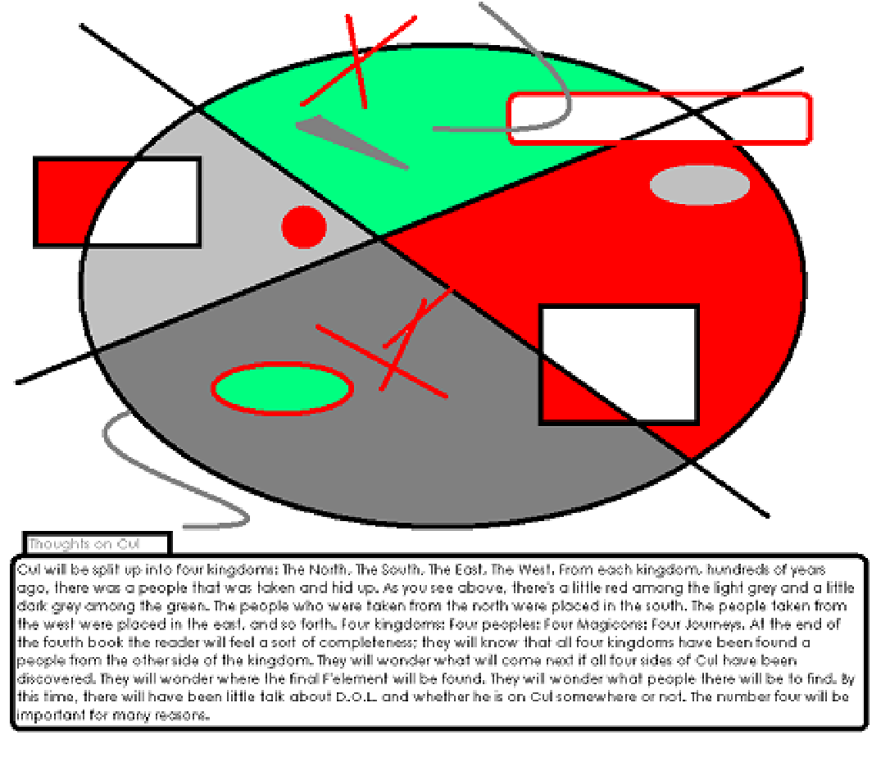

Cul will be split up into four kingdoms: The North, The South, The East, The West. From each kingdom, hundreds of years ago, there was a people that was taken and hid up. As you see above, there's a little red among the light grey and a little dark grey among the green. The people who were taken from the north were placed in the south. The people taken from the west were placed in the east, and so forth. Four kingdoms: Four peoples: Four Magicons: Four Journeys. At the end of the fourth book the reader will feel a sort of completeness; they will know that all four kingdoms have been found a people from the other side of the kingdom. They will wonder what will come next if all four sides of Cul have been discovered. They will wonder where the final F'element will be found. They will wonder what people there will be to find. By this time, there will have been little talk about D.O.L. and whether he is on Cul somewhere or not. The number four will be important for many reasons.

