The World of Clal: Foundations
October 10, 2007

Wizard 1 Prepared a Place
Wizard 1 sees that the Old World will be overrun soon. He gives to his White Dragon a seed stone that he has made and sends the Dragon into the West over the oceans to be forever parted from each other. The Dragon flys very far away and finally breaths ice onto the ocean's surface and builds a small island to land on. He then breaths ice on the seed stone to cover it with ice layers and then drops it into the sea. The seed stone lands at the bottom of the sea and begins to grow. The Dragon then hibernates until he is awaken by the rising up of dry ground. The earth then grows a high mountain where the Dragon is to live among the colder climates until “The One” is to come and find him and call him to his final duty. The land then continues to grow preparing to receive an exodus people to be a sanctuary and a refuge.

The seed was made from a plant called Culunica which is very common upon it's surface. The reader learns that the name of the country is not from the plant that grows there but is named because the beginning of that plant started with the first seed being the seed of the land mass that caused the continent to grow.

Cul country, before the last battle, will travel back to the Old World and collide upon it's eastern shores reuniting with the its mother earth. A major earth quake will occur and Clal later finds out that at that time, Cul country was detatching itself from the ocean's floor beginning its movement towards the Old Country. The movement of the continent from then on will not be felt but noticed in relation to the placement of the stars being abnormally shifted west.

Wizard 1 Prepared a Person
Wizard 1 decided that there needed to be a person to save the people from this evil that, although they were able to escape from, will infest Cul Country to a limited extent. So, he cast a spell on a baby boy that was genetic. A spell that needed a perfect body, and the most perfect person he could find was a new born baby. He searched and searched for a young couple who would give up their first born to a form of magical experimentation of which Wizard 1 was not sure would be successful. He finally did find a couple and the spell went well.

(Maybe because of the need of a perfect baby, maybe he finds a perfect race.)

The spell was genetic and would survive through time until the effect would be realized. The spell is linked to the Dark One so that when the Dark One's is strong enough to become a threat again, a marking on the back of the neck of “The One” to be, will show and mark the time of “The One.” This spell was cast with Wizard 1 risking his life in doing it and was weaker than normal to his dying day (he never recovered after casting this spell.)

Wizard 1 Prepared a Plan(Very Extensive)
He created a plan. Because there was no foundation or plan to fight the Dark One, he believed that this was the reason for their down fall. So, he had a dream that gave him the knowledge to know that he had a mission to serve, a duty to perform. Thus, he decided to prepare a plan for the future to save the people. (Because, he knew that running away would not solve the problem but that he would help the people “run away” and then further help them by preparing a way to gain the “Old Country” back.

Part of this plan was included a law. There were to be Three Wizards: A Tri-Wizard creed. The first being Wizard 1 taking the role as:
The Beginning – the one to start, direct, create, invent, devise, forge the plan needed.
The secong being Wizard 2, his son, taking the role as:
The Shepherd – the one to put things into place to prepare Cul Country for “The One's” coming and to carve out his path for him.
The third being Wizard 3, an orphan son of Wizard 2, taking the role as:
The Guardian – the one to watch over “The One” while he is being prepared to fight “The Dark One Lurking”

Along with this “The Wiiizard Law” purpose come laws that these wizards have to abide by.

The Wizard 3 Law (The Wiiizard)
- Cannot intervien but can direct, guide and aid. The task of defeat must be performed only by the One.
- Each wizard must perform the task that has been assigned to them.
- Each wizard must make sure their life sustains until their task is done.

The Three Wizards Symbolize the Trinity and how each has a part in the plan

Heavenly Father – Wizard One – The Beginning - Who started it all
Jesus Christ – Wizard Two – The Shepherd – He prepares everthing for “The One”
Holy Ghost – Wizard Three – The Guardian – Assists “The One” while he is pursuing his destiny.

Wizard 2 Place the Phenominons
In the Plan that was given to Wizard 2 by his father, there is included a small idea on how to create a force strong enough to defeat “The Dark One Lurking.” All that his father wrote was:

(Make into a poem this phrase (possibly))

What a strength can bind
A weakness can find

He derives a plan of his own...he researches the books and scrolls that his father gave him. In it he finds the 5 weaknesses of “The Dark One”

They are elements: F'elements (meaning Five Elements.)

The F'elements are under development (i.e. De'F'element) lol

1. Fire
2. Song
3. Invisibility
4. Love
5. Beauty – (beauty is mostly in thins that may not appear beautiful on the outside. Beauty is purity, is clean, is goodness, is life, is respect.

Wizard 2 realizes that he must create a force that can reach and master each weakness all at once in a short period of time. He decides that the best way to do this is to mold all five into one. Because he is only the shepherd and by law cannot just give this created weapon to “The One” he decides to lure him to the weapon. But, if “The One” obtains the weapon too early, he will not be prepared to wield the weapon. This puts a damper on the plan as Wizard 2 wonders how this will work.

Alas, his plan is layed out before him in a dream, a vision. He must encapsulate each weakness and have “The One” collect them. The F'elements will be placed in a statue to be held there until all Five Elements are united. Then, the statue will melt away and create a sword with all five weakness elements forged into it. The F'elements will activate on “The One's” command and this is what will happen.

- Fire will protrude from the blade.
- A song will echo from the sword along with a continuous humming.
- The wielder of the blade will become invisible at will
- The sword will be so beautiful that the Dark Lord will seek to obtain it.
- The five sided jewel in the middle of the hilt is from the heart of Cul Country and love will radiate from it

So, as was eluded to previously, The One must not obtain the sword in his heroic infancy. Therefore, Wizard 2 forms 5 phenominons in the course of Cul Country history. This will achieve a few important purposes.

- they will mark The One's path for him, focal points.
- Because they are phenominons they will be great, being endeavored through no small means. Therefore, The One will have to undue each phenominon and in doing so, find the F'element within the Phenominon or Magicon. Basically, Wizard 2 will seal or hide the F'element within each Phenominon. This is a part of Cul Country that makes it extraordinarily unique.

Phenominons (Magicons)
- Beauty:
- (Song) Sky-Land: The rising of a land mass taken from Cul Country that is more of a myth then of a legend, which makes it almost impossible to find. Upon its earth high above Cul is a F'elemnt. The white dragon aids here. A song is always heard when upon this land mass. The sword that it helps create always has a hum about it, and gets louder whence the Dark One is near or when it is about to or fighting the Dark One.
- (Invisibility) The creation of another world upon the sands of a desert. The windows or doors to the world open and close at certain times and can be seen if one knows what to look for. The One has to enter in and find the F'element. The F'element is that, when The One wields the sword he can at his leisure become invisible.
- (Fire) A fire people exist and are located somewhere on Cul. Clal brings the White Dragon at this point also.
- (Love) The heart of the continent has a love that radiates. Part of the heart gives Clal a piece of it's unigue rock which is part of the actual heart of the island. This then becomes the central jewel on the hilt of the sword and is one way that the land fights back. This also shows that the land grew out of profound and unnatual love for the welfare of its future peoples.

At the end of each book we will read a story about how the Dark Lord gained each weakness:

Example: Invisibility
Once, the Dark Lord was fighting and lost the fight because he could not believe in that which he could not see. He could not see his aponant and therefore believed that he was not as harmful as he would have thought.

And so on...

Each journey towards the given Magicon will prepare Clal for the destination.
Example: Invisibility
Clal goes through a forest that grows from an unseen source.
He then passes throug a fog where he cannot sea.
Then he meets a blind boy who helps them
Then at the end he finds The Sands of Illusion through what he learned and learns the lesson from his journey. (A good concept but poor example.)
This will make each book unigue, complex, mysterious, meaningfull, deep, etc.

But, equal to the task, Clal must learn the Five Lessons that the Dark One never learned or chose not to gain as wisdom. This too is a challenge and may also become a weakness if not careful pondered and internalized. And, the Five Lessons become a creed and exclamation to Cul Country and to all people to follow and to adopt. On the blade of the sword is inscribed these Five Lessons.

Each of the first four books will be focused on the Magicons being focused on a lost people.
But the final book will be focused on finding the first people that were lost and that was the people of the Old world. (The Last book will be all about the new and old world and their relationships with one another.

There are people in the Old Country that are still alive and that were not destroyed entirely by the Dark One Lurking. (Yay).

So, the first magicon was the creation of Cul.
Magicons

Sky People – hid up because they were too rightious
Mountain People – hid up because they were too beautiful
Fire People – hid up because they were the wielders of a powerful weapon – a unique kind of fire
Sand People – hid up because of their wickedness (because of their inability to see sin in its true form, they were exiled for their lack of spiritual sight.)

Each Magicon has become a myth of Cul and is almost acklownledge as a story to explain why some things are the way they are. Each magicon hids or covers up a people or society. Each society possessed a strength or something that would give strength to “The Dark One Lurking.” He doesn't have the strength. Maybe they were hid up so that the Dark One couldn't gain the strength.

The Five Lessons

Invisibility:
To the eye is left no trace
Of whence it came from unknown place
But if employed a greater sense
A finer task can then commence
For then beyond the span of sight
Its truest form will come to light
Revealing that which can't be seen
Anew, yet as its always been

Love:
Within the smallest heart is found
An essence of the world around
A fondness for its simplest things
An interest in the joys it brings
But if such love is left to rot
To whither, break, and die alone
The happiness it could have brought
To those in view, will ne'er be known

Fire:
The flames of fire can take their tole
And snuff from man their mortal soul
For then is joy exchanged for grief
Which causes men to beg relief
Yet with each pow'r exists a law
That governs it both great and small
Thus if possessed this key to wield
Man's mast'ry over it is sealed

Song:
Above the oceans, lands, and clouds
The winds of earth do sing aloud
In constant song of onward light
Of birds that wing a lighter flight
But if the ear finds no such voice
Such things as this require a choice
For though the arts of sound are learned
Its greater part must first be earned

Beauty:
Look closely at what that is seen
Perhaps it shows a fainter gleam
Nontheless, it is what it is....

5 Lesson Topics
Invisibility: sight, light, ignorance, faith, 2 Cor. 5:7 – We walk by faith, not by sight.
Love: Charity, sanctification of, purpose
Fire: Holy Ghost, heat, warmth
Beauty:
Song: heart, speech, message, penetrating voice, music, voice

Wizard 3 Prepared a People (Partnership)
Wizard 3, being unable to aid The One in his task must prepare a people to travel with The One. This is extremely difficult as he must not make himself known that he is guiding certain individuals to cross paths with The One. (He could not just approach someone with this sales pitch, “Excuse me sir, would you be interested in risking your life to aid The One in preparing to defeat The Dark One with little or no chance of success by way of no reward in the end or before the journey is embarked upon.” Point made. Needless to say, he does find a way to execute the same purpose.

Wizard 3 is raised in such a way that he is taught the many languages of Cul Country including some animal speech. He is also known as being an outgoing individual being taught phsycology and the behavioral concepts of each race. He was prepared by his Father for his life calling. He was prepared in the art of proper communication.

Each person that Wizard 3 must find will help him find each F'element. Five individuals will travel with him.

- Love: Leara: his twin sister will help here.
- Song: Lark: an elf that can float or fly will have been taught about the Sky-Land from his youth. His people are known for their song
- Beauty:
- Fire: a half fire person
- Invisibility: A character that sees things that others cannot.

Other Notes
The importance of Sun, Moon, and Stars will be evident.

Sun: The Sun is the name of the sword that will emerge from the statue which received the F'elements. The Dawning of time will occur when The Sun rises. “The Sun” is the sword.

Moon: Clal is from the valley of Lyrune which is known for the hills surrounding it being formed into the shape of a crescent.

Stars: The importance of constellations will be used.

Clal will have to leave his old life behind, grow up, and must close the doors of his past to continue successfully to his marked future.

Musical Notes
Each chapter will have a theme song
Full scores of music are better than just a melody of a tune

Make fables, stories, legends, myths, traditions.
Use pictures, songs, poems, music, paintings, sculptures, things found in nature.

THE PROPHECY

Look to the East to find The One.
Who only can unlock the Sun.
The Powers of this world await
Who holds the key to open fate.
And when is found, this One to name
And take his place beside his fame
Remember this, that with his time
Comes danger, mischief, vicious crime.
For not too far from this world’s birth
There is one who roams the earth
Awaiting chance to stake his claim
Upon each heart that has a name
Yet if our One completes his task
The Dark One lurking turns to ash.
But if our One turns inward spite
All hope will fade without a fight

Interpretations

Look to the East to find The One – Because Cul Country's Western shores will colide with the Eastern shores of the Old Country. The word find connotes the following: to be established, to discouver, to be proven, learn, to verify. (If he really is the one then he must prove it at some point.)

Possible “proving” method: Just as the “Dawning of Time” statue is the key of the New World, there will be a key in the Old World; a key that will need to be unlocked...a token maybe.

Sun, Moon, and Stars

Remember, the hand of star, moon, and sun
Will guide the people back to their home
Acting as three, with purpose as one
Giving a place where no more shall roam
Out of the darkness into the light
Will hope then embark upon its last flight
What once did arise, will now see its end.
With sun, moon, and star, a people defend.

- The Sun signifies Father in Heaven that rises when the “turn of the tides” as Gandolf phrases it, begins. (this is very loose and needs some refining on how the “sun” represents Father in Heaven.
- The Moon signifies Christ as “The One” or Clal comes from the valley of Lyrune which is a valley surrounded by the cresent hills.
- The stars guide and direct, like the Holy Ghost.

The Godhood.
A deeper Prophecy that comes during the course of the books. A deeper law, deeper magic, deeper meaning, much deeper purpose, deeper concept.

Clal and Isaiah: Isaiah Inspires Me
Isaiah is the source of much inspiration
Thoughts on Isaiah
Since the beginning of Cul Country, Wizard 2 has constantly tried to help the prevailing population to understand some things that caused the “Old World” to fall.
I want this to be similar to Isaiah
These teachings/prophecies/prophecyings will be named and be well known.
Maybe prophecying of the four peoples that become hidden from the world.

Fire People
Sky People (Elves)
Illusion People
Mountain People

The wizard knows that it will be hard for the people to accept a young boy as the keeper of the prophecy, the saving individual of their time; he will write and try to prepare them for "The One."

Isaiah 13:8 – There faces shall be as flames.

Note: The language of the Isaiahish Prophecies will have this style about it:
- It will be in the voice/words/speech from the Old World: The Jewish Speech that is foreign to English speaking individuals and others.

All “Riches” content is now obsolete (Oct. 10, 2007)
Note: This poem will not be used
Riches:
There are jewels and golden things
Found only in the halls of kings
That nearly hold a holier post
Than life itself, when valued most
Only to blur the mind of man
And steal from him all things that last
As nobler treasures leave his hand
Replaced with shards of broken past

Riches: wealth, treasure, worth, gold, power, greed, where your treasure is there will your heart be also.

Riches: A prince or princess

(Riches) The moving of a montain that covers a cave, an intrance to another civilization, a cruel and evil part of Cul Country, covered up. And within that cave lies a F'element. Riches are the central point of the civilization. The sword gains jewels, metals, and beauty that is so beautiful that he Dark One will seek it, stretch out his clutches and become caught into a trap, having been lead to a place where the Partnership planned for him to come.

Parts of the detective work: Clues
I took a frying pan that had cooked some eggs early in the morning. When I ran water over it there was a design that was desplayed. The small burned pieces of egg that had attached themselves to the pan was not allowing the water to go through it so that water was forced to ho around it. You couldn't tell that it was going to make those shapes and designs just looking at it with no water being poured on the pan.

Basically, in the caves under the mountain, to help them get the next clue on where to go and what to do, they will come to a place of stone and water, a lake or something, and will find things to run under the water that will aid them and direct them based on the designs, which will have meaning, that is seen.

The Decree
When the king of Eldan Vyum finds Clal, he makes a decree over all the land that “The One” is found. The Whole Cul population has been waiting for the “Decree of the One” or “The One Decree.” It will ring out from every house toop. But, it will also firmiliarize “The Dark One Lurking” with the coming of the one and will try to find him.

Myths, Legends, and Symbolisms

The four water maidens located in the ocean.
They control the four winds of the earth.
Every 5 years they meet somewhere marked as the meeting place

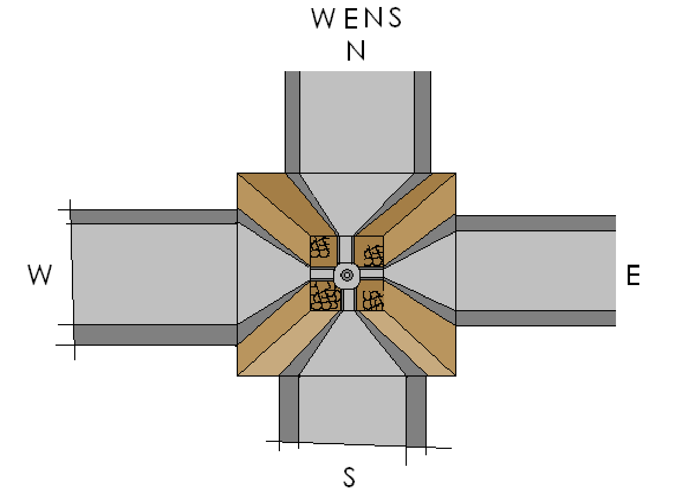
There is a fountain in the middle that flows water. It flows out and over the brim of the fountain, into the bowl, then out onto the row where it meets the wall and then flows up the way and out, cycling in this manner. When the time of the one in the 5th book when the continent will be traveling back to it's mother land, the waters will flow inward (down the walls) and back into the fountain.
Symbolism – Flowing out: the earth giving to the inhabitants. Flowing in: the earth gathering itself to prepare to sail back and collide with the old continent.

Skyland

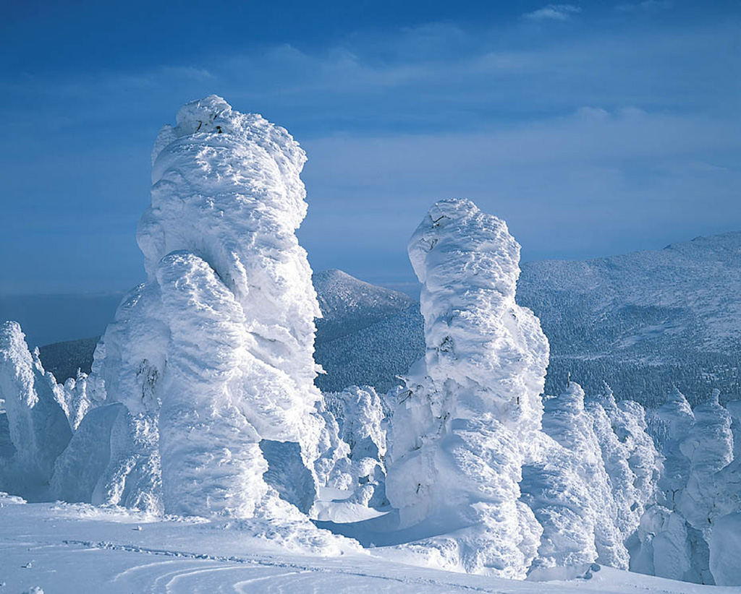
The surface of Skyland, due to its high altatude, is all snow and ice.
Clal will learn the song of the Skyland and in the 5th book he will call the skyland down to return itself to its original formation.

The Book of Myths
Clal reads a book of Myths.
Many are just stories, but some are truth.

Important Myths:
A mountain was moved and covered a cave
An island was sent heavenward being ripped out of the center of an ocean island
A people were changed into fire thus becoming a civilization populated by “fire people.”
There is a desert where another demention's doors open and close randomly
A lady lives at the heart of the land.

Other less important myths:
When you stand in a certain place on the edge of Heaven's cliff, you can see a pathway which is almost invisable but that one can follow
Other myths that won't be realized but just their to help the reader wonder which myth the characters will entertain.

Old Land Myths:
Some, maybe a hand full, will be myths that we will see on the other contant that the reader was reading about thinking that it was talking about the New World. The realization of some really interesting myths.

The Myth of Skyland
The Legend of the Fire People
Book One: The Skyland: Song
Theme: Introduce the Importance of Song for my Series
Book Two: The Fire People: Fire
Theme:
Book Three: The Mountain: Beauty
Theme:
Book Four: The Sands of Illusion: Invisibility
Theme:

Book Five: The Heart: Love
Them: All nature will return to itself:
Skyland returns to where it came from
The Four Waters flow back into the fountain
The entire contant returns to the Old World, coliding and fusing itself to its eastern shores
All of the Magicons are returned
The Mountain
The Skyland
The Sands of Illusion
The trees in a certain (ordained) forest will become younger and younger and eventually appear as a seed on the ground

The Ice Dragon

He breaths Ice
He lives in the Skyland
He is “purposefully locked up”
(It is really good to intruduce him in Book one so that he can be an aid in the rest of the books.
He should die in the end to seal his mission with his blood.
When and where did his race start?

Perhaps a dragon form of an albino...
Shunned from his race and rescued by Wizard one.
Basically, Wizard one found the Ice dragon right when he was a new wizard having been sent on his own after he was done with his apprintaceship. The wizard rescued him and forever became a symbol of his younger days and was very close to Wizard one.

Why is he white? Are there any left? What role will he play? When will the partnership ride him? Can he talk and how does he communicate with the partnership? What will his name mean and why does the Wizard one name him that? If he gets injured, how will this effect the partnership?

Story Ideas
will a F'element become stolen and perhaps show up in another book so that it will include the recuing of the lost F'element?

Who dies? Where does Clal find his love in the story? How does W1 mark Clal's path?

