Character Thought Dump

Character Technique

Flesh out characters; give them desires and dreams. This will help your story come alive and guide its natural results.

5 weaknesses
5 things to strengthen

The Three Wizards

it is wizards that spend their whole existance managing the affairs of the land, helping, guiding...

Part of this plan was included a law. There were to be Three Wizards: A Tri-Wizard creed. The first being Wizard 1 taking the role as:
The Beginning – the one to start, direct, create, invent, devise, forge the plan needed.
The secong being Wizard 2, his son, taking the role as:
The Shepherd – the one to put things into place to prepare Cul Country for “The One's” coming and to carve out his path for him.
The third being Wizard 3, an orphan son of Wizard 2, taking the role as:
The Guardian – the one to watch over “The One” while he is being prepared to fight “The Dark One Lurking”

Along with this “The Wiiizard Law” purpose come laws that these wizards have to abide by.

The Wizard 3 Law (The Wiiizard)
- Cannot intervien but can direct, guide and aid. The task of defeat must be performed only by the One.
- Each wizard must perform the task that has been assigned to them.
- Each wizard must make sure their life sustains until their task is done.

Ottomus
Ottomus: Heavenly Father – Wizard One – The Beginning – The one who set the good forces in motion.

Felsawn
Felsawn: Jesus Christ – Wizard Two – The Shepherd – He prepares the path way for “The One”
Christ's Birth/Clal's Birth
Felsawn recieves a sign that “The One” has been born; he doesn't know who it is. This changes some of his plans and their timeframes.

Morgreth
Morgreth's Destiny
As the books progress Morgreth's participation in Clal's journeys lessens to promote indipendence in Clal's character.

1 Ne. 1:15 – a Wizard that spoke in riddles but becomes more clear as Clal and friends travel and gain more understanding.

Morgreth: Holy Ghost – Wizard Three – The Guide – Assists as “The One” pursues his destiny.

Morgreth, son of Felsawn: The Guide (Wizard 3)
Prepares a People (Partnership)
Wizard 3, being unable to aid The One in his task must prepare a people to travel with The One. This is extremely difficult as he must not make himself known that he is guiding certain individuals to cross paths with The One. (He could not just approach someone with this sales pitch, “Excuse me sir, would you be interested in risking your life to aid The One in preparing to defeat The Dark One with little or no chance of success by way of no reward in the end or before the journey is embarked upon.” Point made. Needless to say, he does find a way to execute the same purpose.

Wizard 3 is raised in such a way that he is taught the many languages of Cul Country including some animal speech. He is also known as being an outgoing individual being taught phsycology and the behavioral concepts of each race. He was prepared by his Father for his life calling. He was prepared in the art of proper communication.

Each person that Wizard 3 must find will help him find each F'element. Five individuals will travel with him.

- Love: Leara: his twin sister will help here.
- Song: Lark: an elf that can float or fly will have been taught about the Sky-Land from his youth. His people are known for their song
- Beauty:
- Fire: a half fire person
- Invisibility: A character that sees things that others cannot.

Queen of Hanone

Illia

In the 1st nania movie there is a scene where a tree’s blossoms fly into the air and gather together forming the figure of a woman which turns and waves at Lucy of which Lucy waves back.
My artwork of the flowers that have a spirit. This could be an idea.

The Mother Earth
Through out the course of the first four books the par;t6y meets a female at the end of each book. Each one tells Clal and his party why Womlon is weak in thisarea. They are shown in the reflection when Womlon became weak on this point.
Lady Wind – just a voice on the wind
Lady of the Pool – in a large pool of water beneath the mountain
The Mirror Maiden – in a mirror among the walls of King Daxius
The Fair Flame of Nilthinon – the woman in the tree of life depicted as Lehi’s Dream

The reader is led to believe that there are four women involved and t6hat they will be understood and explained at some point. However, as we fint out in the fifth book, there is onlyi one woman who is mother earth and lives in the heart of the earth. She tells Clal of the 5th story of Womlon. He is ready for it because in her four intervies at the end of each book she threw in some elements about loving, serving and giving.
Relationship between Clal and Mother Earth
Clal must unite himself with the earth in order to save the people. He must allow love to fill his heart. His purposes must be by love.

Where is the heart of Cul?
Another clue on where the heart of the earth is that in jEldan Vyum it is know that strange things happen there. One thing is that the plants seem to repond to visitors. The spirit of the plant can almost be seen.
Also, the Culanthra plant flourishes in Eldan Vyum.
Things exist and do not exist in Eldan Vyum that do other places.

The land also helps to prepare the way for Clal. When Rakonor (who is this? I don’t remember) has the dream, it stems from the ceter of the earth or the stone seed and also from the F’element. So, the seed or Culanthra creates these things. Then other events happen in history that shape the cultures and the people.

The Heart: Whatever grows closest to the center of Cul is made up of more elements of what flows through Clal’s veins. Thus if there are rocks that reside there then, if made into bricks and used to build a building, the wall would open to Clal. For example: rocks, plants, trees, animals, the air, and maybe a people. As the radious around the heart chamber becomes greater, the power of Clal is lessor.

Also, whatever surrounds the f’elements, acts in the same way but is a lessor powper and is mainly a power or force for its specific symbol or element.

Clal will find out that Hittle is from the center of Cul. He will find out that other things are from the center of Cul.

Womlon

When bad: his color is red

Womlon has closed up his world but has left some things out of it.

When Womlon is around, things whither and die; plants laydown and do not rise again.

at the Dawning of time statue as cClal sees the past of Womlon's weakness moment.
in one of the books at the end of a book during the affiliation with one of the peoples.
Theme: Past, Present, Future: since Clal is “The One” he is entitled to see all three of these.

What is womlon’s weakest things or moments?

Womlon: Heroic Character’s Adversary
What was unforeseen by Ottomus was the fact that Womlon has cracked the code, he’s “figured out” the magic that runs through Clal’s veins, the same magic that the new world is made up of. This is a terrible threat, one in which will cause Clal the greatest worry and grief.

Satan’s Tactics
Creatures, confusion, weather, gains followers, turn people against good, good is called evil and evil good.

Sedrak
Sedrak..... Not ice dragon

Sedrak: The White Dragon
When and where did the dragon’s race start? Why is he white? Are there any left? What role will he play? When will the partnership ride him? Can he talk and how does he communicate with the partnership? What will his name mean and why does the Wizard one name him that? If he gets injured, how will this effect the partnership?

Sedrak: The Ice Dragon
He breaths Ice
He lives in the Skyland
He is “purposefully locked up”
(It is really good to intruduce him in Book one so that he can be an aid in the rest of the books.
He should die in the end to seal his mission with his blood.

Perhaps a dragon form of an albino...
Shunned from his race and rescued by Wizard one.
Basically, Wizard one found the Ice dragon right when he was a new wizard having been sent on his own after he was done with his apprintaceship. The wizard rescued him and forever became a symbol of his younger days and was very close to Wizard one.

Sedrak's Destiny and Participation
Perhaps the dragon can be a mentor, a connection to the old world. What parts to Sedrak play in Clal's course of events?

Anti-Sedrak
White dragon mutated to red dragon

Clal

The Stars
Clal is th only one who can communicate with the starts. They talke to him. They move. They guide him.

Christ's Birth/Clal's Birth
Felsawn recieves a sign that “The One” has been born; he doesn't know who it is. This changes some of his plans and their timeframes.

Cul Country and the Sword
The f’elments will be placed in the order on the sword. Example: the flame ios found in the north so, the north part of the sword is the blade and it is on the blade that the fire will exist.

Concept
Your are laying a found dation of a great work, and that great work is you. Clal is the Magicon.

Clal must prioritize. This is what drives sub plots. (good, better, best) Clal has to chose and will learn what is most important to his quest.
seek to understand relationships with God
seek to understand fam. relationships

How does Clal use his time?

Daily assistance from a certain source must be evident. (like prayer and scriptures) a way that he can draw strength and guidence.

Clal has stewardship and will record what he goes through. Cla must choose whom he will serve. Josh 24:15. Time must be used wisely. Clal's thoughts, words and deeds must be pure. Must rise to his responsibility and take responsibility.

Basically, when Clal is holding the 1st F'element of song, things grow around him; things flourish.

Clal's Destiny
he will walk around Cul using this power given to him by the genetic spell that Ottomus once used to mark his kin.

at the Dawning of time statue as cClal sees the past of Womlon's weakness moment.
in one of the books at the end of a book during the affiliation with one of the peoples.
Theme: Past, Present, Future: since Clal is “The One” he is entitled to see all three of these.

Clal: Heroic Character

Clal will have to leave his old life behind, grow up, and must close the doors of his past to continue successfully to his marked future.

Distinctive Characteristics:
- Ice Blue Eyes
- White/Blond Hair – very light
- One blue eye and one gray eye or any other color which changes based on Clal’s mood
- His common sideways/half smile

Questions:
What does Clal have to do?
What does he want to do?
What can’t he do?
What shouldn’t he do?
What are his priorities?
What does he need help with?

Fatal Flaw
Curiosity

A Legend
The light of a new day
The question: “How do you know when the night is over and a new day has begun?”
The answer: “When you look into the east and see the face of a woman and can say, ‘She is my sister,’ and when you look inito the east and see the face of aman and can say, ‘He is my brother,’ then you know the light of a new day has come.”

This idea is based on the article found in the January 2008 Friend titled, “The Light of a New Day.”

I want to apply this to mystery. Clal may see something in the faces of people that will cause him to understand that he is ready. Clal will change.
He wonders why he sees things in other faces like changes or slight movements. People do not see as he sees which causes some interest in the reader.

Relationship between Clal and Mother Earth
Clal must unite himself with the earth in order to save the people. He must allow love to fill his heart. His purposes must be by love.

Clal’s Changing Motives
Each book Clal should have different motives:
Fear
Duty
Glory
Selfishness
Love
To see the world/adventure
To become famous
To understand self
To choose the right
To be away from family and life problems
To Get out of the ordinary life

Clal’s Powers
Things happen when Clal is present, when he touches things, when he says things, thinks things, and desires things.

Myths, legends and folk lores
“Not all myths are makebelieve, not all legends are lore, and not all fables are ficticious. But your task is to find out which myths, legends and fables are real. For in a few of these will be found the f’elments.”

Other Legends will be important and will serve as a short term solution and guidance. Even the smallest legends will prove important.

Not only does Clal have to defeat, in some respect, the banished at the end of each book, he must also prove that he’s learned the lesson that he was supposed to learn.

The Legends of Clal
All legends are really false on Cul. No one is able to prove them correct. Yet, by Clal’s powers the pathway to each Legend is uncovered and unlocked. This is what makes Clal so special; he has the power to unleash, the power to undo. For example:

Book 1: By Clal the winds inside the crevis of an island picks up and carries them away. (The song of nature).
Book 2: A doorway is uncovered and a cave is revealed by magic where no other individual would have been able to do that.
Book 3:
Book 4: Clal walks on water right into the kingdom of Nilth.

READER to step into a different world.
4 different inner-kingdoms complete with tangible cultural identities
Clal's innate powers alter things along the way
PERHAPS CLAL’S POWERS ONLY WORK WITHIN THE INNER KINGDOMS

Clal struggles
Clal doesn’t want to kill anyone, but his fate is to defeat Womlon. And so he is counciled on the fear.
He says: “I always wanted to be a hero but I never wanted to have to kill or fight.”
Then, a wiser and older figure replies, “Clal, with the glory the valor and the recognition there is a price to pay. Sometimes that price is partly doing thingt that don’t neccessaritly want to do. You’re not killing just to kill; that’s wrong; and that’s why Womlon has come to his current and abomidable state. You are fighting an enemy and his counter parts that will defeat all good in the end if someone doesn’t stop him. That someone is you Clal. You are fighting to defend all that is righet. There is a difference in this and it is significant. You were chosen to do that which you think you cannot do. This is heroism. This is the fate of all who seek to abandon the ordinary life. Remember, you are not killing to kill, you are killing to defend that which is not to be taken. You are the only one Clal who was appointed to do this. You have been chosen to save your people. This has been the case since the beginning.”

“Wars can be an ugly affair.”

Clal's soul in jeapordy
“and they also sought his life, that they might take it away.”
“and they, the enemy, sought his soul, his light, that they might take it away.”
Perhaps a creature that reaches to the very soul in order to inflict pain comes in contact with Clal; (the creature that feeds on the last breath of its prey).

Ansa

The Twins
How were the main characters raised?
What were their parents like?
How do Clal and Ansa respond similarly to situations based on their childhood and parental teachings?

Rythe

Turl

Willa

Tallon

Gwen

Hittle
Hittle: The Chipping Sparrow
Hittle can understand Clal. He appears in the “High Room” and as Clal speaks, he does what Clal says. Ryth notices this and points it out to Clal. Hittle becomes a friend and an important part of Clal’s success. He is a clay colored Chipping Sparrow or is just a chipping sparrow that has a red top of his head like a normal chipping sparrow.

Clal will find out that Hittle is from the center of Cul.

Leara
Leara: Heroic Character’s Love Interest
Romance: Leara
Wehre does Clal find romance?
Meets Leara in Eldan Vyum’s Castle
Meets here along the way in Book one
She is assigned to go with Clal on his journey by a father who is one of the four kings
She should not be from the inner-kingdoms

Since we really don’t have a lot of time or a lengthy path for Clal to follow in Book 5, which, in the previous four books proved to mold Clal and to try him, it will be evident that Clal will have been learning how to love and care throughout the four books

Other ideas:
he has always been interested in elves.
he loves a girlt clost to home.
He meets a special female along the way
what is he looking for in a woman?
the same desire to break out of medeocrity
shyness
a believer in his mission

Larkin

Skyla

The RISHK - The Banished

Do “The Banished” live together? How do they communicate with eachother as well as with Womlon? Define “The Rishk/The Banished.”

Renthar is the ring leader. He is in charge of the Illian opporations. They may meet occasionally. They have to have a quicker way to travel.

A Friend in the Rishk
Perhaps one of the Rishk travels with Clal undercover. He always seems to be somewhat questionable like Snape was and in the end turns against Womlon.

Travel
Krothwing flys on a creature.
Renthar travels through caves that are enchanted.
Skeldruc travels through reflections and appears where he pleases
Imforo travels through shadows and through fire

The Banished
the banished have taken the spell that they have been banished with and have altered it for the uses of evil.
Order of the Banished
what crime do they commit?
who banishes them?
by what power are they banished?
from what are they banished?

Each banished has a special skill. Each banished has their own story; perhaps they were all good men.

what crime?
murder, take over kinging, to steal that which is most precious-perhaps the f'element, what Satan did: rob people of their agency, sought the throne of God.

complication- if they estrange themselves from the a kingdom, why would they need to be banished?

the spell
genetic spell or curse
infects them
creates a forcefield where they cannot go places
death
lose everything
they obtain a mark

Idea: perhaps they are placed in prison

How the Banished come about in Cul Country
Womlon sets his hand to span over the sead to make first contact with Cul coutnry. He sends a messenger to gather followers who will take part of Cul country over then Womlon will come to finish off the rest (King Emish) is found to be the perfect contact between Hanone and Cul. He finds individuals from each ot the four inner kingdoms who desire to enstalve others. They form “The Rishk” and combine to overthrow the innder kingdoms. On and appointed day they part ways and go to the inner kingdoms that they are from. They were given the power to overthrow, that same power Womlon used to overthrow Hanone, was given to “The Four.” They use this power to take over: Edaphlas, Kelvkoroth, Mirrim, and Nilthinon. Something goes wrong as a small detail is overlooked. Womlon didn't realise that Felsawn knew by what powers Womlon uses to conduct his evil affairs thus, creating a force that would cancel out the Rishks' power. so they were caught in the act and sentenced to banishment by magic. They were trying to steal the f'elements perhaps. They were trying to take over the inner kingdom. But, Womlon had a Plan B for the Rishk.

You see, womlon was banished aswll; he had been unsuccessful at tfirst try but he came back and was successful in the end. Womlon was angry non the less with “The Four” for their innability to carry out his desires and orders. But, he had other plans for his far off force. This time they would wait for “The One” for, Womlon gained knowledge of “The One” years ago and has felt no lasting danger from this so called prophecy. But, he decides to destroy “The One” by assigning “The Four” to destroy him. Again, the same dark magic is used for these deeds

Where the banished live
they all live together in a layer and are occasionally gone to carry out their evil devises. Their dwelling place is located:
on an island, in an abandoned castle, with King Emish, in some caaves on a cliff, underground, in a fortress, in a forest, in the barren lands, under a bridge, not sure...

The Recrutement of Clal
The Banished want Clal’s power so they try to convert/recruit him to their evil ways. IN Book 4: they do capture him and use him to open up sacred places. As they are doing this he learns how to turn off his powers so that it doesn’t work anymore. Thus, he is used as a key. They want him as their own.

What threats will/should the banished pose?

Not only does Clal have to defeat, in some respect, the banished at the end of each book, he must also prove that he’s learned the lesson that he was supposed to learn.

The F'elments
the banished know they hold great power so they seek after them. they do not understand their real purpose, to buld the weapon to defeat Womlon.

Renthar

Imforo

Skeldruc

Krothwing



Villians

field sweeper

final breath stealer

Womlon

A wayward king

A sea monster

A phony “The One” (anti-Christ)

Old friends turned ill

A black dragon

a warrior

a poisonous plant

an evil spirit

The Bad Were Good

Old World: Villian History
The Old World is the premortal world just as Satan was “cast out” by Heavenly Father, so will Womlon be “banished” by Ottomus. As heavenly Father used the priesthood to do this, so will Ottomus use deep magic to banish Womlon. Also, Felsawn banishes the rest of the banished four by this same power.

The Bad Were Good: Cauldren Born/Ring Wrathes
To emotionally engage the reader in as many ways as possible, this ideas serves as such a tool. The sadness one feels for an individual who was good but has chosen evil is unique and painful. To see a good man turn to become a murderous individual and to know, in a religious context, that he is probably going to be served justice instead of mercy can be painful. In Lord of the Rings the ring-wrathes were nine Kings that became evil because of the rings they were given. In Lloyd Alexander’s Prydain series the Cauldrin-Born were men who were hollow, used to be men but were empty and evil. This idea could be manifested in a certain type of creature that is used for Womlon’s evil devices. Or, this could describe the state of the banished and even Womlon himself.

Snape Factor
Plot Strategies
Snape factor – To create a character that the reader cannot identify as being on Clal’s side or against him.
A king, a member of the banished, a nilthinian-kelvkorothian-mirrish-edophlay individual.

TREES
Trees must be used to thicken the story.
Tree charactars?
LOTR – the Ent race complete with history and destiny.
Narnia – “Even some of the trees are on her side.”
In the 1st nania movie there is a scene where a tree’s blossoms fly into the air and gather together forming the figure of a woman which turns and waves at Lucy of which Lucy waves back.
My artwork of the flowers that have a spirit. This could be an idea.

Millurin Pike
Millurin Pike
This man has been the author of some tales about the inner-kingdoms. People consider his creativity astounding and is famous all thorugh the land. But Clal finds the man’s stories interesting and deems them worthy of attention for his quest. He does find and visit with Millurin Pike, who leads Clal to more information about the inner-kingdoms and where to find them.

The Journals of Millurin Pike
Clal stumbles upon some journals. He carries them with him until he reaches a place with people who can interpret the journals. He may carry them for a few books trhough until he finds out what their purpose is.

Outter Kingdoms:

N. Kingdom – King Blorien, Queen Lisreetha

E. Kingdom – Queen Othransa

S. Kingdom – King Narin

W. Kingdom – King Emish

Inner Kingdoms:

Edaphlas -

Kelvkoroth – Princess Rinica

Mirrim – King Daxius

Nilthinon –

The Four Waters Maidens
The Four Waters Maidens
The four water maidens located in the ocean. They control the four winds of the earth.
Every 5 years they meet somewhere marked as the meeting place

The Roaming Wisemen
The Roaming Wisemen
There is a man or wise men who roam the earth and cycle every year to the same spot and begin again.
They are called to study the land and its signs.
They have never been seen but their pathway is revealed.
They play a part in Clal's success but keep to themselves and don't really show care or charity for the characters.

The 7 Council Members
Names of all my children

The Speaking Tree
The Speaking Tree: Clal’s Twin in life force

Located in the Dawning of Time chamber.
It was sprouted when Clal was born as a sign that The One is soon to come.
It wilts when Clal is not doing well, when he is on the wrong path, when things are turning ill and to be careful.
It is almost dead before the end come for Clal.
It’s a mystery.

The Tree that Bears Stone Fruit
It bears special fruit on special occasions and they wait for it.

Name Bank

Who Dies?

Larkin

Sedrak

Krothwing
By the RISHK after he helped Clal and his band

Morgreth

Names Bank
Legerdemain, Falmer, Zyalan, Zwoshar, Visqar, Anthinon, Articose, Antnor, Artor, Alum, Adirious, Althon, Argnu, Barthlo, Beluth, Birgnor, Blothious, Buntol, Boshnis, Dargnoe, Ern, Elisar, Ensolor, Eluth, Firumas, Fregose, Mottra, Nargose, Owrenk, Frone, Drashrael, Atnumo, Arkin, Artol, Toslin, Pilthus, Hirn, Gilth, Rebinig, Rebin, Elson, Delson, Reebin, Reafin, Shinsawn, Ensawn, Quashni, Zorithor, Finahan, Yarsone, Prytok, Preytok, Prozle, Pridon, Shaydor, Sarnos, Sarnor, Bleeckus, Anthin, Rotnus, Rawtnus, Sartun, Miltawrn, Miltor, Frathus, Reabor, irhan, airhan, Illiria,
Onlue, Minan, Alvavaz, Timply, Timbly, Vilgar, Vilngorn, Fitln, Bitln, Quomble,

Salable

Mothod – I mistyped the word “method” and liked the way that “mothod” looks. I think I would like to use it for the name of a:
City
Race or people
Villian or evil force
Good force
The name of a book
Melaman
Rurthus
Rorthus
Ranthis
Ranthos

Cul/Culanthra to be renamed to:
Lirianon, Exawndus, Eccsawndus, Egzawlndus, Payapus, Pira, Pyra, Illiria, Illanthra, Illiriana,

The New World: Illiria
The Keeper of the Seed and the woman known in all 4 Inner-Kingdoms: Illiriana

================

Character Thought Dump

Ottomus
Ottomus: Heavenly Father – Wizard One – The Beginning – The one who set the good forces in motion.

Felsawn
Felsawn: Jesus Christ – Wizard Two – The Shepherd – He prepares the path way for “The One”

Morgreth
Morgreth: Holy Ghost – Wizard Three – The Guide – Assists as “The One” pursues his destiny.

Morgreth, son of Felsawn: The Guide (Wizard 3)
Prepares a People (Partnership)
Wizard 3, being unable to aid The One in his task must prepare a people to travel with The One. This is extremely difficult as he must not make himself known that he is guiding certain individuals to cross paths with The One. (He could not just approach someone with this sales pitch, “Excuse me sir, would you be interested in risking your life to aid The One in preparing to defeat The Dark One with little or no chance of success by way of no reward in the end or before the journey is embarked upon.” Point made. Needless to say, he does find a way to execute the same purpose.

Wizard 3 is raised in such a way that he is taught the many languages of Cul Country including some animal speech. He is also known as being an outgoing individual being taught phsycology and the behavioral concepts of each race. He was prepared by his Father for his life calling. He was prepared in the art of proper communication.

Each person that Wizard 3 must find will help him find each F'element. Five individuals will travel with him.

- Love: Leara: his twin sister will help here.
- Song: Lark: an elf that can float or fly will have been taught about the Sky-Land from his youth. His people are known for their song
- Beauty:
- Fire: a half fire person
- Invisibility: A character that sees things that others cannot.

Queen of Hanone

Illia

Womlon

Sedrak
Sedrak: The White Dragon
When and where did the dragon’s race start? Why is he white? Are there any left? What role will he play? When will the partnership ride him? Can he talk and how does he communicate with the partnership? What will his name mean and why does the Wizard one name him that? If he gets injured, how will this effect the partnership?

Sedrak: The Ice Dragon
He breaths Ice
He lives in the Skyland
He is “purposefully locked up”
(It is really good to intruduce him in Book one so that he can be an aid in the rest of the books.
He should die in the end to seal his mission with his blood.

Perhaps a dragon form of an albino...
Shunned from his race and rescued by Wizard one.
Basically, Wizard one found the Ice dragon right when he was a new wizard having been sent on his own after he was done with his apprintaceship. The wizard rescued him and forever became a symbol of his younger days and was very close to Wizard one.

Sedrak's Destiny and Participation
Perhaps the dragon can be a mentor, a connection to the old world. What parts to Sedrak play in Clal's course of events?

Clal

Ansa

Rythe

Turl

Willa

Tallon

Gwen

Hittle
Hittle: The Chipping Sparrow
Hittle can understand Clal. He appears in the “High Room” and as Clal speaks, he does what Clal says. Ryth notices this and points it out to Clal. Hittle becomes a friend and an important part of Clal’s success. He is a clay colored Chipping Sparrow or is just a chipping sparrow that has a red top of his head like a normal chipping sparrow.

Clal will find out that Hittle is from the center of Cul.

Leara
Leara: Heroic Character’s Love Interest

Larkin

Skyla

The Banished
The Banished
the banished have taken the spell that they have been banished with and have altered it for the uses of evil.
Order of the Banished
what crime do they commit?
who banishes them?
by what power are they banished?
from what are they banished?

Each banished has a special skill. Each banished has their own story; perhaps they were all good men.

what crime?
murder, take over kinging, to steal that which is most precious-perhaps the f'element, what Satan did: rob people of their agency, sought the throne of God.

complication- if they estrange themselves from the a kingdom, why would they need to be banished?

the spell
genetic spell or curse
infects them
creates a forcefield where they cannot go places
death
lose everything
they obtain a mark

Idea: perhaps they are placed in prison

How the Banished come about in Cul Country
Womlon sets his hand to span over the sead to make first contact with Cul coutnry. He sends a messenger to gather followers who will take part of Cul country over then Womlon will come to finish off the rest (King Emish) is found to be the perfect contact between Hanone and Cul. He finds individuals from each ot the four inner kingdoms who desire to enstalve others. They form “The Rishk” and combine to overthrow the innder kingdoms. On and appointed day they part ways and go to the inner kingdoms that they are from. They were given the power to overthrow, that same power Womlon used to overthrow Hanone, was given to “The Four.” They use this power to take over: Edaphlas, Kelvkoroth, Mirrim, and Nilthinon. Something goes wrong as a small detail is overlooked. Womlon didn't realise that Felsawn knew by what powers Womlon uses to conduct his evil affairs thus, creating a force that would cancel out the Rishks' power. so they were caught in the act and sentenced to banishment by magic. They were trying to steal the f'elements perhaps. They were trying to take over the inner kingdom. But, Womlon had a Plan B for the Rishk.

You see, womlon was banished aswll; he had been unsuccessful at tfirst try but he came back and was successful in the end. Womlon was angry non the less with “The Four” for their innability to carry out his desires and orders. But, he had other plans for his far off force. This time they would wait for “The One” for, Womlon gained knowledge of “The One” years ago and has felt no lasting danger from this so called prophecy. But, he decides to destroy “The One” by assigning “The Four” to destroy him. Again, the same dark magic is used for these deeds

Where the banished live
they all live together in a layer and are occasionally gone to carry out their evil devises. Their dwelling place is located:
on an island, in an abandoned castle, with King Emish, in some caaves on a cliff, underground, in a fortress, in a forest, in the barren lands, under a bridge, not sure...

The Recrutement of Clal
The Banished want Clal’s power so they try to convert/recruit him to their evil ways. IN Book 4: they do capture him and use him to open up sacred places. As they are doing this he learns how to turn off his powers so that it doesn’t work anymore. Thus, he is used as a key. They want him as their own.

Renthar

Imforo

Skeldruc

Krothwing

Millurin Pike
Millurin Pike
This man has been the author of some tales about the inner-kingdoms. People consider his creativity astounding and is famous all thorugh the land. But Clal finds the man’s stories interesting and deems them worthy of attention for his quest. He does find and visit with Millurin Pike, who leads Clal to more information about the inner-kingdoms and where to find them.

The Four Waters Maidens
The Four Waters Maidens
The four water maidens located in the ocean. They control the four winds of the earth.
Every 5 years they meet somewhere marked as the meeting place

The Roaming Wisemen
The Roaming Wisemen
There is a man or wise men who roam the earth and cycle every year to the same spot and begin again.
They are called to study the land and its signs.
They have never been seen but their pathway is revealed.
They play a part in Clal's success but keep to themselves and don't really show care or charity for the characters.

The 7 Council Members
Names of all my children

The Speaking Tree
The Speaking Tree: Clal’s Twin in life force

Located in the Dawning of Time chamber.
It was sprouted when Clal was born as a sign that The One is soon to come.
It wilts when Clal is not doing well, when he is on the wrong path, when things are turning ill and to be careful.
It is almost dead before the end come for Clal.
It’s a mystery.

Name Bank

Names Bank
Legerdemain, Falmer, Zyalan, Zwoshar, Visqar, Anthinon, Articose, Antnor, Artor, Alum, Adirious, Althon, Argnu, Barthlo, Beluth, Birgnor, Blothious, Buntol, Boshnis, Dargnoe, Ern, Elisar, Ensolor, Eluth, Firumas, Fregose, Mottra, Nargose, Owrenk, Frone, Drashrael, Atnumo, Arkin, Artol, Toslin, Pilthus, Hirn, Gilth, Rebinig, Rebin, Elson, Delson, Reebin, Reafin, Shinsawn, Ensawn, Quashni, Zorithor, Finahan, Yarsone, Prytok, Preytok, Prozle, Pridon, Shaydor, Sarnos, Sarnor, Bleeckus, Anthin, Rotnus, Rawtnus, Sartun, Miltawrn, Miltor, Frathus, Reabor, irhan, airhan, Illiria,
Onlue, Minan, Alvavaz, Timply, Timbly, Vilgar, Vilngorn, Fitln, Bitln, Quomble,

Salable

Mothod – I mistyped the word “method” and liked the way that “mothod” looks. I think I would like to use it for the name of a:
City
Race or people
Villian or evil force
Good force
The name of a book
Melaman
Rurthus
Rorthus
Ranthis
Ranthos

Cul/Culanthra to be renamed to:
Lirianon, Exawndus, Eccsawndus, Egzawlndus, Payapus, Pira, Pyra, Illiria, Illanthra, Illiriana,

The New World: Illiria
The Keeper of the Seed and the woman known in all 4 Inner-Kingdoms: Illiriana

Face Bank

Men

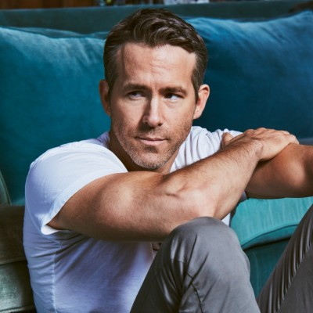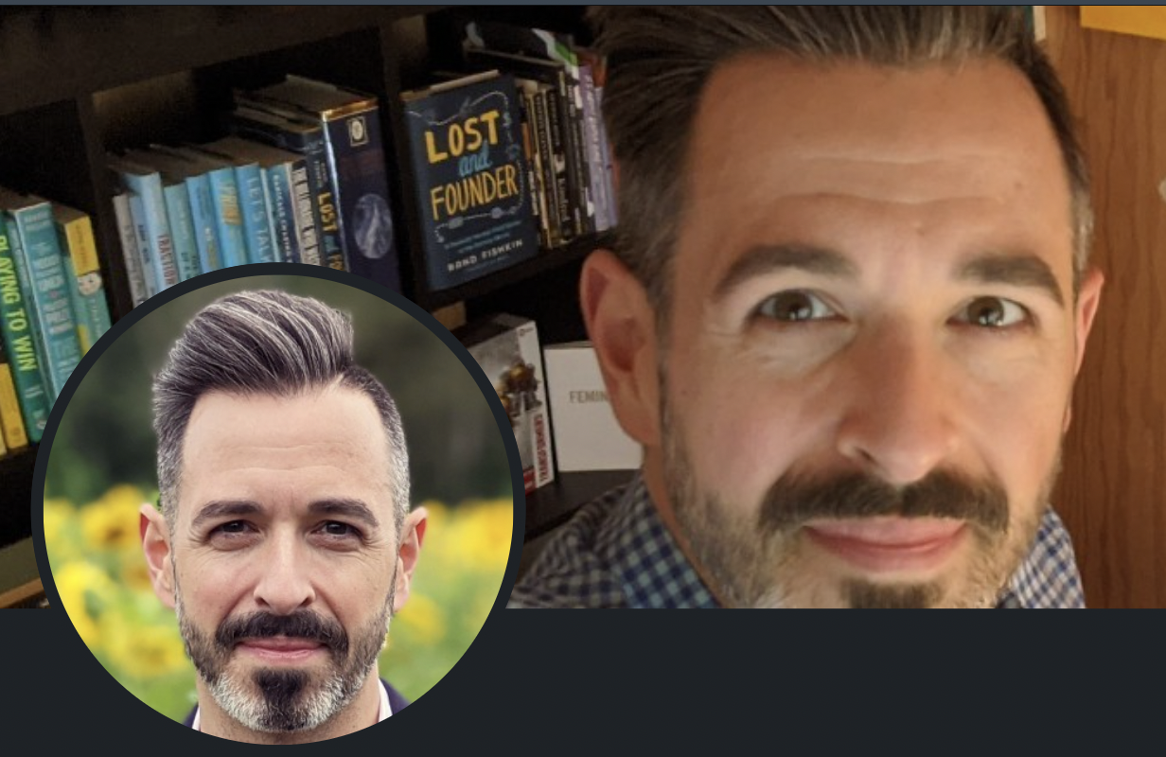
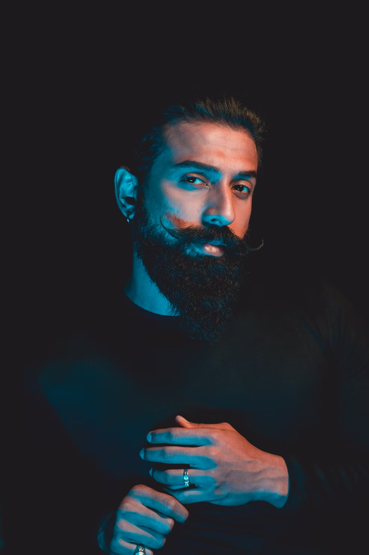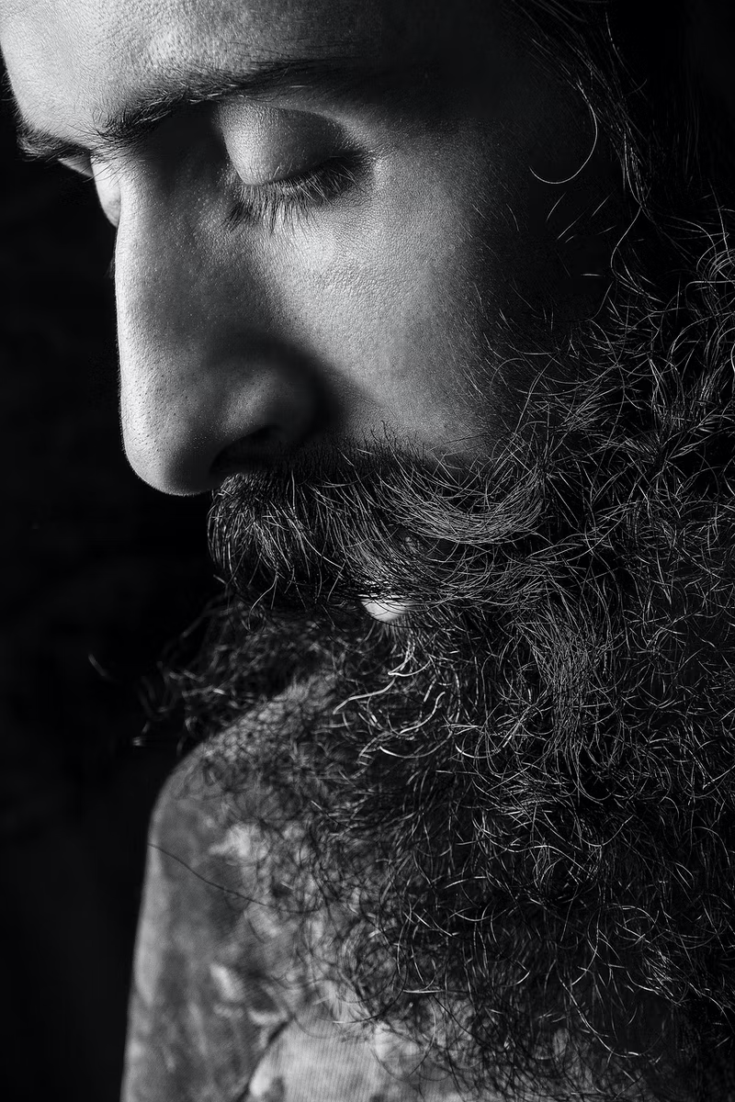

Women



