The Twisted Peak

Legends of Clal
Book 1

J. A. Holladay
Official Rewrite: August 19, 2022

Chapter 1 - The Stone

A glistening sapphire sky yielded to the fiery orange glow of the sunrise as Clal fixed his gaze on the horizon. His blond hair whipped against his rough skinned cheeks as he searched the onyx sea.
Squinting, his crystal blue eyes scanned, searching the Eastern sky. Clal bit his lower lip.
He stepped forward, looking down at the wet sand, his feet sinking slightly. Clal paused, then crouched low.
Leaning forward, he reached out and scooped some ocean water out of a wave that was reaching toward him. He watched the water drip onto the white sand letting the drops stream down and around his rough fingers and palm.
Clal rubbed the water between his fingers then looked again into the East.
Today, he thought, lips curling into a brief smile. For a moment, Clal reflected on what would soon take place as he imagined it with mystery and wonder. But, how could it already be, today? His smile faded as he rose to stand.
The wind blew and the leaves sang there song. Clal watched the sun as it climbed higher into the sky. The stars were fading fast.
Clal reached into the folds of his worn clothing and produced a small pouch. He scooped up a handful of sand and let it filter through his fingers. He extracted a pinch of sand then tossed it into his pouch. He continued to comb through the sand.
“Clal!” a girl’s voice echoed from over the hill directly behind him. “It’s time.”
He continued to forage around the area, first to where the grass was growing, then to a pile of odds and ends tossed ashore. He found a twig, a pebble, and a piece of a gray shell.
“Clal?” the voice came again.

Clal walked along the beach as his shadow upon the landscape began to form. He spotted another small shell nearby and added it to his stash.
In the midst of his searching Clal caught a glimpse of a red bird from the corner of his eye flying toward him. It darted past him then fell to the ground.
Clal leaned over and examined the place where the bird had landed. When he looked closer, it wasn’t a bird at all, but a mysterious red apple with one bite taken out of it.
Clal looked up and surveyed the scene. He saw no one among the edge of trees and shadows. He stood up then paused.
It only took a moment before Clal heard the distant sound of giggling behind a trembling small tree.
“Ansa!” Clal said as he stompped his foot in the sand, “I said I would be back in a minute. I’m just fin…”
Another apple flew through the air, this time almost colliding with Clal’s chest, a near miss if he hadn’t stepped aside.
The once muffled giggling was now laughing.
“Alright. Alright. You’ve had your fun. Now…”
“Have I?” Ansa said, bounding from a tree. She wore a wide smile capped by two rosy cheeks on both ends. She was tall, slender, and her long sandy blond hair curled around her neck.
“Not as much fun as I’ll have racing you up ole’ Crescent-Keep and getting to the cart first, dear brother.”
Then Ansa added, patting her pocket, “And wait until I show you what I found a few nights ago when I went digging near the crescent hills.”
Clal’s jaw dropped. “Ansa, you shouldn’t keep secrets from me.” Clal thrust forward laughing. Ansa plunged into the forest ahead of him.
Clal watched Ansa reach the top first, look behind her, then lean forward and race down the other side still giggling. Clal came to the top, still determined to catch her. But, something caused him to catch his breath, and he whipped around and gazed into the East.
The sun had broken over the horizon and was steadily rising as he watched it. He had always wished upon the sky that the dragon of his dreams would emerge somewhere behind a cloud or between the sun’s golden rays and come to him; that it would carry him away to the places of valor, the places of yester-age that the songs were written about, places where he could show the world what no one really knew was deep inside of him.
Into the East.
Clal placed his hand on the place where his small pouch was layers beneath his clothes. He smiled as his fingers clenched the lump and nodded.
Clal spun around and sped down the other side of the mountain, being the tallest peak that was surrounded by a crescent arrangement of hills below. Clal and Ansa had always thought is was like the keep of a castle, so one day long ago they named it such. They didn’t know it’s proper name. But, that didn’t matter. It was theirs, and always would be.
When Clal arrived at the cart that was near the two room cottage, he found a hunched-over-Ansa heaving in each breath as she leaned on the large wooden, wheel of the cart. Clal joined her as they both cuaght their breath.
The horse whinnied once then stomped its left hoof.
“Ginger, you old thing.” Ansa stood walking to the horse and patting her on the shoulder. “We’re leaving soon, silly.” Ansa rubbered her gray mane then scratched between her ears.
The cart was filled with countless barrels, almost to capacity, except for a small space in the back. The wheels were taller than the wooden planked sides of the cart and there was just enough room for one or two small people to sit and guide the cart on a small wooden platform in the front.
“Well?,” Aerol said, stepping from the entry of the cottage, “I believe it’s time to go. There’s enough sunlight now.”
Clal’s older brother walked past Ansa, adjusted the horse’s gear, then climbed up and sat with reins in hand.
“Mina,” he said, turning his head to the right. “Come, Mina. Or I’ll let Ansa sit by me.”
A small child about ten years of age darted from the cottage and plopped herself beside him in a blur. She wrapped her arm around Turl’s elbow then looked up at him. Turl smiled and winked at her.
Clal and Ansa approached Aerol who was now joined by Willa.
“Uncle, how will you ever manage without us?” Ansa said, cocking her head to one side and putting her fist on her hip.
“Ansa, I don’t think we will.” He said, pinching her nose and smiling. “Hurry back, you two, but only when you’ve completed the time we’ve contracted for you to be there.”
Ansa gave Aerol a squeeze. She looked up at his tanned, round face and smiled. She then hugged Willa who was now teary eyed.
Clal only looked into the eyes of the most wonderful people he knew. He didn’t know what to say. It was a moment he never thought was come, but now, was almost over.
Willa chuckled and stepped forward putting her hand on his shoulder, “Now, Clal, my child,” She said, “You’re going off to those adventures you’ve always wanted to go on.” She held his face with her palm. “You’ll see.”
“Yes,” he said, “But...this feels different.”
She pulled him close. “Yes.” She said as she held him. “And remember, Clal, find your path.” She pulled him away so she could look into his eyes. “Find your path, Clal, then find the courage to live it.”
Willa smiled, and the light in her eyes told him much more than she had said.
“Well Willa,” Aerol reached out for her arm, “they’re sixteen now, these twins, and they’re on their way if you can believe that.” Aerol shook his head. “Time, it moves so swiftly somehow,” he said, scratching the side of his chin.
“Thank you so much, aunt and uncle, for all you’ve done for Ansa and I.” Clal said half smiling. “We are who we are because of the both of you.”
“You are who you are because of what you have chosen to be,” Willa smiled, her chestnut hair gently waving in the wind.
“Yes, thank you.” Ansa added. “And we’ll be back the very day we finish.”
“Yes,” Clal smiled, “the very day!”
Ansa turned to Clal with her mouth open wide. “That’s what I said, the very day. What’s wrong with that? It is possible.”
“Nothing,” Clal smiled as he walked toward the wagon, “It’s just that, what if we want to sleep first, then wake up in the morning and leave for home? Or, what if it takes longer than a day, or suppose…”
“We’ll miss you both,” Ansa said to Aerol and Willa, colliding with Clal. They both fell into the cart and started to laugh.
Ansa sat up, “And don’t mind Clal, he doesn’t know what he’s saying half the time,” she said, pushing him back down. “I’ll be sure he doesn’t get himself into any trouble.” She turned to Clal waving her finger at him as he sat halfway up now displaying a dirt smudged face.
Aerol huffed, then held his breath, then let out a loud laugh, “I’m not sure that’s possible. It might take a small army to accomplish such a task.”
Clal frowned then folded his arms. He shook his head then started laughing again.
“Alright, Turl, get going now. You don’t want to be late. Adventus season yields quite a crowd,” Aerol said looking at Willa, “Stay busy!”
“And take care of each other. Stay together.” Willa said, raising her arm and waving. “We don’t want what happened last year to happen again.”
Mina turned around and smiled at her mother while Willa smiled back, wagging her finger in Mina’s direction.
“Okay father.” Turl and Mina waved as the cart began to creak forward.
“Bye, Momma!” Mina said.
As the cart rolled down the thoroughfare Clal watched Aerol and Willa who were frozen in time, embarrassing each other as they watched him. There was no possible way for Clal to have been prepared for what came the moment the cart pulled him around the first corner and out of sight of the world he always knew. He didn’t know when he'd be back, what would happen from now until then, and it didn’t quite feel the same as in years past when they traveled to Eldan Vyum as long as he could remember.
A small feeling started to grow within him as he watched Ansa settled down, close her eyes, and slip into a much needed slumber. The sun reached higher into the autumn sky as they rolled along.
The trees reminded him of the ocean everytime the wind blew, his ocean, his sea and the waves upon the shore. It was all so close, just a climb away across the Crescent-Keep pass. But now…
Clal watched Ansa’s slow breathing as she leaned against one of the wooden barrels. And we’ve never been apart, Ansa and I, Clal thought.
He thought about this year when they thought they would lose the crop from the early freeze and how Mina tried to talk Willa into keeping the pig that showed up one day. And his stash of drift wood and things that he’d collected over the years. And Turl, he was so different now after his journey to the North, last winter.
Clal turned to steal a peak at Turl leading Ginger along the road. Then he looked away. We used to be so close, Clal thought. He didn’t understand it.
A long while passed as Clal thought in silence. Turl and Mina were conversing but Clal couldn’t hear what they were saying. The cart continued to inch forward and soon the top of Crescend-Keep was lost to Clal’s view.
The sunlight was shining on Ansa’s face now who was beginning to stir. She turned over and nestled back into her fetal position. Clal saw Ansa whince and open one eye. She looked straight forward for a moment then gapsed. She padded her thighs then her hips hurridly.
“Oh, there.” She said. Ansa sat straight up. “Clal, come here.” She waved him over as Clal scooted closer.
“Now,” she said, scooting away from Clal slightly, “You must promise me, Clal Winden, to listen to me,” She watched Clal, “Clal, promise me that you’ll listen. I have a lot to tell you.” She smiled, pulling a pouch out of her pocket. “Agreed?”
“What do you mean?” Clal said scratching his head.
“Remember?” She whispered, “I told you that I had something to show you?”
Clal’s eyes widened.
“Promise.”
Clal looked her in the eyes then smiled and nodded. “I promise, Ansa.” Ansa had never talked to him quite like that before. She held him spell bound both by her well known art of suspense and by her suspicion of Clal.
Ansa looked up at Turl and Mina who were in quiet conversation. Mina giggled and Turl chuckled as he continued to drive the cart along. Ansa looked back at Clal, waved for him to come closer then untied the pouch.
They sat, huddled over Ansa’s cupped hand in front of her as she turned the pouch over. A smooth, blue stone slipped from within the pouch and rested in the center of her palm. Its shape was perfectly round, and though it was flat it still held a measure of thickness as the edges were perfectly tapered. The surface with smooth like glass and the blue was pure and untainted by any flecks of discolored stone. There was no other stone like this in Lyrune that they’d ever known and when Clal looked into the stone itself, it seemed as though he could peer into the very depths of eternity.
“Clal,” Ansa started. “It was not two nights ago that I found this stone. I had been digging for some of those ginger roots as I often do this time of year.”
Clal continued to eye the stone. “May I see it?” he said. His curiosity had got the better of him as this stone lay before them.
“Yes,” Ansa shot a glance at him, “But, listen first, remember.”
“Right.”
“I was digging, it was late, but the moon was full. The light hit the ground just right, then something in the ground caught my attention. I leaned over, scraped the dirt away and found this, this stone.”
“But Clal,” her face now grave, “the moment I held it in my hand,” she paused.
“Yes, Ansa,” Clal looked at her, “I’m listening,” he said smiling wide.
“Well,” Ansa swalled, “perhaps you should hold it now…here,”
Ansa placed the stone in the middle of Clal’s palm. Clal lifted the stone up to the light of the sun and held it there trying to look through it. He squinted with one eye open and examined what he might find in the center of the stone. He thought he spied a dot, a small, lighter colored blue dot in the center.
He lowered his hand and placed the stone back in the center of his palm. Both Ansa and Clal were looking down at the stone when Ansa gasped. Clal’s eyes got wider as the stone began to change.
What was once a small dot a moment ago was now a growing glow pulsing ever so slightly. It began to fill the stone and reached its edges.
“Oh…uh…Ansa?” Clal said, looking at her. “What’s it doing?”
Ansa shook her head and reached for the stone. She held it up, level to her line of sight. But, by then the light within was gone and the stone had now returned to its original condition.
“Clal, look.” She held it out in front of him.
“It’s…gone,” he said.
<<< writer’s group cut off if 2500 words >>>
Ansa, eyeing Clal, gently caught hold of Clal’s hand, turned it over and set the stone upon his palm again. Clal pushed the stone toward her but she pushed it back.
Clal looked at her then down at the stone and pulled it back, closer to his chest.
They sat for a long while, staring at the stone as the cart swayed and bumped along the dusty road. Once again, the glow of the stone grew from the center then out, casting a soft blue glow upon Clal and Ansa’s faces.
Clal looked at Ansa then back at the stone. Ansa began to smile. She reached out to touch the smooth surface of the stone when the cart stopped abruptly.
“Time to water ole’ Ginger.” Turl said. “Come on, Mina. She’s slowing down and we still have a ways to go before we make camp for the night.”
Clal stuffed the stone into his pocket. He sat there on the edge of the cart in a daze.
Ansa pulled his arm, “Come on! Follow me.” She said.
They both slid down from the back of the cart and slipped into the forest.
Turl and Mina had unhitched Ginger and were leading her to the stream nearby. Ansa stopped for a moment near a tree, squinted, then pulled Clal deeper into the forest.
“Come, Clal!”
“Where are we going?”
“I want to have another look,” her voice trailed behind her as she hurried further now moving upstream.
They arrived at the river bank which was overgrown with grass and moss. A few large builders cut the slow moving water as it flowed past. Birds were singing above as the wind pushed the trees back and forth.
Ansa led him to a fallen tree where they both sat. Clal pulled out the stone which was glowing already. He held it out.
“Ansa,” he said looking deep into the stone, “I don’t know what this means. How is this even happening?”
Ansa shook her head. “I don’t know.” She leaned forward and examined the stone. “I don’t understand.”
Clal stood up, then looked around him. Ansa sat on the log as he started to approach the side of the river.
“Clal?” she whispered. “Clal, what are you going to do?”
“I have an idea.” He said.
“You don’t know…”
He leaned over closer to the water, “I wonder what would happen…”
He pinched the stone between his fingers then dipped the glowing stone into the water.
Like lightning, the water flashed from one side of the river bank to the other. Clal pulled the stone away from the water and instinctively thrust the stone back into his pocket.
Clal shot off into the woods.
“Clal!” Ansa yelled following him into a thick of trees.
What just happened? Things were getting more strange by the moment. This stone…Clal shook his head and touched the stone in his pocket again.
He ran to the cart then jumped in. Was now resting his chin in his palm.
Of all the stories he’d been told, of dragons and elves and swords and heroes, he’d never heard of glowing stones. And to think that when Ansa held it…
“Clal,” Ansa whispered as she climbed into the back of the cart and leaned in close to him. “I’m sure it doesn’t mean anything. It’s one of those rare stones that are just…rare.” She shrugged her shoulders.
Clal’s jaw dropped. He looked at Ansa and blinked several times, “Rare?”
“All set?” Turl said a moment later.
They both nodded in tandem and the cart lurched forward.
The clip-clopping of the horse’s hooves on the wooden planks of the bridge that spanned the river echoed against the trees. While watching the water flow under the bridge, Clal returned to his own thoughts. He leaned his head back and rested it upon one of the large barrels. This was what he needed, silence for a while. The stone had brought upon him an overwhelming amount of curiosity, but also uncertainty. Clal placed his hand on the stone in his pocket and closed his eyes.
He breathed deeply, listening to the creaking of the wheels. The cart rocked back and forth as Clal imagined the rolling waves of the sea back home. The sounds of the forest slipped away.
* * *
He was crouching near the edge of the shore again. The sky was dark and there were only a few stars in the sky. There was no sunrise. Clal leaned closer to a small wave crashing against the land. He reached out and touched the water.
The wave immediately froze and the ocean water filled with light. Then there was a voice.
“Remember, the hand of star, moon, and sun,” Clal heard the voice from the water as the light pulsed beneath it. “...will guide the people back to their home. ​​Acting as three, with purpose as one…”
“As one…as one…Eldan…Eldan…”
Clal opened his eyes. How long had he been sleeping? Dusk was approaching. Ansa was leaning over him.
“Eldan Vyum,” Ansa said hovering over Clal. “Tomorrow, we’ll be there. But, we need to set up camp, Clal. Wake up.” Ansa giggled.
Clal looked around at the curtain of black that now shrouded the sky and forest around them. Turl had started a fire where the others had led Ginger and the cart off the road. The chill in the air was cooler than Clal was expecting but the heat of the fire warmed his spirits.
Turl was sitting on the forest floor beside Mina. Ansa sat beside Mina and looked up at Clal watching him closely.
Clal wasn’t in the mood to sit, he had just woken up from a confusing dream. Since leaving Lyrune there seemed to be no shortage of curious happenstances. Clal felt his pocket where the stone was then scratched the back of his head with raised eye brows.
Mina was throwing leaves and sticks in the fire while Turl was running his fingers through her dark brown hair, his gaze was lost in the orange flames of the fire.
Ansa broke the silence.
“I don’t suppose anyone’s up for a game of finders?” Ansa smiled looking around. “It’s best when it’s dark.” She looked at the moon which was only a sliver of a light in the sky.
“It’s late,” Turl spoke with a horse voice, keeping his eyes on the fire. “It’s late…” he repeated himself, which he did when he was lost in thought. An occurance that happened more frequently in recent months. “...and you shouldn’t waste your time with such childish…” Turl looked up, almost in surprise. He looked at Ansa and then to Clal.
“Turl,” MIna looked up into his face, “You didn’t mean that, did you?”
Turl looked down at Mina then whispered, “Oh, no, Mina. I’m sorry.” He rubbed her hair with his hand. He shook his head then stood up.
“I think I’ll turn in.” Turl stretched then walked over to the blanked that was strewn accross the leaves and pine needles of the forest ground. “We have to wake up early so we can get a good spot.”
He layed down and was snoring in minutes.
Ansa guided Mina to her sleeping spot, covered her with her own blanket then walked over to Clal. “We should get some sleep Clal.” Ansa was standing above Clal who was still sitting, watching the flames.
“I slept.” He said. “I dreamed,” he said keeping his gaze fixed on the stories the flames told, each flame different than it’s previous counterpart.
Ansa touched his shoulder then sat beside him. “What dream?” She whispered.
“Ansa,” Clal said turning to her. “You didn’t tell me everything, did you?”
Ansa’s mouth opened to speak, but she didn’t say anything.
“Ansa,” Clal turned and held her shoulders with his hands, “what aren’t you telling me?” He leaned closer to her and looked into her eyes. The flames of the fire were reflected upon the surface of her eyes that were now opened wide.
“When you…”
“When I found the stone,” she began “it was deep, buried.” Clal let go of her.
“And, when I reached down to pick it up…” Ansa paused.
“...when I touched it…” Ansa whinced.
“What happened when you touched it?” Clal whispered.
“Clal, I’m sorry, it’s just that…” Ansa turned from him.
Clal put his hand on her arm. “Ansa?” He said. “It’s okay. I’m listening.”
She turned to him, looked him i the eye then said, “I heard a voice.”
They looked at each other in silence as the fire crackeled and cast a moving glowing upon their faces and clothes.
Clal turned and yielded his gaze once again to the fire which was now half the size it was when Clal first came to sit beside it. “That might explain it,” he said to himself.
“Explain what?” Ansa said. “Clal, what?” she nudged Clal’s shoulder.
“My dream.” Clal smiled. “But…how?”
“Clal,” Ansa growled. “Tell me.”
Then Clal turned his attention back to Ansa, “Not until you tell me everything about that night,” Clal smiled a sideways smile, “Everything!” he whispered loudly.
Ansa paused, then smiled. “Well…it was sort of,” Ansa looked up toward the sky and put her finger to the corner of ther lips. “...confusing.” She said.
“Confusing?” Clal replied.
“Yes.” Ansa pointed in the air with her finger. “It was confusing because I didn’t know from where the voice was coming from. And so I grabbed the stone, slipped it into my pouch that I always carry with me, then looked around, listening for the voice. Which, of course, was gone.” She shook her head.
“But, I thought I would just walk around to see if I could find out who might have been speaking, or…” She corrected herself, “Singing.”
Singing? Clal mouthed the word.
“But after searching,” Ansa continued, “There was no one.”
Clal pinched his chin between his fingers. “Anything else that you remember?”
“Yes,” Ansa said. “Just that I thought I saw more than one place where the moonlight had reflected off the ground, like there were more of these stones, but I was so distracted by the voice, I just hurridly covered up the place where I found it.”
Ansa scooted closer to Clal, “But, Clal,” she whispered, “What about this dream of yours?”
Clal thought about the voice that he heard as he imagined that he was back home, back on the shore beneath Crescent-Keep. Should I tell her? I don’t even know what it means, he thought.
“Clal, tell me.” Ansa begged.
“Okay,” he said.
Clal told her about the dream and that he heard singing and the words but that he didn’t know what they meant.
“And the stone, I fell asleep touching it in my pocket.”
The silence aftwards reigned as they watched the fire grow smaller then finally die out. Clal rose first then Ansa. They hobbled to where they would sleep then layed down. Clal could hear Ansa’s deep breathing as she too seccumed to slumber.
But Clal, he had slept and didn’t feel tired. In fact, he wasn’t planning on sleeping, not for a while, not until he tried the virtue of the stone again.
When everyone was asleep for a long stretch, Clal slowly sat up, stood up, then stole into the darkness of the forest.
Clal looked up to the sky and found the stars within the dark canvas of night like the sands upon the shore, shimmering in the sky. Clal knew that they must have stopped near a stream or river so that Ginger could drink before the final portion of their journey tomorrow, but he wasn’t sure.
Clal listened, then walked in one direction before stopping again to listen. Though faint, he heard the unmistakable sound of flowing watter. He smiled then walked toward it.
It occured to him that if he wasn’t careful, he might loose where the others were camped so he looked behind him. Though the fire was out he could still see the glow against the boards of the cart and the gray shape of Ginger who was moving her head to her left at that moment.
Clal regained his courage and moved toward the water. It ended up being closer than he had expected when Clal’s foot slipped and plunged though the surface into the shallows of the stream.
“Oh,” Clal said, “Wet!”
Clal had put his hand in his pocket just then and the glow of the stone caught Clal’s eye. He pulled it out and saw it’s reflection on the water’s surface. It was a beautiful sight and he could tell it was pale blue as he looked at it in the water with facination.
Clal held the stone close to the water, this time not daring to touch it to the surface. He moved it to the left then to the right as he watched his face light up. Then, he leaned closer to the water and positioned the stone so that it too was as close to the water as he dared to hold it. He wanted to see what he could spy at the bottom of the stream.
But then, as he was searching, he caught sight of his own face and how it was shining and glowing blue. Clal knew it was himself, his face. But when he looked, it didn’t feel like him, almost an older and wiser version of himself.
Then to his surprise, within the reflection of the water, there appeared another face, a woman’s face with long, white hair behind him, to his right, as if there was someone, another person, standing with him above the stream. Clal froze. She blinked then smiled.
Clal whipped around. He stretched out his arm with in front of him holding the stone in his hand. He waved it back and forth, now breathing quickly.
But, there was no one.
He stood their like a statue holding the stone, his arm stiff, his knees bent. Then he relaxed.
Immediately Clal regreted that he had ever left the camp. He was alone in the depths of his curiosity. It did not serve him this time and rarely ever did. Trouble.
He slipped the stone back into his pocket.
Trouble. That’s all he ever found when he was curious. And now, the stone, the light, it was all too much to forget, but he would have to for the night.
Clal noticed something, though as he thought about what had just happened while walking back to camp. It wasn’t fear that had overwhelmed him, though he had certainly felt a little. He had to admit that he was feeling something, something new, or, maybe not so new, just that he hadn’t felt for a long time.
Clal and Ansa had yet to solve the riddle of why they ever came to the home of his uncle and aunt, Aerol and Willa in the first place. They had always been told, ‘We’ll tell you when you are old enough to understand.’ And everytime, Clal thought about it, about who his parents might be, or might have been, about that part of his life, or part of who he really is, of who the twins really are, that thought always brought Clal a feeling of excitement and adventure, to know that there is more to know about who he really is.
And he’d often thought that if it turned out to be nothing worth learning, that that would still be okay because he would know the truth someday.
He realized, as he came to where he had set up to sleep for the night, that he felt that same feeling ever since the stone came, and the light, and now this face, the woman in the stream. And with these thoughts Clal smiled, closed his eyes, and slept, awaiting the arrival of a new day, of more, the unravaling that had started to happen ever since Ansa’s finding, ever since the holding of the azure stone in his hand.

Chapter 2 - Eldan Vyum (el-dawn-vee-you-m)

As the cart rolled over a small hill, the glow of the sunrise lit the sky behind them. They had been traveling in the dark of morning for a few hours before the light of day revealed the narrow road, their path.
They were traveling to the central city, Eldan Vyum, the largest city and capitol of Illia. This was the country, a large island among the seas of the world…
It was Adventus, the festival to honor Seldenlum, the long awaited deliver…
It was the market that they sought….

the spires of the castle of Eldan Vyum came into view. Cutting through the rays of the setting sun, it sent stripes of light upon the road and forest below.
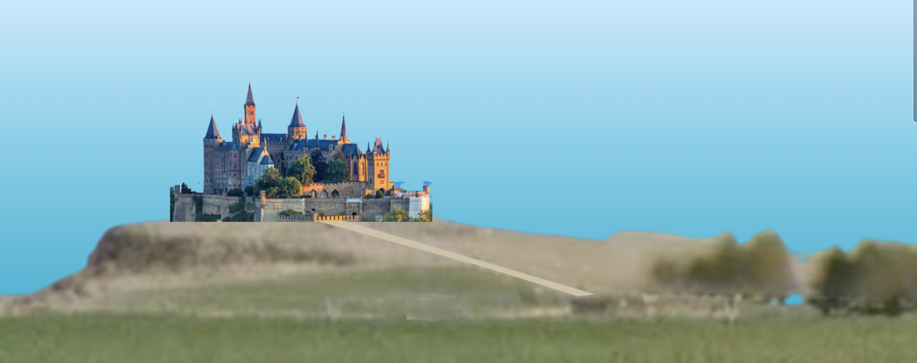

The castle was set on the top a flattened hill with a long road reaching up to it’s massive front gates. The stone walls bore three towers and the castle keep towered over the spires. The golden flags whipped in the wind and the gray guards stood like statues on either side of the dark wooden planked gate.
They crossed the great intersection of the road that took travelers north and south, the very road that Turl had traveled. Clal had never set foot in either direction but had only crossed this way as they went to Eldan a few times a year. Clal looked down the road to the South then the to the North and imagined what adventures existed in either direction.
They inched toward the bustling city as the sun slipped behind the mountains in the west and cast it’s golden light upon the bottom of the clouds in the sky.
After a few turns around busy corners they arrived at the market. A man called out and waved.
“Ho, Turl!” The thin man approached. “Hullo, there,” he smiled. “You made good time, I see.”
“Hello Uncle Tallon. Yes,” Turl said. “Ginger still has it in her.”
“Another year.” Tallon rubbed the tired horse with his rough hand. “And Mina, dear.” He grabbed her off the cart bench and swung her around. “Look how you’ve grown.”
She giggled. “I brought you some flowers, Uncle Tallon.”
Tallon gasped, then his face turned red. He pinched the flower stems between his fingers and slid them into his shirt pocket. He looked back at Mina who had covered her mouth with both hands and gave her a smile.
“Well,” Turl said walking up to Tallon and Mina, “Where are we to set up this year?”
“Ah, follow me.” Tallon waved. Turl climbed back into the cart then urged Ginger forward. They followed Tallon along the street while Mina walked beside Tallon holding his hand.
There were merchants setting up with a variety of goods….
(describe based on picture)

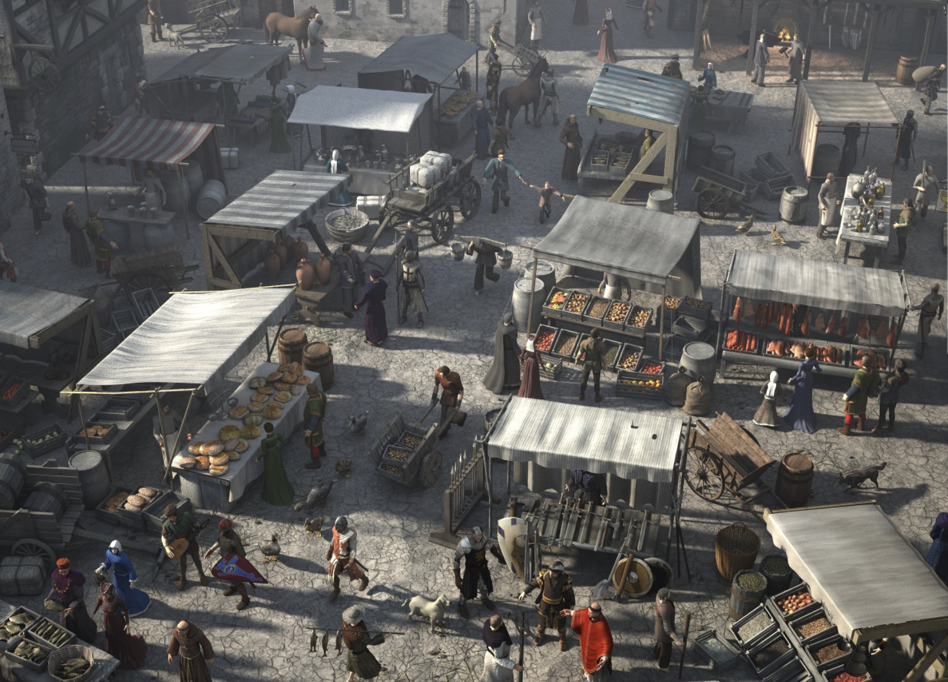
After passing by many merchants setting up, Clal noticed an empty section. Tallon stretched out his arms. “Here,” he said. “I’ve brought your usual market equipment,” Tallon pointed to the pile in the center of the open area. There were several wooden poles, a large gray canvas folded neatly laying on the hard packed dirt. There were two columns of wooden boxes stacked several feet high. There was also a hand cart with spoked wooden wheels.
“Is this to your liking?” Tallon said reaching toward Turl with his hand.
“Yes. It’s better than last year,” Turl smiled, “And the year before.”
For the rest of the evening Turl, Mina, Clal, Ansa, and Tallon worked to unload, setup, and arrange their goods within the barrels they had carried from Lyrune. With the posts and canvas they had fashioned an awning. Several barrels were set up where the wooden boxes were placed on top. And the boxes were filled with apples, bright green, deep red, and golden yellow. Clal grabbed one of the red apples, looked at Ansa who was watching him, then smiled and tossed it her way. Ansa caught it and took a bite.
Clal walked over to Turl, “Do you need any more help, Turl?” he smiled.
Turl had been leaning over to fetch more apples from a nearby barrel. He turned to Clal, “No,” he said with an expressionless face. “You two should make haste.”
Puzzled at Turl’s reluctancy to interact with him, Clal shrugged and turned to find Ansa. She had been talking to Mina the last time he had noticed. By this time Ansa was holding Mina in her arms rocking her while she sang her favorite lullabye.
“...(the finding people song)” Ansa sat her in the back of the cart and leaned her up against one of the remaining barrels. “We’ll be back before you know it, okay.”
“Where are you going?” Mina mumbled, her eyes partway opened.
“Remember, I’m going to spend a few months with Gwynn to help her sew.” She touched Mina’s nose with her forefinger. “And Clal, he’s going with Tallon to learn how to make swords and daggers…”
“...and horse shoes, and nails.” Tallon added who was standing nearby.
“We’ll visit you in a few days, though.” Ansa leaned over and rubbed her nose against Mina’s, “And I’m gonna’ see if you’re behaving.” Ansa giggled.
“Nope.” Mina smiling a sideways kind of sleepy smile. “I…don’t…want…to…” Mina yawned. “...behave.”
Ansa watched Mina for a moment then turned, pulled her sack from the back of the cart. She walked over to Clal. “Ready?”
Clal nodded, “Tallon, we’re ready.”
Tallon was walking toward Turl who was looking at the fine display of boxes.

