The Legends of Clal
Table of Contents

The Nugget 4
The Three Wizards 6
Ottomus: The Beginning (Wizard 1) 6
Prepares a Plan 6
Prepares a Place 6
Prepares a Person 7
Felsawn, son of Ottomus: The Shephard (Wizard 2) 8
Creates the Phenominons 8
Morgreth, son of Felsawn: The Guide (Wizard 3) 11
Prepares a People (Partnership) 11
The Central Force and Forces 12
Master Characters 12
Clal: Heroic Character 12
Womlon: Heroic Character’s Adversary 13
Leara: Heroic Character’s Love Interest 13
Major Characters 13
Minor Characters 14
Hittle: The Chipping Sparrow 14
Sedrak: The Ice Dragon 14
Books 1 – 5 15
Book One: 15

Summary

The Nugget

The Legends of Clal

Fantasy-Adventure

The Heroic Character-Clal, a youth from Lyrune
Central Issue of the Story:
- Heroic Goal-To battle the ancient evil villain
- The Worthy Adversay-Womlon, the ancient threat

A wizard named Ottomus devised a plan to save the people from Womlon, the force of darkness. He prepares a plan by preparing a person so save the people and a place for a refuge. The one to save the people emerges and finds himself unprepared for the task. But with the help of his friends, family, and alliences he will embark on a journey that will bring him closer to his destiny but further from his home. Only through the powers within him will he be able to defeat the dark forces and return peace to all who live.

Book 1: The Journey Begins; The Beginning; The Legend of Skyland;

Book 2: The Moved Mountain; Of Mountains and Things; The Mountain of Kelvkoroth; Into the Depths

Book 3: Sands of Illusion

Book 4: The Flame of Nilthinon

Book 5: The Dawning of Time

Questions to Be Answered

Sedrak: The White Dragon
Why is he white? What role will he play? When will the partnership ride him? Can he talk and how does he communicate with the partnership? What will his name mean and why does the Wizard one name him that? If he gets injured, how will this effect the partnership?

Will a F'element become stolen and perhaps show up in another book so that it will include the recuing of the lost F'element?

Who dies? Where does Clal find his love in the story? How does Ottomus mark Clal's path?
How will my story be different? Why will the reader want to read more?

What do I replace God with in Nilth and in the entire story meaning, what should I call the force of God? Answer: the flame; light; goodness.

Should each inner-kingdom come out of hiding after the its f’element is removed, like a mass exodus? The virtue of the f’element is the power by which the inner-kingdoms thrive and exist…???

How will the story begin? (I have yet to write my climax scene let alone the opening one.)
- Ottomus and Felsawn on a windy and darkening night. Ottomus is trying to yell to Felsawn his plans while they are endeavoring to escape Womlon’s forces. Something was unforeseen but Felsawn never quite gleans the specifics from his Father.
  - Then the scene when Clal is traveling towards Eldan Vyum for the examinations
  - (This scene will not reveal the history of the story because the characters and such are not yet known to the reader. Hopefully, this will create some anticipation and interest.
- A scene with Womlon fighting Ottomus.
- Clal at home in the valley of Lyrune

Is it wise to make Clal’s magic fallacious as the banished counter it with a distorted version of the magic?
What threats will/should the banished pose?

The Three Wizards
The Three Wizards Symbolize the Trinity and how each has a part in the plan

Ottomus: Heavenly Father – Wizard One – The Beginning – The one who set the good forces in motion.
Felsawn: Jesus Christ – Wizard Two – The Shepherd – He prepares the path way for “The One”
Morgreth: Holy Ghost – Wizard Three – The Guide – Assists as “The One” pursues his destiny.

Ottomus: The Beginning (Wizard 1)

Prepares a Plan
He created a plan. Because there was no foundation or plan to fight the Dark One, he believed that this was the reason for their down fall. So, he had a dream that gave him the knowledge to know that he had a mission to serve, a duty to perform. Thus, he decided to prepare a plan for the future to save the people. (Because, he knew that running away would not solve the problem but that he would help the people “run away” and then further help them by preparing a way to gain the “Old Country” back.

Part of this plan was included a law. There were to be Three Wizards: A Tri-Wizard creed. The first being Wizard 1 taking the role as:
The Beginning – the one to start, direct, create, invent, devise, forge the plan needed.
The secong being Wizard 2, his son, taking the role as:
The Shepherd – the one to put things into place to prepare Cul Country for “The One's” coming and to carve out his path for him.
The third being Wizard 3, an orphan son of Wizard 2, taking the role as:
The Guardian – the one to watch over “The One” while he is being prepared to fight “The Dark One Lurking”

Along with this “The Wiiizard Law” purpose come laws that these wizards have to abide by.

The Wizard 3 Law (The Wiiizard)
- Cannot intervien but can direct, guide and aid. The task of defeat must be performed only by the One.
- Each wizard must perform the task that has been assigned to them.
- Each wizard must make sure their life sustains until their task is done.

Prepares a Place
Wizard 1 sees that the Old World will be overrun soon. He gives to his White Dragon a seed stone that he has made and sends the Dragon into the West over the oceans to be forever parted from each other. The Dragon flys very far away and finally breaths ice onto the ocean's surface and builds a small island to land on. He then breaths ice on the seed stone to cover it with ice layers and then drops it into the sea. The seed stone lands at the bottom of the sea and begins to grow. The Dragon then hibernates until he is awaken by the rising up of dry ground. The earth then grows a high mountain where the Dragon is to live among the colder climates until “The One” is to come and find him and call him to his final duty. The land then continues to grow preparing to receive an exodus people to be a sanctuary and a refuge.

The seed was made from a plant called Culunica which is very common upon it's surface. The reader learns that the name of the country is not from the plant that grows there but is named because the beginning of that plant started with the first seed being the seed of the land mass that caused the continent to grow.

Cul country, before the last battle, will travel back to the Old World and collide upon it's eastern shores reuniting with the its mother earth. A major earth quake will occur and Clal later finds out that at that time, Cul country was detatching itself from the ocean's floor beginning its movement towards the Old Country. The movement of the continent from then on will not be felt but noticed in relation to the placement of the stars being abnormally shifted west.

Prepares a Person
Wizard 1 decided that there needed to be a person to save the people from this evil that, although they were able to escape from, will infest Cul Country to a limited extent. So, he cast a spell on a baby boy that was genetic. A spell that needed a perfect body, and the most perfect person he could find was a new born baby. He searched and searched for a young couple who would give up their first born to a form of magical experimentation of which Wizard 1 was not sure would be successful. He finally did find a couple and the spell went well.

(Maybe because of the need of a perfect baby, maybe he finds a perfect race.)

The spell was genetic and would survive through time until the effect would be realized. The spell is linked to the Dark One so that when the Dark One's is strong enough to become a threat again, a marking on the back of the neck of “The One” to be, will show and mark the time of “The One.” This spell was cast with Wizard 1 risking his life in doing it and was weaker than normal to his dying day (he never recovered after casting this spell.)

THE PROPHECY

Look to the East to find The One.
Who only can unlock the Sun.
The Powers of this world await
Who holds the key to open fate.
And when is found, this One to name
And take his place beside his fame
Remember this, that with his time
Comes danger, mischief, vicious crime.
For not too far from this world’s birth
There is one who roams the earth
Awaiting chance to stake his claim
Upon each heart that has a name
Yet if our One completes his task
The Dark One lurking turns to ash.
But if our One turns inward spite
All hope will fade without a fight

Interpretations

Look to the East to find The One – Because Cul Country's Western shores will colide with the Eastern shores of the Old Country. The word find connotes the following: to be established, to discouver, to be proven, learn, to verify. (If he really is the one then he must prove it at some point.)

Possible “proving” method: Just as the “Dawning of Time” statue is the key of the New World, there will be a key in the Old World; a key that will need to be unlocked...a token maybe.

Sun, Moon, and Stars

Remember, the hand of star, moon, and sun
Will guide the people back to their home
Acting as three, with purpose as one
Giving a place where no more shall roam
Out of the darkness into the light
Will hope then embark upon its last flight
What once did arise, will now see its end.
With sun, moon, and star, a people defend.

The Sun signifies Father in Heaven that rises when the “turn of the tides” as Gandolf phrases it, begins. (this is very loose and needs some refining on how the “sun” represents Father in Heaven.
The Moon signifies Christ as “The One” or Clal comes from the valley of Lyrune which is a valley surrounded by the cresent hills.
The stars guide and direct, like the Holy Ghost.

The Godhood.
A deeper Prophecy that comes during the course of the books. A deeper law, deeper magic, deeper meaning, much deeper purpose, deeper concept.

Interpretation: The importance of Sun, Moon, and Stars will be evident.

- Sun: The Sun is the name of the sword that will emerge from the statue which received the F'elements. The Dawning of time will occur when The Sun rises. “The Sun” is the sword.

- Moon: Clal is from the valley of Lyrune which is known for the hills surrounding it being formed into the shape of a crescent.

- Stars: The importance of constellations will be used.

Felsawn, son of Ottomus: The Shephard (Wizard 2)

Creates the Phenominons
In the Plan that was given to Wizard 2 by his father, there is included a small idea on how to create a force strong enough to defeat “The Dark One Lurking.” All that his father wrote was:

(Make into a poem this phrase (possibly))

What a strength can bind
A weakness can find

He derives a plan of his own…he researches the books and scrolls that his father gave him. In it he finds the 5 weaknesses of “The Dark One”

They are elements: F’elements (meaning Five Elements.)

The F’elements are under development (i.e. De’F’element) lol

1. Fire
2. Song
3. Invisibility
4. Love
5. Beauty – (beauty is mostly in thins that may not appear beautiful on the outside. Beauty is purity, is clean, is goodness, is life, is respect.

Wizard 2 realizes that he must create a force that can reach and master each weakness all at once in a short period of time. He decides that the best way to do this is to mold all five into one. Because he is only the shepherd and by law cannot just give this created weapon to “The One” he decides to lure him to the weapon. But, if “The One” obtains the weapon too early, he will not be prepared to wield the weapon. This puts a damper on the plan as Wizard 2 wonders how this will work.

Alas, his plan is layed out before him in a dream, a vision. He must encapsulate each weakness and have “The One” collect them. The F’elements will be placed in a statue to be held there until all Five Elements are united. Then, the statue will melt away and create a sword with all five weakness elements forged into it. The F’elements will activate on “The One’s” command and this is what will happen.

- Fire will protrude from the blade.
- A song will echo from the sword along with a continuous humming.
- The wielder of the blade will become invisible at will
- The sword will be so beautiful that the Dark Lord will seek to obtain it.
- The five sided jewel in the middle of the hilt is from the heart of Cul Country and love will radiate from it

So, as was eluded to previously, The One must not obtain the sword in his heroic infancy. Therefore, Wizard 2 forms 5 phenominons in the course of Cul Country history. This will achieve a few important purposes.

- they will mark The One’s path for him, focal points.
- Because they are phenominons they will be great, being endeavored through no small means. Therefore, The One will have to undue each 1ighteous1 and in doing so, find the F’element within the Phenominon or Magicon. Basically, Wizard 2 will seal or hide the F’element within each Phenominon. This is a part of Cul Country that makes it extraordinarily unique.

Phenominons (Magicons)
- Beauty: (Felsawn moves the mountain during the night time.)
- (Song) Sky-Land: The rising of a land mass taken from Cul Country that is more of a myth then of a legend, which makes it almost impossible to find. Upon its earth high above Cul is a F’elemnt. The white dragon aids here. A song is always heard when upon this land mass. The sword that it helps create always has a hum about it, and gets louder whence the Dark One is near or when it is about to or fighting the Dark One. (Felsawn does this magicon during the day time.
- (Invisibility) The creation of another world upon the sands of a desert. The windows or doors to the world open and close at certain times and can be seen if one knows what to look for. The One has to enter in and find the F’element. The F’element is that, when The One wields the sword he can at his leisure become invisible.
- (Fire) A fire people exist and are located somewhere on Cul. Clal brings the White Dragon at this point also.
- (Love) The heart of the continent has a love that radiates. Part of the heart gives Clal a piece of it’s unigue rock which is part of the actual heart of the island. This then becomes the central jewel on the hilt of the sword and is one way that the land fights back. This also shows that the land grew out of profound and 1ighteous love for the welfare of its future peoples.

At the end of each book we will read a story about how the Dark Lord gained each weakness:

Example: Invisibility
Once, the Dark Lord was fighting and lost the fight because he could not believe in that which he could not see. He could not see his aponant and therefore believed that he was not as harmful as he would have thought.

And so on…

Each journey towards the given Magicon will prepare Clal for the destination.
Example: Invisibility
Clal goes through a forest that grows from an unseen source.
He then passes 1ighteo a fog where he cannot sea.
Then he meets a blind boy who helps them
Then at the end he finds The Sands of Illusion through what he learned and learns the lesson from his journey. (A good concept but poor example.)
This will make each book unigue, complex, mysterious, meaningfull, deep, etc.

But, equal to the task, Clal must learn the Five Lessons that the Dark One never learned or chose not to gain as wisdom. This too is a challenge and may also become a weakness if not careful pondered and internalized. And, the Five Lessons become a creed and exclamation to Cul Country and to all people to follow and to adopt. On the blade of the sword is inscribed these Five Lessons.

Each of the first four books will be focused on the Magicons being focused on a lost people.
But the final book will be focused on finding the first people that were lost and that was the people of the Old world. (The Last book will be all about the new and old world and their relationships with one another.

There are people in the Old Country that are still alive and that were not destroyed entirely by the Dark One Lurking. (Yay).

So, the first magicon was the creation of Cul.
The last magicon is the colliding of Cul into Hanone. The last magicon is also Clal’s ability to slay the Dark One.

Sky People – hid up because they were extremely virtuous and good.
Mountain People – hid up because they were too beautiful
Fire People – hid up because they were the wielders of a powerful weapon – a unique kind of fire
Sand People – hid up because of their wickedness (because of their inability to see sin in its true form, they were exiled for their lack of spiritual sight.)

Each Magicon has become a myth of Cul and is almost acklownledge as a story to explain why some things are the way they are. Each magicon hids or covers up a people or society. Each society possessed a strength or something that would give strength to “The Dark One Lurking.” He doesn’t have the strength. Maybe they were hid up so that the Dark One couldn’t gain the strength.

The Five Lessons

Invisibility:
To the eye is left no trace
Of whence it came from unknown place
But if employed a greater sense
A finer task can then commence
For then beyond the span of sight
Its truest form will come to light
Revealing that which can’t be seen
Anew, yet as its always been

Love:
Within the smallest heart is found
An essence of the world around
A fondness for its simplest things
An interest in the joys it brings
But if such love is left to rot
To whither, break, and die alone
The happiness it could have brought
To those in view, will ne’er be known

Fire:
The flames of fire can take their tole
And snuff from man their mortal soul
For then is joy exchanged for grief
Which causes men to beg relief
Yet with each pow’r exists a law
That governs it both great and small
Thus if possessed this key to wield
Man’s mast’ry over it is sealed

Song:
Above the oceans, lands, and clouds
The winds of earth do sing aloud
In constant song of onward light
Of birds that wing a lighter flight
But if the ear finds no such voice
Such things as this require a choice
For though the arts of sound are learned
Its greater part must first be earned

Beauty:
Look closely at what that is seen
Perhaps it shows a fainter gleam
Nontheless, it is what it is….

Or

Note: This poem may or may not be used

There are jewels and golden things
Found only in the halls of kings
That nearly hold a holier post
Than life itself, when valued most
Only to blur the mind of man
And steal from him all things that last
As nobler treasures leave his hand
Replaced with shards of broken past

5 Lesson Topics
Invisibility: sight, light, ignorance, faith, 2 Cor. 5:7 – We walk by faith, not by sight.
Love: Charity, sanctification of, purpose
Fire: Holy Ghost, heat, warmth
Beauty: unsure of this one…
Song: heart, speech, message, penetrating voice, music, voice

Morgreth, son of Felsawn: The Guide (Wizard 3)

Prepares a People (Partnership)
Wizard 3, being unable to aid The One in his task must prepare a people to travel with The One. This is extremely difficult as he must not make himself known that he is guiding certain individuals to cross paths with The One. (He could not just approach someone with this sales pitch, “Excuse me sir, would you be interested in risking your life to aid The One in preparing to defeat The Dark One with little or no chance of success by way of no reward in the end or before the journey is embarked upon.” Point made. Needless to say, he does find a way to execute the same purpose.

Wizard 3 is raised in such a way that he is taught the many languages of Cul Country including some animal speech. He is also known as being an outgoing individual being taught phsycology and the behavioral concepts of each race. He was prepared by his Father for his life calling. He was prepared in the art of proper communication.

Each person that Wizard 3 must find will help him find each F'element. Five individuals will travel with him.

- Love: Leara: his twin sister will help here.
- Song: Lark: an elf that can float or fly will have been taught about the Sky-Land from his youth. His people are known for their song
- Beauty:
- Fire: a half fire person
- Invisibility: A character that sees things that others cannot.

The Weighing machine


This represents the four Kingdoms of Cul; the ones that are not Legends. This may be kept by Wizard 3 which measures something like the wickedness in each land, like the influence of Womlon.

The Central Force and Forces
The land also helps to prepare the way for Clal. When Rakonor has the dream, it stems from the ceter of the earth or the stone seed and also from the F’element. So, the seed or Culanthra creates these things. Then other events happen in history that shape the cultures and the people.

The Heart: Whatever grows closest to the center of Cul is made up of more elements of what flows through Clal’s veins. Thus if there are rocks that reside there then, if made into bricks and used to build a building, the wall would open to Clal. For example: rocks, plants, trees, animals, the air, and maybe a people. As the radious around the heart chamber becomes greater, the power of Clal is lessor.

Also, whatever surrounds the f’elements, acts in the same way but is a lessor powper and is mainly a power or force for its specific symbol or element.

Clal will find out that Hittle is from the center of Cul. He will find out that other things are from the center of Cul.

Characters
Flesh out characters; give them desires and dreams. This will help your story come alive and guide its natural results.

Master Characters

Clal: Heroic Character

Clal will have to leave his old life behind, grow up, and must close the doors of his past to continue successfully to his marked future.

Distinctive Characteristics:
- Ice Blue Eyes
- White/Blond Hair – very light
- One blue eye and one gray eye or any other color which changes based on Clal’s mood
- His common sideways/half smile

Questions:
What does Clal have to do?
What does he want to do?
What can’t he do?
What shouldn’t he do?
What are his priorities?
What does he need help with?

Fatal Flaw
Curiosity

Womlon: Heroic Character’s Adversary
What was unforeseen by Ottomus was the fact that Womlon has cracked the code, he’s “figured out” the magic that runs through Clal’s veins, the same magic that the new world is made up of. This is a terrible threat, one in which will cause Clal the greatest worry and grief.

Leara: Heroic Character’s Love Interest

Major Characters

The Banished
the banished have taken the spell that they have been banished with and have altered it for the uses of evil.
Order of the Banished
what crime do they commit?
who banishes them?
by what power are they banished?
from what are they banished?

Each banished has a special skill. Each banished has their own story; perhaps they were all good men.

what crime?
murder, take over kinging, to steal that which is most precious-perhaps the f'element, what Satan did: rob people of their agency, sought the throne of God.

complication- if they estrange themselves from the a kingdom, why would they need to be banished?

the spell
genetic spell or curse
infects them
creates a forcefield where they cannot go places
death
lose everything
they obtain a mark

Idea: perhaps they are placed in prison

How the Banished come about in Cul Country
Womlon sets his hand to span over the sead to make first contact with Cul coutnry. He sends a messenger to gather followers who will take part of Cul country over then Womlon will come to finish off the rest (King Emish) is found to be the perfect contact between Hanone and Cul. He finds individuals from each ot the four inner kingdoms who desire to enstalve others. They form “The Rishk” and combine to overthrow the innder kingdoms. On and appointed day they part ways and go to the inner kingdoms that they are from. They were given the power to overthrow, that same power Womlon used to overthrow Hanone, was given to “The Four.” They use this power to take over: Edaphlas, Kelvkoroth, Mirrim, and Nilthinon. Something goes wrong as a small detail is overlooked. Womlon didn't realise that Felsawn knew by what powers Womlon uses to conduct his evil affairs thus, creating a force that would cancel out the Rishks' power. so they were caught in the act and sentenced to banishment by magic. They were trying to steal the f'elements perhaps. They were trying to take over the inner kingdom. But, Womlon had a Plan B for the Rishk.

You see, womlon was banished aswll; he had been unsuccessful at tfirst try but he came back and was successful in the end. Womlon was angry non the less with “The Four” for their innability to carry out his desires and orders. But, he had other plans for his far off force. This time they would wait for “The One” for, Womlon gained knowledge of “The One” years ago and has felt no lasting danger from this so called prophecy. But, he decides to destroy “The One” by assigning “The Four” to destroy him. Again, the same dark magic is used for these deeds

Where the banished live
they all live together in a layer and are occasionally gone to carry out their evil devises. Their dwelling place is located:
on an island, in an abandoned castle, with King Emish, in some caaves on a cliff, underground, in a fortress, in a forest, in the barren lands, under a bridge, not sure...

The Recrutement of Clal
The Banished want Clal’s power so they try to convert/recruit him to their evil ways. IN Book 4: they do capture him and use him to open up sacred places. As they are doing this he learns how to turn off his powers so that it doesn’t work anymore. Thus, he is used as a key. They want him as their own.

Minor Characters

Hittle: The Chipping Sparrow
Hittle can understand Clal. He appears in the “High Room” and as Clal speaks, he does what Clal says. Ryth notices this and points it out to Clal. Hittle becomes a friend and an important part of Clal’s success. He is a clay colored Chipping Sparrow or is just a chipping sparrow that has a red top of his head like a normal chipping sparrow.

Clal will find out that Hittle is from the center of Cul.

Sedrak: The Ice Dragon
He breaths Ice
He lives in the Skyland
He is “purposefully locked up”
(It is really good to intruduce him in Book one so that he can be an aid in the rest of the books.
He should die in the end to seal his mission with his blood.

Perhaps a dragon form of an albino...
Shunned from his race and rescued by Wizard one.
Basically, Wizard one found the Ice dragon right when he was a new wizard having been sent on his own after he was done with his apprintaceship. The wizard rescued him and forever became a symbol of his younger days and was very close to Wizard one.

Books 1 – 5
Because each f’element is connected by the stone seed, the reader may notice some similarities in each of the four Inner-Kingdoms.

In each book there is always a focus on the center of Illiria/Cul; always a focus on the center of the land and what may be at its heart.

Through the books progression, the reader understands that this isn’t just another ordinary land. By the end of the 4th book and beginning of the the 5th there should be an emmince amount of magic and change in the land yielding a reality that this land is not just another medieval land but different. It must seem different. My writing should be so vivid that the reader aches to see the scenes on the screen.

Not only does Clal have to defeat, in some respect, the banished at the end of each book, he must also prove that he’s learned the lesson that he was supposed to learn.

Book One:
Theme: Introduce the Importance of Song for my Series
Edaphlas: The Inner-Kingdom
Skyland:

In skyland there will be a portion of ground that is glowing and light is glowing through the snow. This will be a part of moving the plot. Could be:
a certain item glowing in the snow.
a pathway somewhere
a hole
a beginning of lights where the party travels further and finds more lights

In Rexburg Idaho there is a Porter Park. In this park there is a small, brick building sitting on the North side of it. I was thinking that Clal could approach a house like this when they first come onto the skyland. Inside would be a crochety old man who doesn't want any visitors, or perhaps a faithful servant stationed to lead the visitors to the center, or gateway into the hidden Kingdom.

The servant would perhaps note that no one has ever come to the island or known how to get on. This
may be an interesting fact.

Plot
Characters
The F’element of Song and Its Lesson
God in Edaphlas
The song within us or the voice.
Ideas
Possible name for the book – The Legend of Island’s Song

The Sword, The Ice Rod
When Clal gets inside or just outside the ice fortress, he stops and is instructed by the guide to reach up and grab an Ice Rod (icecycle) along an overhang. They do, and use the Ice Rods in hand to cross an icey chiasm or fly across a gulf. Basically, the ice rod is very prevailant in their culture and is the center of their power. It will be a central part of the world of Edaphlas.

A Kingdom Revealed
When Clal brings Skyla and Larkin down from Edaphlas, people are surprised to see these elves, the word spreads about Clal and the fictitional reality manifests his calling

The Spoken Forest
A forest that speaks as the wind moves through it. Different sounds are formed by the wind and the combinations of the trees characteristics: shape, size, bark, trunk thickness. When the wind blows people come to get inspiration from what they hear.

Book Two: The Mountain: Beauty
Kelvkaroth: The Inner-Kingdom
Plot
Characters
The F’element of Beauty and Its Lesson
God in Kelvkaroth
T
Ideas
The Leaf
Clal picked up the leaf and searched its surface. “Ryth, there’s a leaf here. How do you suppose it got here.” Ryth removed himself from the corner where he was searching and came to Clal’s side. “It probably blew in from the outer realm.”
“But the opening to the cave was blowing out air, not blowing it in.” Clal spoke in a whisper. “I feel a draft and it is going out, against our chests. The leaf must have come from down there.”
“Perhaps the leaf was carried from outside and dropped at this point of the passage way. I really don’t think this means much Clal.” Ansa stated as she shook her head.
“Yet, the reality is that we are looking for something and not simply travelers with a diffinate and defined destination. Entertaining possibilities is to our advantage.” Clal stated then focused his attention on the leaf. “I wonder what kind of leaf this is. Look at the veins in it, they almost look silver. And the tecture is much different than any I have felt. There must be something more.”
“If we are sure that there is an Inner-Kingdom beyond the opening of this passage way then, we can assume that this leaf could yield some sort of evidence of such an existence. What do we know so far about the f’element that we are searching for?” Lark spoke as he searched the faces of his comrads.
“I think the greatest manifestation of our path set before us is what was displayed on the mural at Time’s Dawning. It showed a mountain.” Ryth spoke.
“Yes, I took the liberty to copy it down.” Ansa revealed the pages of a book in which she used to illustrate the mural’s depiction of their quest. Everyone surrounded Ansa as she took out her light stone and began to speak.

The Sun Spot: From circle to oval
Clal held up a thin piece of metal and held it under a circle of light that was protruding from the ceiling above. As he continued to search the metal he bent the metal out of habit which caused the circle of light to become an oval. This reminded him of the oval he had seen a few weeks ago which sparked a thought and answered a question which caused a solution and now they’re on their way. Somehow the bending of the metal and the making of the oval revealed something in the metal that he would not have seen. Perhaps the protruded parts of the metal were aligned and created a pattern.

Veins: The Theme
Veins in leaves, veins in rock, veins in body; same veins in mountain is same veins in leaf. The viens in the rock grow and are magical.

Clal catches a glimmer of a vein that is different from all of the rewst of the silver veins in the rocks. They do not figure it out then but this is the vein that is from the center of the earth, from the stone seed.

lava purification, beauty, wealth, gold, value, fire, song, illusion, stone, heat, purity, process

The Tree that Bears Stone Fruit
It bears special fruit on special occasions and they wait for it.

Being Followed
What if, once Clal is in Mirrim, he notices that he’s being followed. This could be either an enemy or a friend.

Book Three: The Sands of Illusion: Invisibility
Mirrim: The Inner-Kingdom
Plot
Characters
The F’element of Invisibility and Its Lesson
Note: This poem may or may not be used

There are jewels and golden things
Found only in the halls of kings
That nearly hold a holier post
Than life itself, when valued most
Only to blur the mind of man
And steal from him all things that last
As nobler treasures leave his hand
Replaced with shards of broken past

Riches: wealth, treasure, worth, gold, power, greed, where your treasure is there will your heart be also.

Riches: A prince or princess

(Riches) The moving of a montain that covers a cave, an intrance to another civilization, a cruel and evil part of Cul Country, covered up. And within that cave lies a F'element. Riches are the central point of the civilization. The sword gains jewels, metals, and beauty that is so beautiful that he Dark One will seek it, stretch out his clutches and become caught into a trap, having been lead to a place where the Partnership planned for him to come.
Ideas
Today, I thought about my third book: The Legends of Clal: Clal and the Sands of Illusion. Here is what I have come up with:
- My ideas today center around the Mirror Prison in the Rishk layer. This is a room with four walls that are mirrors. They place prisoners inside this room and come back a few days later finding that the prisoners vanish. This is done to all their prisoners.
- Clal and his companions are placed in this prison after some events that involve the Risch. They hear loud sounds after being in their and are split up four ways as they all are transported through the different four walls of the prison. This is a portal to Mirrim, or the origin of the Mirage/Dimension Windows that are seen in the Sands of Illusion that Clal was trying to get into.
- Clal eventually finds some of the prisoners of the Rishk. One of the prisoners that Clal meets it Gulnerye.
- This is where Gulnerye’s Legend is revealed. Basically, Gulnerye was hunting the Rishk. He found out many things about who they are and tried to crack them and divulge their plans. But he became captured and put away. The Legend is that Gulnerye was a well known man, a wise man. But he became a legend because the simply disappeared and if a man who is well respected just disappears, there is some attention brought to his disappearance. And so he became a legend.
- Gulnerye aids Clal and his quest.
- Many of the prisoners are set free and become an important part of the rest of Clal’s fate.
- Meeting Gulnerye Clal begins to understand more of what he is really in for. This Gulnerye character and purpose is to deepen the story and create more fear of the Rishk.
- Some of the prisoners help during Clal’s battle with Skeldruc.

Mirror Prison splitting up the party
When the Rishk or the Banished capture Clal and his companions they speak to them and try to get them to betray their cause. Prior to this, the companionship had been all the way to the sands of illusion when they had been caught or had been turned away by failure; they couldn't figure out how to get into the windows of dementioned.

Around the Corner
Clal walks around the corner of a room which reveals another corner. He pursues his path further turning this corner yet again facing another corner. It is magic that gives demention to the room.

He is searching for something. He is in a hurry. He is chasing something. He’s searching for someone. He is out of time.

The Corridor
In the Bensen bldg:
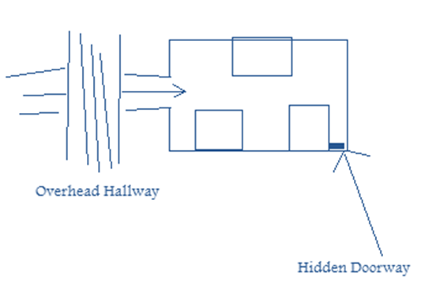
He’s surrounded. Finally he finds a door or the wall opens up to him.

God in Mirrim
The reflection of
Book Four: The Fire People: Fire
About Nilthinon: The Inner-Kingdom
In Nilth water is the theme. Water flows through the walls.
Plot
Characters
The F’element of Fire and Its Lesson
If Clal walks on water to get into Nilthinon, he exits the place by walking on stairs of fire. (First baptism by water, then baptism by fire. Jesus was only baptized when he was ready to fulfill his mission.) These steps disappear after he steps to another step. The fire is not yellow/orange/red fire, it is blue and white fire.
God in Nilthinon
The flame within us and, for Nilthinions, also on the outside.
Ideas
Lehi’s dream: My original Idea was to just have the physical representation of the dream within a chamber in Nilth, however, if it does exist then there must be a history behind it. Here is the history:

Lehi and Nephi will be represented as two individuals; Rakonor and Rakonan. The story goes that Rakonor saw a dream and saw Lehi’s dream. Rakonan wanted to understand the dream so he meditated and then saw it. Great meaning which is linked to the Flame of Nilthinon. Rakonor wanted his people to remember this dream and its imporatne so he began to build it in the center of his castle. But nbefore he was to die he told his son to finish building it which he did. Then Rakonon used the f’elemnt to activate it so that it shows the dream in action and required all NIlthinions to pass through it in their coming of age.

The Flame of Nilthinon
This fire, in the end, will do one of two things: It will either purify the people because it will be as a refiners fire. Or, it will burn the entire person to nothing. The concept is simple. If the person is mostly pure but have a little impurity here and there, then, the burning will not destroy them but just pain them a little. If another person is mostly impure with a little purity, then most of the person will be purged which will cause the little impurity to be swallowed up in detriment. The people of Nilthinon are the purest of all the people of the land. That’s why they are the keeper of the flame, until the final day.

Book Five: The Heart: Love
Hanone: The Ancient Kingdom
Plot
Characters
The F’element of Love and Its Lesson
God in Cul and the Heart Chamber
Ideas
Theme: All nature will return to itself:
Skyland returns to where it came from
The Four Waters flow back into the fountain
The entire contant returns to the Old World, coliding and fusing itself to its eastern shores
All of the Magicons are returned
The Mountain
The Skyland
Cul returns to Hanone
Then, the people return to the land
People from Mirrim
People from Nilthinon
The trees in a certain (ordained) forest will become younger and younger and eventually appear as a seed on the ground

The banished are not killed in the final battle. So what is to be done with them then.
When a new land is claimed, a ceremony is performed. This is what happens when Hanone is reclaimed. This portion of the story is the beginning of the end.

When the seed stone is taken from its place, the earth detaches
It is morning. The sun is up, and while the continent moves towards Hanone, the sun does not move because the the whole continent is moving. This is manifested as a sign. This is where some things on Cul return to their beginning state.

The Final Fight
Womlon grabs a piece of glass which turns into a sword.
Clal grabs a piece of wood which turns into a staff.
They grab things and use them as they change into what so ever they desire.
(This would be an awesome scene to watch.)

Religious Orientations

Book of Mormon Counter Parts
I want to represent these people and events from the Book of Mormon in The Legends of Clal:
King Benjimin, Ammon, Alma, Nephi, Captain Moroni, Moroni, Helaman
The Ships of the Brother of Jared
Nephi building a ship

Idea inspired by the above excersise:
Because I planned to sail away the people from Hanon and make Clal’s time 600 years from the voyage, maybe I can pattern the “pre-Cul Country” time like Lehi and his posterity. Maybe Ottomus or wizard 1 should really symbolize Lehi a little bit, and the take over of Womlon be like the city Jerusalem being destroyed. Hmm.

Truths to be taught in my Books
The truth about the Savior
Pre-earth life
The second coming and the paradacical glorification of the earth
There is one that has come to save the people
What is tought in the Book of Mormon that is not taught in the Bible
Temple importance

Religious Meaning
Clal picks tares from wheat and learns the lessons.
Include Jesus’ parables
Include an essence of Isaiah.
A little from all standard works.

Sword Bathed in Heaven (D&C 1:13)
Ezek. 21:3; D&C 35:14; 84:114; 85:3.
Clal and Isaiah: Isaiah Inspires Me
Isaiah is the source of much inspiration
Thoughts on Isaiah
Since the beginning of Cul Country, Wizard 2 has constantly tried to help the prevailing population to understand some things that caused the “Old World” to fall.
I want this to be similar to Isaiah
These teachings/prophecies/prophecyings will be named and be well known.
Maybe prophecying of the four peoples that become hidden from the world.

Fire People
Sky People (Elves)
Illusion People
Mountain People

The wizard knows that it will be hard for the people to accept a young boy as the keeper of the prophecy, the saving individual of their time; he will write and try to prepare them for "The One."

Isaiah 13:8 – There faces shall be as flames.

Note: The language of the Isaiahish Prophecies will have this style about it:
It will be in the voice/words/speech from the Old World: The Jewish Speech that is foreign to English speaking individuals and others.

History of the World
These scriptures tell a history of the world.
Parrable of the wheat and the tares: D&C 86
Jacob 5 – Parable of the olive tree.

The Music of Clal’s Adventures
Musical Notes
Each chapter will have a theme song
Full scores of music are better than just a melody of a tune

Make fables, stories, legends, myths, traditions.
Use pictures, songs, poems, music, paintings, sculptures, things found in nature.

Names Bank
Legerdemain, Falmer, Zyalan, Zwoshar, Visqar, Anthinon, Articose, Antnor, Artor, Alum, Adirious, Althon, Argnu, Barthlo, Beluth, Birgnor, Blothious, Buntol, Boshnis, Dargnoe, Ern, Elisar, Ensolor, Eluth, Firumas, Fregose, Mottra, Nargose, Owrenk, Frone, Drashrael, Atnumo, Arkin, Artol, Toslin, Pilthus, Hirn, Gilth, Rebinig, Rebin, Elson, Delson, Reebin, Reafin, Shinsawn, Ensawn, Quashni, Zorithor, Finahan, Yarsone, Prytok, Preytok, Prozle, Pridon, Shaydor, Sarnos, Sarnor, Bleeckus, Anthin, Rotnus, Rawtnus, Sartun, Miltawrn, Miltor, Frathus, Reabor, irhan, airhan, Illiria,
Onlue, Minan, Alvavaz, Timply, Timbly, Vilgar, Vilngorn, Fitln, Bitln, Quomble,

Salable

Mothod – I mistyped the word “method” and liked the way that “mothod” looks. I think I would like to use it for the name of a:
City
Race or people
Villian or evil force
Good force
The name of a book
Melaman
Rurthus
Rorthus
Ranthis
Ranthos

Cul/Culanthra to be renamed to:
Lirianon, Exawndus, Eccsawndus, Egzawlndus, Payapus, Pira, Pyra, Illiria, Illanthra, Illiriana,

The New World: Illiria
The Keeper of the Seed and the woman known in all 4 Inner-Kingdoms: Illiriana

Magic in Illia
There are different types of magic. If one person knows magic, this doesn’t mean that they know all magic, just the type of magic that they use.
- Magic within Clal and the earth
- Dark and evil magic
- Trivial magic
- Plant/nature based magic
- The binding magic that was used to banish.

I want magic in my world to be different than the typical magic. I want, instead of different words to be used like in Harry Potter, but that you have to understand the purpose of the type of magic where it becomes a more intimate experience to cast the spell.

The Character of the Nature Magic
Perhaps there is a wizard who knows some nature magic. He lives in a field, or so they say, but really, the plants that are growing are plant stems above ground but, when he beckons them, they pull up out of the ground an become beds, chairs, walls of a house, and even his food.

Notes from Novel Writing Books
Begin with the end in mind:
What are the Climax' of the first four books?
After ther Climax, the ending should feel to be the natural result.

The Cardinal Rules
  - Never be boring, not for one scene, paragraph, sentence or word.
  - Every writing rule in the book has an exception—except for Cardinal Rule #1
  - Begin with the end in mind.
  - If you don’t envision a truly heroic character with heroic goals, on an action-packed journey, encountering obstacles and a worthy opponent and arriving alive and wiser at the end of your novel after having engaged in a titanic struggle, it’s not likely your novel will be seriously considered in the publishing business.
  - Finish your novel before you make the first attempt to sell it.
  - At the minimum, you should have three master characters for your novel. At the maximum, you should have three.
  - Your novel plays out in relation to the world of your heroic character. If an action, setting or other character does not relate to the heroic character—either as a cause or an effect—odds are, that action, setting or character doesn’t belong in the novel.
  - Think of your novel as a heroic characters’ universe clashing with his adversary’s universe and you will have distilled the business of writing a novel to its essence.
  - Never get sidetracked on issues such as exhaustive biographical sketches and detailed physical settings. Do all of your important writing in your novel, not in preparation.
  - A heroic character’s goals and motivations cannot lead to trivial pursuits. Master characters must be giving to furious passions, driving forces, lifetime ambitions and fundamental values. A character must be willing to risk all, even life, for such things.
  - The central conflict in a novel arises from the powerful, usually violent struggle between the opposing goals and motivations of the heroic character and his adversary.
  - Even the most heroic character is somehow flawed, often seriously, and the nastiest villain has some saving grace, no matter how small.
  - Give major characters—and even minor characters—goals and motivations of their own. Permit them to have personal reasons for being in your novel rather than using them as set pieces for your convenience.
  - Begin your novel by writing the climactic scene first.
  - No scene in your novel is as important as your climax. Every scene that preceded the climax must logically build toward it, and every scene that follows the climax to the end of the story must be a logical result of it.
  - When contemplating a scene, if you can’t clearly establish the purpose for a scene, don’t create that scene. Use narration to make your point and convey your readership to the next scene.
  - What matters is not so much what people say when they pick up your novel as what they say after they put it down.
  - Anytime in the course of a novel that the story changes direction because of problems introduced or complications resolved between master characters, write it as a master scene.
  - You elevate the grand-scale pace of your novel by bunching master scenes; likewise, you relax that pace by inserting major scenes, minor scenes and various narrative devices between your master scenes.
  - A subplot must establish a direct connection to the main story line, advancing and complicating the story. If a subplot is a parallel issue that never affects the outcome of the main story line in a significant way, leave it out.
  - Write your favorite master scenes first. After you’ve revised that scene, choose your next favorite master scene. And so on, until you’ve written an entire first draft of your novel as master scenes.
  - No matter what form of concordance you employ, always use fix cards. Fix cards will clear your mind of mechanical trivialities, leaving it free to concentrate on the act of creation.
  - Use a third-person, past-tense point of view (POV), and limit the novel’s omniscience to your master characters.
  - Study best-selling writing by copying selected segments of your favorite best-selling authors’ novels word for word.
  - Always try using verbs and nouns before resorting to adjectives and adverbs. A concrete noun partnered with a precise verb will rock on adjectives and adverbs any day of the week.
  - Write to suit yourself.
  - Build action into every scene, every passage of dialogue, every sentence of your novel. When in doubt, use action.
  - Capitalize on conflict. Assert it in every scene of your novel, never allowing it to fall below a discernible level of tension.
  - If a line of dialogue doesn’t indicate conflict or isn’t leading up to conflict, don’t bother writing it. Use some other narrative device.
  - Rather than describe, create powerful images.
  - Research only as much as necessary to enrich your novel with reality or, even better, a sense of wonder or discovery. Never include data for its own sake or, worse, to show how brilliant you are.
  - Take a stand. Avoid splitting hairs in images and emotions, especially in master scenes. Dramatize. Exaggerate. Embellish facts. Clarify your fictional truths.
  - Once you clarify images and emotions, be consistent with the stand you’ve taken. Never change on whimsy or by coincidence. Once established, only the characters influenced by their realistic, competing motivations—and not the author—can reorder images and emotions.
  - Play fair. Don’t withhold details crucial to understanding the story just so you can spring a surprise later.
  - Maintain singularity: one idea for each sentence; a single topic for each paragraph; a singular plot point for each scene. And stick to the main story line in writing your novel’s first draft.
  - Achieve dramatic effect by adding snap—power words, quick pace and high emotion—to the ends of your critical sentences, paragraphs and scenes.
  - Sell your novel not with the idea that publishers should give you and your agent money for it, but with the notion that buying your manuscript will make money for them.
  - Don’t waste people’s time.
  - Sell your novel as fresh, distinctive and radically new—but not radical.
  - To improve your writing, write.

Just write and the story will unfold. If you aren’t writing, your story isn’t breathing.

Geography
Use Victoria Falls, Zimbabwe for a scene. A canyon of waterfalls.
Send the characters to a place where it smells and the odor is unbearable.
Literary Stratigies
Plot Strategies
Snape factor – To create a character that the reader cannot identify as being on Clal’s side or against him.
A king, a member of the banished, a nilthinian-kelvkorothian-mirrish-edophlay individual.

Plot Thickeners
Gulnery’s Legend
Millurin Pike

Themes
Extinction, Addiction, Curiosity, Premonition

After Watching Narnia Movie #1
Trees must be used to thicken the story.
LOTR – the Ent race complete with history and destiny.
Narnia – “Even some of the trees are on her side.”

The land as well as the plants have spirit.
In the 1st nania movie there is a scene where a tree’s blossoms fly into the air and gather together forming the figure of a woman which turns and waves at Lucy of which Lucy waves back.
My artwork of the flowers that have a spirit. This could be an idea.

Millurin Pike
This man has been the author of some tales about the inner-kingdoms. People consider his creativity astounding and is famous all thorugh the land. But Clal finds the man’s stories interesting and deems them worthy of attention for his quest. He does find and visit with Millurin Pike, who leads Clal to more information about the inner-kingdoms and where to find them.

General Ideas

The Frying Pan
I took a frying pan that had cooked some eggs early in the morning. When I ran water over it there was a design that was desplayed. The small burned pieces of egg that had attached themselves to the pan was not allowing the water to go through it so that water was forced to ho around it. You couldn't tell that it was going to make those shapes and designs just looking at it with no water being poured on the pan.

Basically, in the caves under the mountain, to help them get the next clue on where to go and what to do, they will come to a place of stone and water, a lake or something, and will find things to run under the water that will aid them and direct them based on the designs, which will have meaning, that is seen.

The Decree
When the king of Eldan Vyum finds Clal, he makes a decree over all the land that “The One” is found. The Whole Cul population has been waiting for the decree. There are special bells that are saved for this occasion. But, it will also firmiliarize “The Dark One Lurking” with the coming of the one and will try to find him.

The Four Water Maidens
The four water maidens located in the ocean. They control the four winds of the earth.
Every 5 years they meet somewhere marked as the meeting place

WENS Fountain
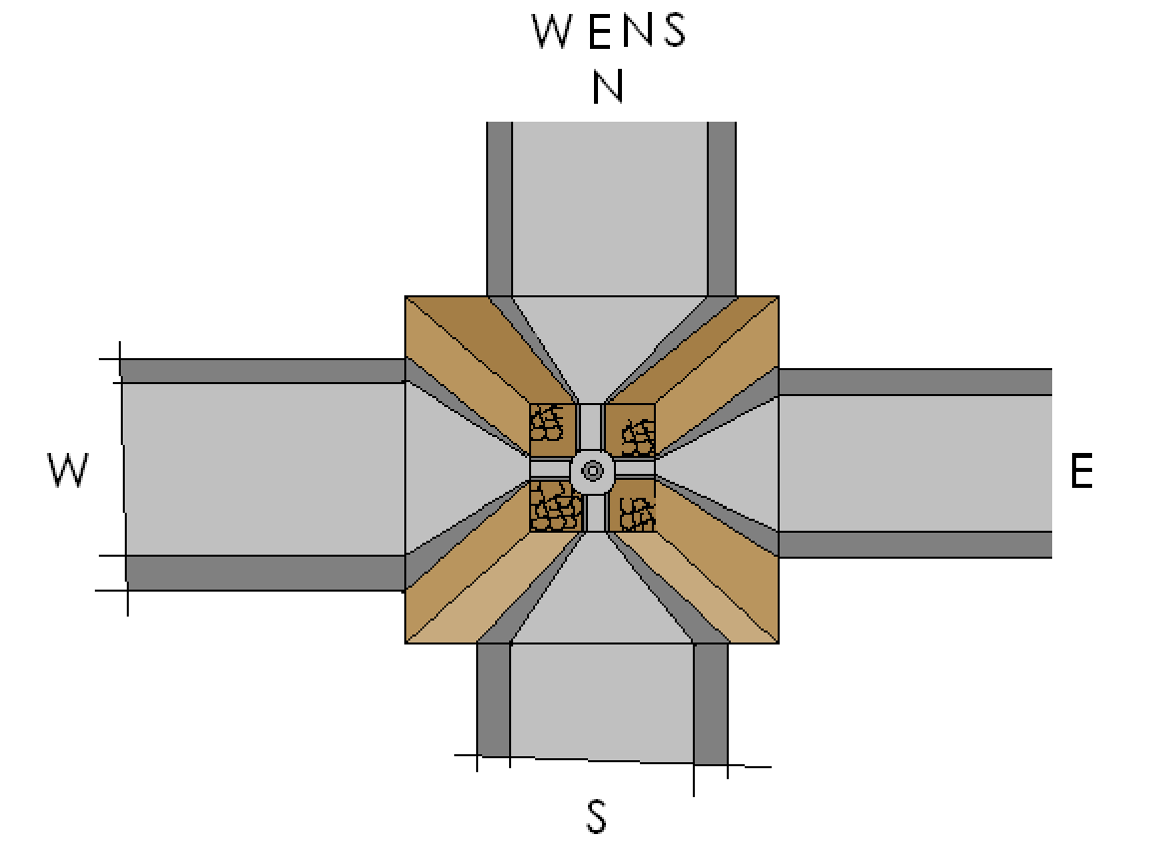
There is a fountain in the middle that flows water. It flows out and over the brim of the fountain, into the bowl, then out onto the row where it meets the wall and then flows up the way and out, cycling in this manner. When the time of the one in the 5th book when the continent will be traveling back to it's mother land, the waters will flow inward (down the walls) and back into the fountain.
Symbolism – Flowing out: the earth giving to the inhabitants. Flowing in: the earth gathering itself to prepare to sail back and collide with the old continent.
The surface of Skyland, due to its high altatude, is all snow and ice.
Clal will learn the song of the Skyland and in the 5th book he will call the skyland down to return itself to its original formation.

The Book of Legends
written by Felsawn and given to Clal in the High Chamber room

Clal reads a book of Myths.
Many are just stories, but some are truth.

Important Myths:
A mountain was moved and covered a cave
An island was sent heavenward being ripped out of the center of an ocean island
A people were changed into fire thus becoming a civilization populated by “fire people.”
There is a desert where another demention's doors open and close randomly
A lady lives at the heart of the land.

Other less important myths:
When you stand in a certain place on the edge of Heaven's cliff, you can see a pathway which is almost invisable but that one can follow
Other myths that won't be realized but just their to help the reader wonder which myth the characters will entertain.

Old Land Myths:
Some, maybe a hand full, will be myths that we will see on the other contant that the reader was reading about thinking that it was talking about the New World. The realization of some really interesting myths.

The Myth of Skyland
The Legend of the Fire People

The Roaming Wisemen
There is a man or wise men who roam the earth and cycle every year to the same spot and begin again.
They are called to study the land and its signs.
They have never been seen but their pathway is revealed.
They play a part in Clal's success but keep to themselves and don't really show care or charity for the characters.

The Sacred Forest (old name: pale forest)
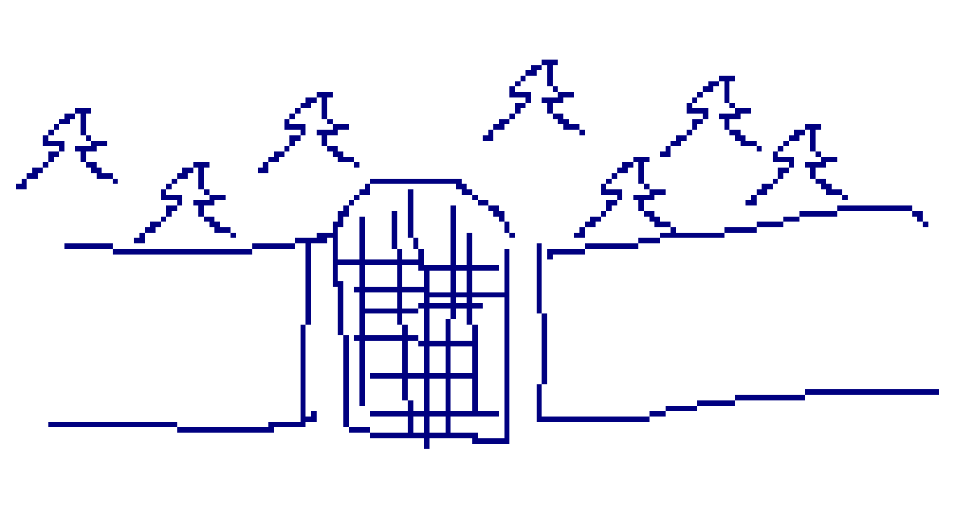
The pale forest – possibly glass trees

The forest that was supposed to become seeds when all the earth is returning unto itself, will no longer digress but will become as the rest of the earth will be, as a sea of glass.

It is a forest that is surrounded by walls. It is a sacred forest. It returns to its purest state. The forest is linked to the old world and is different than any other forest. It has a history.

“Wonderful landing Sedrak. Thank you for bringing us to this place.”
“You’re quite welcome Clal.”
“Ryth, look; the trees they’re not digressing,” Clal squinted a moment and said in a wisper; “…they’re changing.”

Clal reached into his pocket and brought out a large rusted key with the symbol of a tree on it. He placed it into the key hole and turned to the right, then to the left, then to the right again. As soon as the gate unlocked Clal pushed it open. He beckoned the others to follow him.

As they entered they each felt the trees around them. They looked strange and foreign but the same life seemed to radienta from its bark, a bark that was beginning to yield its self to a transparent like nature. The trees were beginning to look like glass.

Ansa spoke first. “These trees are loosing its color. Why?”

“Well, it was spoken that this was the Pale Forest but no one really knew why.” Ryth replied. “Now we know.”

Clal turned to face Ryth. “But it was supposed to return to what it was, I don’t think it was ever a forest of trees of glass.”

Street Signs
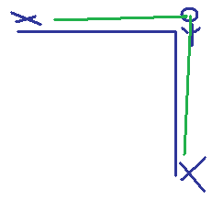
“Look.” Clal pointed to his right. “I can see, far down this road, that there is a symbol created by the buildings, the trees and the people. Then, when I look down this other road, I see a distinct symbol but it is different. Could this mean something?”

The Speaking Tree: Clal’s Twin in life force

Located in the Dawning of Time chamber.
It was sprouted when Clal was born as a sign that The One is soon to come.
It wilts when Clal is not doing well, when he is on the wrong path, when things are turning ill and to be careful.
It is almost dead before the end come for Clal.
It’s a mystery.
The Cliff: Dawning of Time
As the books progress, this place is only known as a place that the reader visits at the end of every book. However, Clal will need to visit it more often as the books progress. It will be kind of exciting because we will find out more aobut this place and it will be a sort of surprise to the reader to be back there well before the end of the present book.

The Illuminator
This is the name of the light source that is brought while on their trek.
This is a special light source that only shows a certain sort of magic to the eye.

The Recital Hall Echo
To be used in Book 3 (perhaps)
Basically, there is an echo between two walls that goes on forever, or so it seems.
When someone is there, they can enter the world of the echo.

When He Moves His Head
I would like to put in a scene where Clal is facing an enemy. The difficulty lies in the fact that everytime he turns his head to the voice of his enemy, there is a flash and the enemy is once more behind him. He turns his head several times but still, his enemy escapes him. Clal learns that if he stays still he has a better chance of confronting the enemy but, this doesn’t make sense because how can he defend himself against an enemy that he cannot see? This would be useful in Book 3 when Clal faces Skeldruc. I favor the suspense that this scene will provide.
Camden’s Lego Ball
Camden threw a huge lego ball against the window and it just exploded into a thousand lego pieces. I thought that something like that would work well in my story, perhaps from an enemy or just to portray the magic within the ball. Perhaps an ice ball that shatters and becomes something great.

The Grassy Lawn of the Razor Maze
bWhat if Clal was walking across a field or some grass and finds himself suddenly amidst a rising maze of razor sharp walls.

Fuzzball From Where
I saw a fuzzball fly through the air before me. Clal follows from wense it came and finds more and moves to a flower that produces the fuzz ball.

When Filling the Bucket
Like filling up a bucket with water, Clal faces a trap where water is swiftly filling up, the threat of raising water.

A Friend in the Rishk
Perhaps one of the Rishk travels with Clal undercover. He always seems to be somewhat questionable like Snape was and in the end turns against Womlon.

When Push Comes to Shove
Clal tries and tries to push something but it doesn’t move or budge. Time is of the essence. He panicks and finally it budges.

The Bed Frame
Our bedframe looks Victorian and it has balls in the middle. In my story the balls will move up and down. Perhaps a sacred tool that tells the learned about the current events in the world.
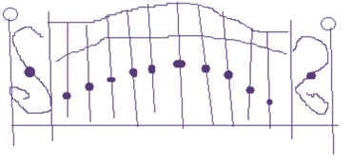
Time Continum
Sometimes 3 minutes seems like 3 hours.
Sometimes 3 hours seems more like 3 minutes.
Find a place where time is realitive; a place where one can live in 3 minutes for a lifetime.

The Filling Ritual
Clal fills a water glass up occasionally either at a sacred place or as a ritual and either the ritual, water, or glass has a significant meaning.

Eliza R. Snow Building Attic/Roof Door
One day I was in the attic in the Snow building. There was a latter then a door to get out onto the roof. The wind was blowing hard and all I could hear was the wind howling. This would be a perfect sound to listen to while I write about a windy place. Who would have thought that wind could yield so much inspiriation?

Unearthed
Clal is looking for something or just happens to unearth something in the dirt. It is important. It changed his direction..

Not a Treasure Hunt
Although the majority of the story is a treasure hunt, make it feel like more than that.

A Place with a Flag
One day I was working on campus for several hours. It was windy. All through the day I kept hearing flags whip in the wind. That sound would be neat to have in a scene to either define the place that Clal visits or to increase the suspense because as the wind blows comes only ill.

The Spinning Arrow
Good Idea. Not sure what I meant by it.

Bundles of Light Spheres
When I was walking in the Eliza R. Snow there is work being done on the ceilings so there were hanging lights along the ceiling. I walked around a corner and found a pile of these lights in a corner; they were still on and glowing however. I thought about if a pile of glowing glass balls were to be in my story; a queer scene. Perhaps this is where the light source for the party’s travels would come from. It was an interesting sight, one that was magical indeed.

The Bad Were Good: Cauldren Born/Ring Wrathes
To emotionally engage the reader in as many ways as possible, this ideas serves as such a tool. The sadness one feels for an individual who was good but has chosen evil is unique and painful. To see a good man turn to become a murderous individual and to know, in a religious context, that he is probably going to be served justice instead of mercy can be painful. In Lord of the Rings the ring-wrathes were nine Kings that became evil because of the rings they were given. In Lloyd Alexander’s Prydain series the Cauldrin-Born were men who were hollow, used to be men but were empty and evil. This idea could be manifested in a certain type of creature that is used for Womlon’s evil devices. Or, this could describe the state of the banished and even Womlon himself.

The Mountain-top Stone
Clal must search on the tops of mountains for a special stone in order to qualify as a receiver of the f’element.

The Race
I think it would be fun to include Clal in a race or a competition. This would show that he really is “The One”.

Out of Touch, Out of Read
Clal drops something that is important and just before he leans over to pick it up, it rolls underneath a place that he thinks that he may be able to reach it. Clal engages then in a struggle to get this “thing.”

The Showers of the Tank
Clal and some are put into this place where the waters flow thorugh tunnels and they finally end up falling down several waterfalls into a tank where the water is rising. A trap, or just a fun place to bring in some excitement and wonder.

Oil on Water
If there is oil on water light cast a silvery glimmer upon it. If there is a light across the room you can align your sight so that you can see a distorted version of light upon the oil water.

Reflections in Mirrim
Like the reflection of the gymn in the Hinckley building, polished stone for flooring can yield a truer reflection of what is really there. There is only one type of stone that does this, it is special stone and is taken from a mountain that is sacred.

Scenery Notes
Note: Organize images on laptop

Great scenery for a scene: Victoria Falls, Zimbobwe - Webshots

HERE BEGINS THE REST…

it is wizards that spend their whole existance managing the affairs of the land, helping, guiding...

Kingdom ownership ideas
Kingdom ownership/leadership
question: should the Kingdoms have...
a steward
king only
queen only
king and queen
princess or prince
or no authority

Outter Kingdoms:
N. Kingdom – King Blorien, Queen Lisreetha
E. Kingdom – Queen Othransa
S. Kingdom – King Narin
W. Kingdom – King Emish

Inner Kingdoms:
Edaphlas -
Kelvkoroth – Princess Rinica
Mirrim – King Daxius
Nilthinon –

Questions:
How much should the inner kingdoms reflect the outer kingdoms?

should the outer kingdoms fight with eachother?

should the inner kingdoms fight with eachother?

A: no. Felsan separated each of the four inner kingdoms; this keeps them pure and untainted of gree and authoritative desires. Thus, creating a safe place for the f'elements to reside; and it does work. None of the inner kingdoms pose a threat to the existance of the f'elements and are not a source of complication for the plot as a whole.

how involved are each outer kingdoms?

Note: there are almost too many kingdoms. some of the outer kingdoms may not be described or part of the story line.

The Inner-Kingdoms
this is where the plot comes alive. Magic prevails in the inner-kingdoms. this is where the power of the f'elements can possibly fall sway. Ideas: elves fly, dwarves do magic, men diappear, melds are the fire people. Creativity will make the inner kingdoms exciting, curious, wonderous. The inner kingdoms will be full of new ideas, new sights, interesting cultural elements. This will be the alternate reality in my story. The same magic will fuel each of the four inner-kindoms. But, each civilization will have done something different with the same magic; therefore, building their worlds differently.

Doorway to Mirrim
Clal and friends find a place inside The Rishk layer as they are running from the Rishk. Skeldruc has a doorway into Mirrim. They find the place. I like the idea that the party gets split up in the third book when entering into Mirrim by way of a mirror. They are split up and have to find eachother while trying to find the f'element.

Subplots
Goal:
to leave each inner-kingdom better then it was before they came.
to help the inner-kingdom do something that they couldn't do themselves
(each book Clal finds out a little piece, bit by bit, about himself)
to place forks in the road wherel Clal will have to choose which road to take.

Clal's Destiny
he will walk around Cul using this power given to him by the genetic spell that Ottomus once used to mark his kin.

Elements of an exciting story
READER to step into a different world.
4 different inner-kingdoms complete with tangible cultural identities
Clal's innate powers alter things along the way
Questions the reader may have:
how will Clal get back to deposite the f'elements?
Book 1: by way of dragon
Book 2: by way of cave entering the room behind the mural
Book 3: by way of mirror
Book 4: by way of a pool of water in the corner of the room
Explanation: Clal has to go back to find his companions after spending time in Nilth. They are waiting outside for him. They are led to a hidden pool of water of which they jump into and arive in the statue room.

Climax scenes
book 1: while Clal is trying to leave on Sedrak
book 2: Renthar is hidding in a cave
book 3: in a room full of mirrors
book 4: outside of Nilth when Clal is going to retreive his friends

The F'elments
the banished know they hold great power so they seek after them. they do not understand their real purpose, to buld the weapon to defeat Womlon.

Book 5
When the f'elment is taken from the heart of the earth, the kingdom that it was taken from loses some supreme virtue and so Clal has to replace the f'element with something of equal value. This idea could foster a subplot where Clal would not only have to retreave the f'element but have to bring something with him to replace it with.

Or perhaps they don't need to be replaced but, unlike with the first four previous f'elements, the fifth one, the stone seed, does effect its environment when it is removed. Why?
because the seed is the source of life on Cul. When Culanthra removes it, the earth begind to do or lose power; die. All the power of Cul is transferred into the sword.
the continent then beginds to digress beginning with the seperation of Cul from the ocean floor. It sails back to its mother earth. Many things return to their first estate but not all things.
Culanthra breaks through the earth and become sa physical form. Her mission is over.

Theme music should only be written for the master scenes.
I saw a bag in the middle of the road of which was impossible for me to avoid. I thoguht of Clal or sanother character unable to avoic the pitfall before them. This creatws drama and emotion. The character could be falling, they could have to make a quick decision.

Idea: “There are birds in the trees.”

Theme must be opposion in all things. If there are good flowers, there must be evil flowers too. If theme is a good forest, then there must be an evil forest.

Element of time travel
at the Dawning of time statue as cClal sees the past of Womlon's weakness moment.
in one of the books at the end of a book during the affiliation with one of the peoples.
Theme: Past, Present, Future: since Clal is “The One” he is entitled to see all three of these.

Concept:
in the church the bar needed to be reaised to meet demands of the work that needs to be performed. Clal must be part of thise as well as the people that live around him on Cul.

5 steps to raise the bar:
figure out where we are
find out where we want to be – goals
find that next step
pray and ask for help
then just do it

5 weaknesses
5 things to strengthen

Physical – Book 2 – in the mountain he has to push rocks, climb, jump, it will be a harsh obsticle course.
Social – Book 1 – making lasting friendships, gains companions, the song of a people and of the earth
Spiritual – Book 4
Intellectual – Book 3

Clal must prioritize. This is what drives sub plots. (good, better, best) Clal has to chose and will learn what is most important to his quest.
seek to understand relationships with God
seek to understand fam. relationships

How does Clal use his time?

Daily assistance from a certain source must be evident. (like prayer and scriptures) a way that he can draw strength and guidence.

Clal has stewardship and will record what he goes through. Cla must choose whom he will serve. Josh 24:15. Time must be used wisely. Clal's thoughts, words and deeds must be pure. Must rise to his responsibility and take responsibility.

5 Seals on a book
This is what holds the records of Womlon. When Clal has deposited each f'element he will have the power to remove the seal and read about Womlon. Great idea which needs some attention to develop.

Satan’s Tactics
Creatures, confusion, weather, gains followers, turn people against good, good is called evil and evil good.

Light Ficture
Light ficture found in Eldan Vyum. Symbolizes the four kingdoms
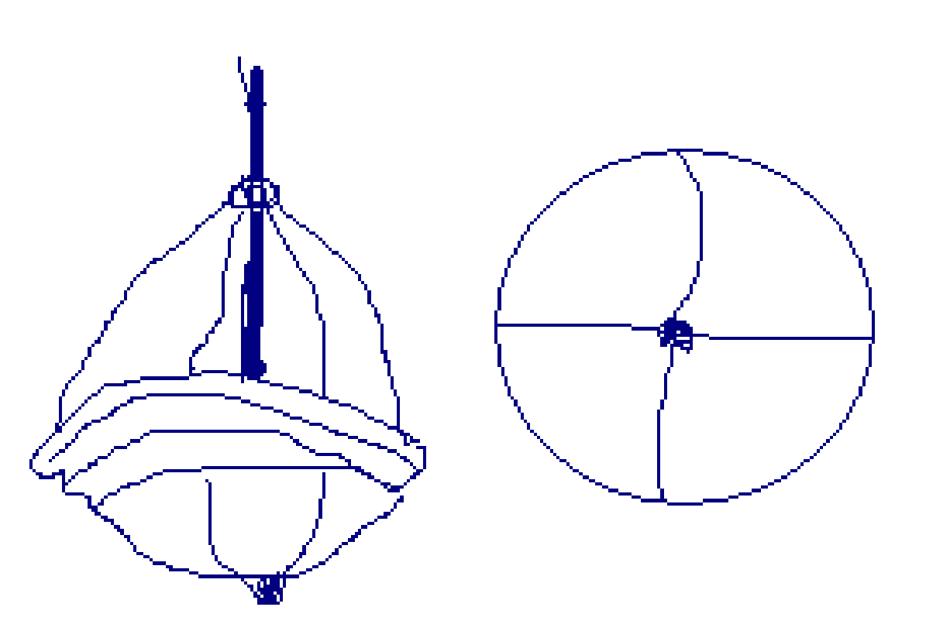

In Eldan Vyum the theme of the structures and buildings and decorations will be four sides, four sections, four as one.

Cul Country and the Sword
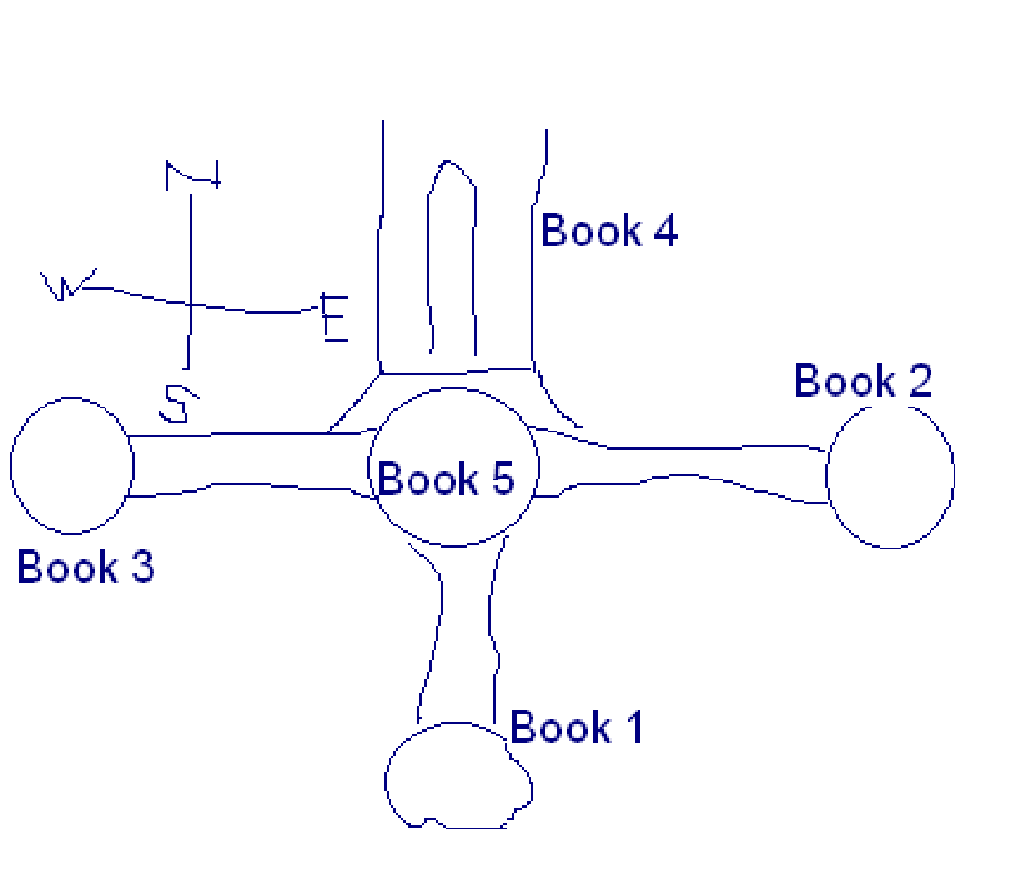
The f’elments will be placed in the order on the sword. Example: the flame ios found in the north so, the north part of the sword is the blade and it is on the blade that the fire will exist.

Concept
Your are laying a found dation of a great work, and that great work is you. Clal is the Magicon.

The Arches of Amnber
3 door ways will stand in the land of Cul. This is where the two wizards and others will come through. This is where the first vision will be illustrated. Perhaps Clal will use the 3 arches to walk through and accomplish some tasks before they are used by the Wizards.
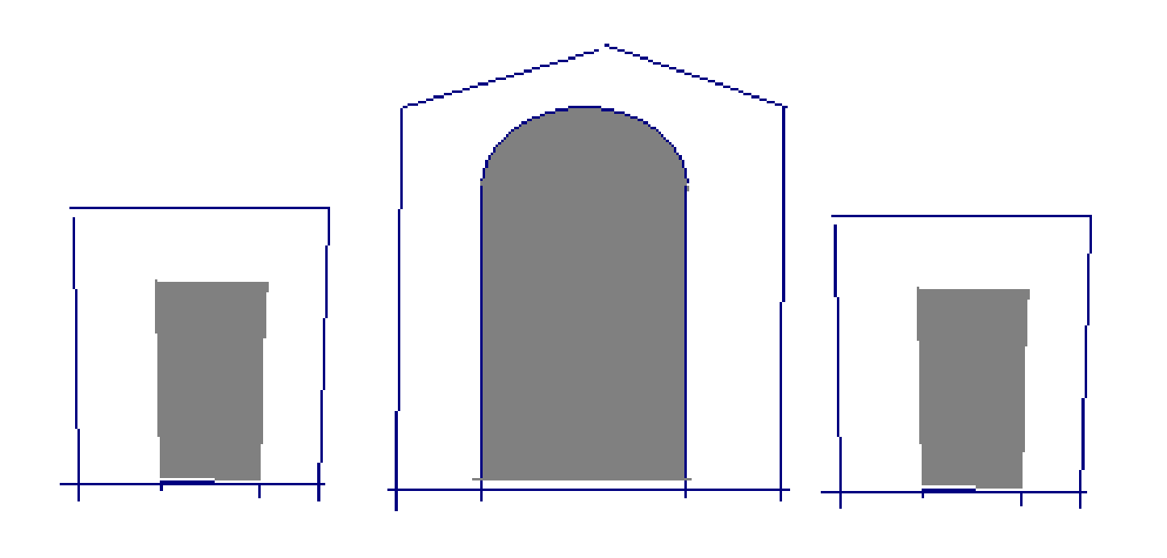
Sands of Illusion
Clal and friends go to the Sands and see thing s but they can’t get passed and into the pockets that open
and close.

Clal’s Powers
There are many things that are activated through out the control only by “The One”.
The Arches of Amnber
The cliff of the dawning of time
The corradore to the heart of the earth
The sword
The growth of plants and life
Passage ways
Magical activations.
Basically, Clal finds out that his was given powers and learns how to use them.

Skyland
So, as it is difficult to represent song or music on the hilt of the sword, I’ve related song to a few more defining factors:
The song represents the song of the earth which is heard upon the winds of nature.
The Four Winds – these are the weinds that carry mother earth’s song. The Northern, Eastern, Southern, and Western winds. Each wind has a sacred name.
Along with making things grow while Clal has the sword in hand, he will also have the four winds at his leasure to use against Womlon.
While on the Skyland Terrain, the song of the earth is heard.
There is a creature that lives where Skyland was moved

The Moves Moutain
This story will focus on how a love of riches becomes a weakness for Womlon. There is a society that lives under the mountain. They posses a stone that is sought after by Womlon. This is the amber looking stone that fills the mountain.

The Mother Earth
Through out the course of the first four books the par;t6y meets a female at the end of each book. Each one tells Clal and his party why Womlon is weak in thisarea. They are shown in the reflection when Womlon became weak on this point.
Lady Wind – just a voice on the wind
Lady of the Pool – in a large pool of water beneath the mountain
The Mirror Maiden – in a mirror among the walls of King Daxius
The Fair Flame of Nilthinon – the woman in the tree of life depicted as Lehi’s Dream

The reader is led to believe that there are four women involved and t6hat they will be understood and explained at some point. However, as we fint out in the fifth book, there is onlyi one woman who is mother earth and lives in the heart of the earth. She tells Clal of the 5th story of Womlon. He is ready for it because in her four intervies at the end of each book she threw in some elements about loving, serving and giving.

Clal struggles
Clal doesn’t want to kill anyone, but his fate is to defeat Womlon. And so he is counciled on the fear.
He says: “I always wanted to be a hero but I never wanted to have to kill or fight.”
Then, a wiser and older figure replies, “Clal, with the glory the valor and the recognition there is a price to pay. Sometimes that price is partly doing thingt that don’t neccessaritly want to do. You’re not killing just to kill; that’s wrong; and that’s why Womlon has come to his current and abomidable state. You are fighting an enemy and his counter parts that will defeat all good in the end if someone doesn’t stop him. That someone is you Clal. You are fighting to defend all that is righet. There is a difference in this and it is significant. You were chosen to do that which you think you cannot do. This is heroism. This is the fate of all who seek to abandon the ordinary life. Remember, you are not killing to kill, you are killing to defend that which is not to be taken. You are the only one Clal who was appointed to do this. You have been chosen to save your people. This has been the case since the beginning.”

Outter Kingdoms’ Roles
Each kingdom holds safe a special part of Cul that is to remain unaltered and hallowed. Example:
The four waters – each water lane is a different size from the rest

Skyland
The Moved Mountain
and so forth…

There are one of these in every Kingdom that will return to the earth in the 5th Book.

Romance: Leara
Wehre does Clal find romance?
Meets Leara in Eldan Vyum’s Castle
Meets here along the way in Book one
She is assigned to go with Clal on his journey by a father who is one of the four kings
She should not be from the inner-kingdoms

Since we really don’t have a lot of time or a lengthy path for Clal to follow in Book 5, which, in the previous four books proved to mold Clal and to try him, it will be evident that Clal will have been learning how to love and care throughout the four books

Other ideas:
he has always been interested in elves.
he loves a girlt clost to home.
He meets a special female along the way
what is he looking for in a woman?
the same desire to break out of medeocrity
shyness
a believer in his mission

The Sword and the Statue
The sword may have the colors of the four outer-kingdoms but the elements of the inner-kingdoms.
On the statue the holes where the f’elments go will be in the place where they were found. There will be a key that will show north, east, south, west like on a map. Clal will learn that each f’element is to go in the designated place.

There is a creature that lives where the skyland was who guards or just lives there. He serves a purpose and inadveratantly helps them in some way.

A Legend
The light of a new day
The question: “How do you know when the night is over and a new day has begun?”
The answer: “When you look into the east and see the face of a woman and can say, ‘She is my sister,’ and when you look inito the east and see the face of aman and can say, ‘He is my brother,’ then you know the light of a new day has come.”

This idea is based on the article found in the January 2008 Friend titled, “The Light of a New Day.”

I want to apply this to mystery. Clal may see something in the faces of people that will cause him to understand that he is ready. Clal will change.
He wonders why he sees things in other faces like changes or slight movements. People do not see as he sees which causes some interest in the reader.

Relationship between Clal and Mother Earth
Clal must unite himself with the earth in order to save the people. He must allow love to fill his heart. His purposes must be by love.

Clal’s Changing Motives
Each book Clal should have different motives:
Fear
Duty
Glory
Selfishness
Love
To see the world/adventure
To become famous
To understand self
To choose the right
To be away from family and life problems
To Get out of the ordinary life

Dialog: Tools
Leara stood up before the group and said, “You need tools Clal; tools that will serve to find out which legends are the ones that will bring you closer to the f’elements. Tools come in any form. They serve a purpose then are set back on the shelf. There must be a legend proving tool somewhere.”

Clal’s Powers
Things happen when Clal is present, when he touches things, when he says things, thinks things, and desires things.

Myths, legends and folk lores
“Not all myths are makebelieve, not all legends are lore, and not all fables are ficticious. But your task is to find out which myths, legends and fables are real. For in a few of these will be found the f’elments.”

Other Legends will be important and will serve as a short term solution and guidance. Even the smallest legends will prove important.

Where is the heart of Cul?
Another clue on where the heart of the earth is that in jEldan Vyum it is know that strange things happen there. One thing is that the plants seem to repond to visitors. The spirit of the plant can almost be seen.
Also, the Culanthra plant flourishes in Eldan Vyum.
Things exist and do not exist in Eldan Vyum that do other places.

“Wars can be an ugly affair.”

Plants and herbs should be factored in to the world of Cul, especially the Cul plant. Build their importance.

Creatures of Cul: What will they be?

The New Sun
The world needs the rising of a new sun. The daily sun serves no lasting purpose but the rising of a more significant sun can be addative.

The New Sun- is blue, like the “fair flame”. It breaks forth from the satutue as a normal sun would exploding in rays of blue and rising while the cliff melts and the whole room desolves. But the lighut dims slightly which allows the on looker to persice the revolving swodsd with in a translucent, blue sphere.
When the blue sun rises the earth will be changed forever.

What is my stories deep magic?

Perhaps there should be written a book before the last to fully eplain the creation and histry of the world, like in the Chronicles of Narnia.
Create culture, land marks, and different cultural ideals.

…Is the absence of…
Anger is the absence of
Understanding
Love
The Holy Ghost
Hate is the absence of love
Darkness is the absence of
light.
Blindness
ingnorance
Silence is the absence of
sound
voice
Fear is the absence of hope
Blindness is the absence of sight
The earth has a voice
The earth has a light
The earth has a hope (Clal)
Despare is the absence of joy
Dumb is the absence of thought

Womlon has closed up his world but has left some things out of it.
“I have grave news for you.” (grave)

Characterization
How were the main characters raised?
What were their parents like?
How do Clal and Leara respond similarly to situations based on their childhood and parental teachings?

1 Ne. 1:15 – a Wizard that spoke in riddles but becomes more clear as Clal and friends travel and gain more understanding.

Christ's Birth/Clal's Birth
Felsawn recieves a sign that “The One” has been born; he doesn't know who it is. This changes some of his plans and their timeframes.

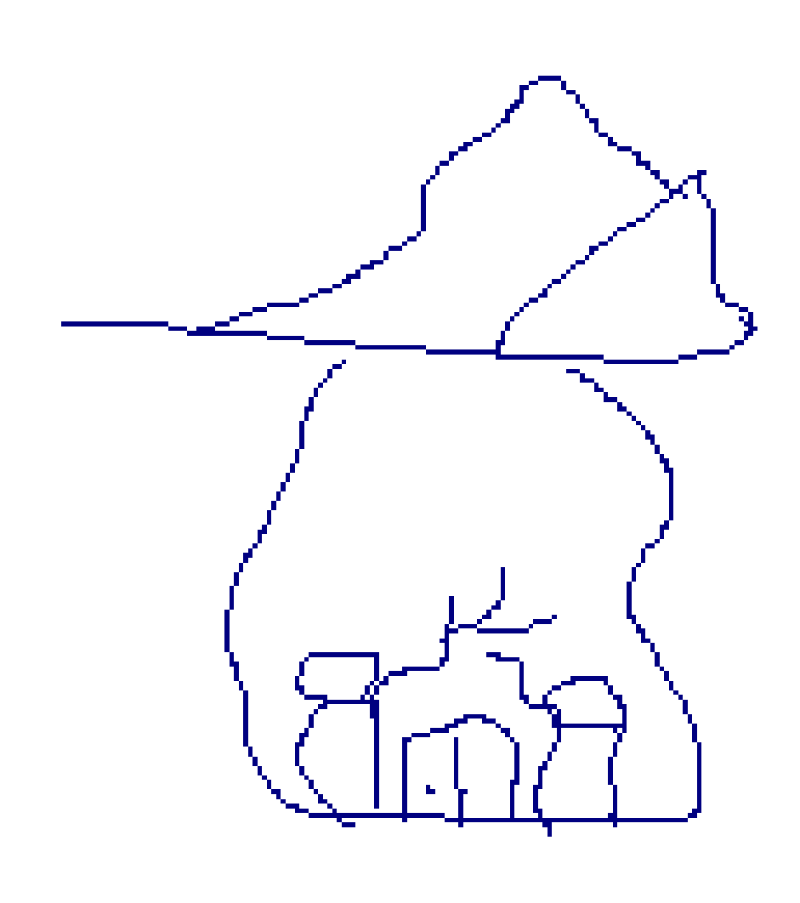
Book 2: The Moved Mountain

(Inspired by a cough drop in its translucent wrapper)
Underground and in the tunnels the walls are partially uncovered baring a stange colored stone behind the dirt. Clal takes a closer look and sees through the yellowish stone and sees a face staring at him which looks surprised and quickly disappears. Throght that stone, is an entire civilization. They have to find the entrance.
Patriarchal Blessing: 2 parts
Part 1: recieves in the High Chamber room in the form of a prophecy.
regarding his destiny to find the f'elments
Part 2: By the Fair Flame of Nilthinon
regarding his destiny to defeat Womlon and all evil

The Journals of Millurin Pike
Clal stumbles upon some journals. He carries them with him until he reaches a place with people who can interpret the journals. He may carry them for a few books trhough until he finds out what their purpose is.

Clal's soul in jeapordy
“and they also sought his life, that they might take it away.”
“and they, the enemy, sought his soul, his light, that they might take it away.”
Perhaps a creature that reaches to the very soul in order to inflict pain comes in contact with Clal; (the creature that feeds on the last breath of its prey).

Morgreth's Destiny
As the books progress Morgreth's participation in Clal's journeys lessens to promote indipendence in Clal's character.

The Stars
Clal is th only one who can communicate with the starts. They talke to him. They move. They guide him.

The Evil Creatures of the Ground
Dust, smoke, Fog:
(lesser idea) in the story there is a mist that directs Clal. It moves and bades them to follow it.
(better idea) in all the stories there will be a creature or creatures that exist in the air; an air borne enemy
Book 1: Fog, Cloud, Icey Wind
Book 2: Dust
“Dust Devils” - a scene where the party stirs up dust, a place that is extremely dusty ground, and they notice that the dust comes to life. They tell eachother not to stir up dust and creates some suspense. Chocking, blinding, coughing.
Book 3: Sand storm/wind,
Book 4: Smoke, Ocean Mist
In the end the reader will find out what causes this force from the ground; a force even Culanthra can't stop.

Cul Country: A Spirit of Love
In every natural thing on Cul, there is a spirit of love, safety, and care. The stems from the center of the earth where Culanthra is. This will be manifested in animals, plants, and other things.

Book 2: Riches/Beauty
One becomes rich by their relationships with others. Clal must learn this. Beauty is within, not without. Find the value and beauty in everything around.

Book 3: See to believe
Womlon needed to see to believe. This is not healthy for the spiritual self.

Book 1: Music
The music or song that Clal learns draws powers from the earth and the air. Thought is also changed by music. Feelings are altered for the good or the ill.

Book 5: The Keystone
And arch and the keystone.
The word “keystone” in cantanese means: the heart of the arch. Allow the Book of Mormon to be the keystone of my religion. Incorperate “the heart” into many things beyond the arch. What other things have a heart to it?

The High Chamber
A room that has been sealed from others was prepared by the Wizards and some others for “the one.” In it is three boxes from each wizred. They will understand here that he is “the one.” Clal is brought up to this room followed by many others who watch awaiting this moment because, only “The One” is able to open its doors. He reaches his hand out, and the doors open.

Footprints in the Snow
The party will arive on Skyland by some means and will travel from its parimaters to a mountain off in the distance. They will walk for a ways and come across some footprints. They will follow them ujnil there is a fooot fork in the road. Maybe the legend is that “The One” will take the right side road which was a move that was long fortold. This would be a good place for dialog so we can see how his throught and decision process works.
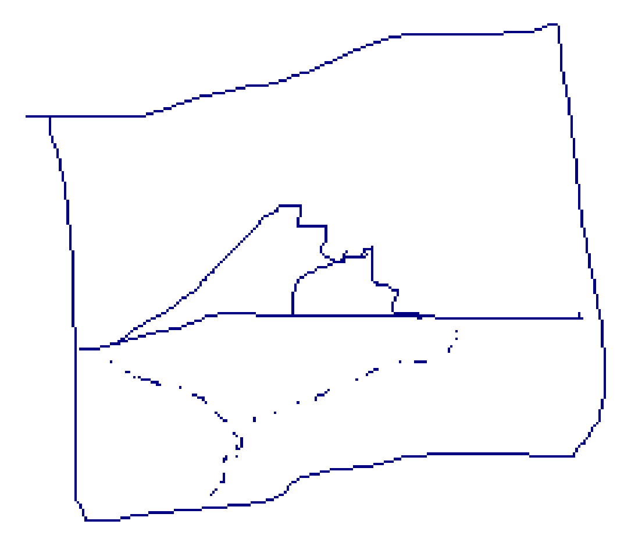

Book 5: The Heart
Clal will have to hit Womlon's heart to defeat him. “Heart” is the theme of Book 5 anyways so it would make sense. Black heart of Womlon. He will then catch on fire as Nilthinon's Flame penitratet the evilest blood traveling through blood streams as he falls to the ground and turns to ash.

Ice Blanket
On Skyland the terrain will be snow and on that snow there will be a thin layer of ice everywhere. This can be ellaborated into some thing significant.

Bramuta's Sands
the Sands of Illusion will function like the Bramuta triangle, when people visit the area, they are never seen again (they get sucked into the pockets). But Clal and his friends do not have the same fate there.

Swift Return to the Statue
Book 1: the dragon will
Book 2: travel through a tunnel. this will also be a foreshadowing because they will see a glimse of the woman at the heart of the country. They will walk behind a murrle where the statue is.
Book 3: There will be a mirror that they pass through and come into the statue room through a mirror.
Book 4: They will be shown a pool of water and will jump into it. They will end up in the statue room passing up through a pool of water that has been sitting in the corner of the room for the past three books.

The F'elemental Power: The Sneak Peak
When the partnership is in possesion of the f'elements, the power of the f'elements will be manifested for a verey short time. The people will notice it. This will set up a firmiliarity when the sword, when completely put together, is as a whole and will do the same things that the f'elements did. This creates just another exciting part of the plot.

Idea: Perhaps Clal will find a scabbord (the thing that holds swords) and will be from the ancient world. He will work what this is for. The reader will or may know at this point that Clal will be getting a sword so the destiny of the scabbord may comfuse the reader until then.

Sword and the Stone
The fifth and final f'elment is inserted into the statue, but nothing happens. They wonder what to do. But, drawing conclusions from what he has been thinking about when it comes to swords, Clal instinctively runs to the statue and thrusts his sword into the statue which immediately melts away into the statue. Then, the weapon to defeat Womlon rises to fulfill its destiny. Clal receives a sword in the beginning of the book; not a fantastically ornamented or meaningful sword but just an ordinary sword. Through Gulnerye's Legend and the Journals of Millurin Pike, he will find out that a sword is also needed to make the weapon in the statue. This sword will be compared to Clal and that as the sword will become strong and fulfill a great destiny, so will Clal. This ordinary sword will become the sword that will defeat Womlon. And Clal, an ordinary boy will be the extraordinary individual that will wield it.

The Four Inner-Kingdoms
When Felsawn came with what was left of the people from Hanone, there were some who settled in each quarter of the land. Because Ottomus planted the five elements into the stoneseed, there needed to be a people to keep safe these elements. So, Felsawn asked the four different races to split up and keep safe these elements. Then, they were all four hidden up to the rest of the world. The fifth was a special task to ask of anyone; for, to the one female to ask, it would forfeat her chance to marry and bear children and would be a lonely task to perform.

Clal and Lehi’s Dream
There will be aplace, a room, a hall dedicated to Lehi’s Dream. I(t will be a sacred place, a oplace where the fair flamemof Nilthinonon will be. It’s a spiritual journey that all must travel on when then come of age. It will begin at the Iron Rod and the individual will have to journey to the tree where the Flam e will appear in the tree. Along the way, flame peop0le without body figures like spirirts will appear. Each person experiences something different. The fair flame of Nilthinons will be seen by all.

The New World
Many things wil happen when the contents meet and Womlon is defeated.
Upon the ancient foundations of Amnber a new castle will be constructed either by hands or spirits or the fire people.
A new King will be crowned
The four kingdoms will be reestablished.
Prophecies will be fulfilled
A new Wizard will be named

Each race will have certain responsibilities at the dawning of time and the colliding of the 2 worlds.

Book 4:
Nilthinon will be located in the water.
Christ came through water and fire, by being baptized and through the gift of the Holy Ghost, and so will Clal. Nilth is located at the edge of a mountain range that goes into the sea.
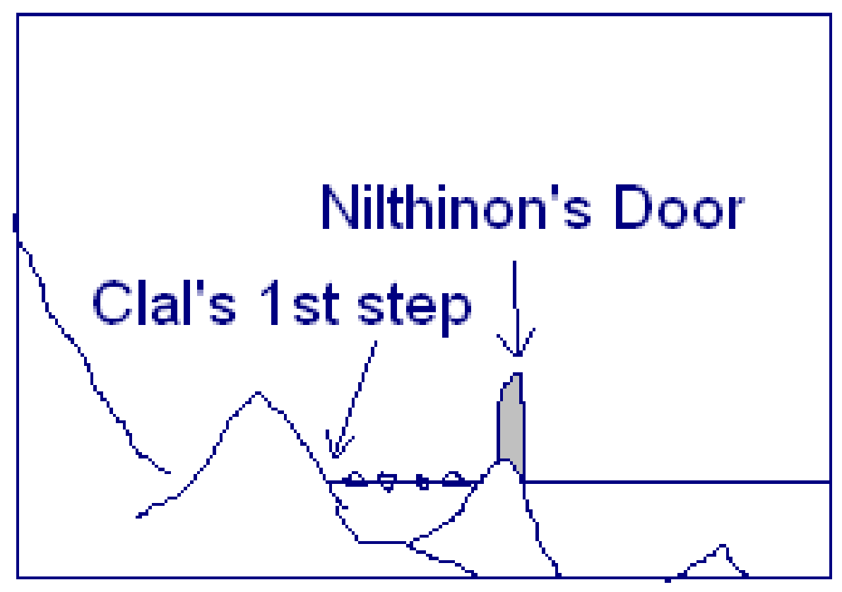
When Clal steps foot on the water, he begins to walk “on” it. This is where Clal must go alone because his friends are not able to follow. Christ had to go through the atonement alone and had to do many things on his own. His friends will wait; their agenda during this time has yet to be decided. Once Clal reaches the second peak, he will then see a doorway and will go through it. What will then happen has yet to be decided.

Book 4 is to be the most spiritual. Everything he does reflects the Savior.
he passes through water and fire (baptism and Holy Ghost)
walks on water
Lehi's Dream
The Spirit – The Flame possessed by all Nilthinions

The Legends of Clal
All legends are really false on Cul. No one is able to prove them correct. Yet, by Clal’s powers the pathway to each Legend is uncovered and unlocked. This is what makes Clal so special; he has the power to unleash, the power to undo. For example:

Book 1: By Clal the winds inside the crevis of an island picks up and carries them away. (The song of nature).
Book 2: A doorway is uncovered and a cave is revealed by magic where no other individual would have been able to do that.
Book 3:
Book 4: Clal walks on water right into the kingdom of Nilth.

Final parting of Ottomus and Felsawn
Previously, I decided that the scene would be rushed and that Ottomus told Felsawn little of what his plans were and of what he had prepared. This idea will not suffice because Felsawn needs to know more about what his father's plans were. Because so many things will be unlocked by Clal in many different ways, Felsawn really needs to understand the spell and how to make something like that be effected by Clal. Another issue is that Clal's lineage has the same magic flowing through their veins and they didn't unlock things like Clal can. The explanation is that Clal's powers only became evident when Womlon's powers reach a certain degree of threat. This is why Clal becomes more powerful when Womlon is powerful. So, the interchange between Ottomus and Felsawn must include a detailed explanation of some very important things.

Villians
field sweeper
final breath stealer
Womlon
A wayward king
A sea monster
A phony “The One” (anti-Christ)
Old friends turned ill
A black dragon
a warrior
a poisonous plant
an evil spirit

Cover Art
not too pale, not to real life looking, not too weird, not too cartoonish, inspiring, must fit my style.

Old World: Villian History
The Old World is the premortal world just as Satan was “cast out” by Heavenly Father, so will Womlon be “banished” by Ottomus. As heavenly Father used the priesthood to do this, so will Ottomus use deep magic to banish Womlon. Also, Felsawn banishes the rest of the banished four by this same power.

For 600 Years
Lehi's exodus to Christ's birth accounted for 600 years. It will be 600 years after the Hanone exodus that Clal will come to his destiny.

Goal in writing this series of books.
to weave in as much eternal truth that i can wihout the reading know it; truths that only the LDS faith believe; things that differenciate LDS beliefs from others.
The Book of Mormon
Three degrees of Glory
premortal life
families are eternal
Joseph Smith's role
the preisthood revolation
8 year old baptism
need of baptism
temple work
work for the dead
sealing power
resurrection
hiarchy of the church
family history
corruptness of the bible
apostacy and the restoration

The Banished
Their magic stems from in between their fingers.

This will be something different than some stories. I like the idea.

A Passage Way Revealed
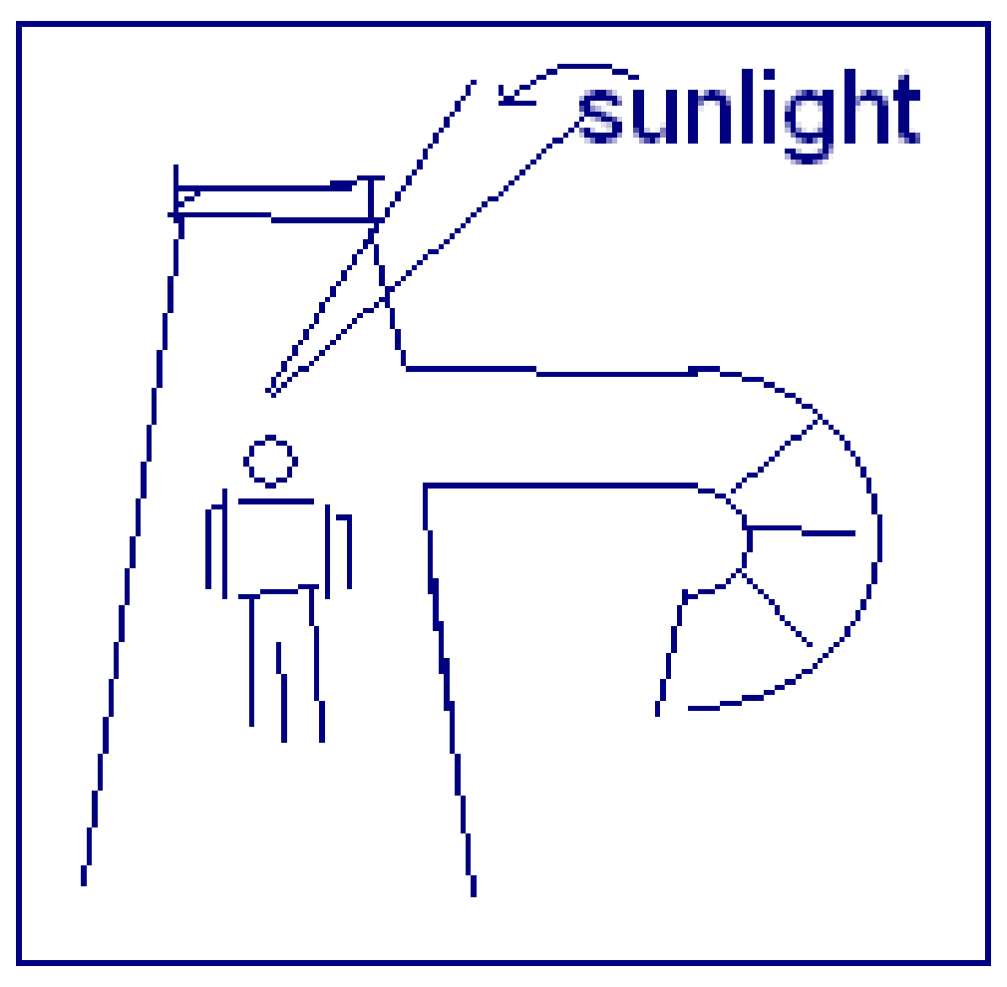
I was walking around on a construction site heading upstairs to the attic. I went through a room and opened a door to the outside. The sunlight was so bright that I turned my head, and to my right I saw a pathway with stairs. It was an interesting transition and feeling as the sun caused me to turn and I there discovered a “secret pathway” that I would have missed otherwise. This could be the case for Clal at some point in a future scene. Perhaps in Book 2 when they are traveling around in caves.

Sedrak's Destiny and Participation
Perhaps the dragon can be a mentor, a connection to the old world. What parts to Sedrak play in Clal's course of events?

The Wizards
Ottomus and Felsawn pass through the viel when their work is completeled. They are suspended in time until the time comes for them to return.

Book 3: The Door Maze

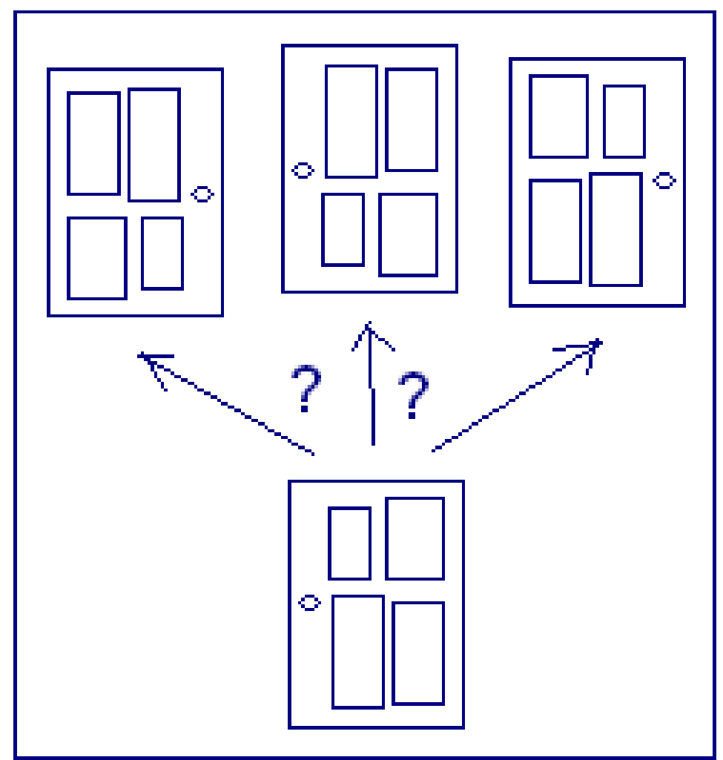
I was hired to help a friend of a friend move from their old house to their new one. While traveling into their basement to put things away, I opened a door. In the hall way beyond there were three other doors to chose from. I immediately thought of this idea as a perfect scene for Clal in Book 3 where the theme of illusions is at work.

Setting: Clal will either be running from an enemy or will be in a hurry searching for something. He enters a labrinth of doors and rooms.

Book 3
Skeldruc blinds Clal with a fog over his eyes

Book 1
In or on Skyland there will be Ice sculptures all around that will hold things. Clal will pass by these things with a curiosity in his thoughts.

Clal will be on Skyland at their wits end and will sit down to rest. Clal will hear a voice singing. But, it will not sound like a song but just the wind. They will follow the song along their way until it disappears. They will meet the song again before they return to Cul.

Book 4
children will be a huge part of both the Inner and Outer Kingdoms.

After one has passed through “Lehi's Dream” the words uttered by The Fair Flame of Nilthinon what was uttered will be kept in a pouch on the arm of a Nilthinion. They will refer to this sort of Patriarchal Blessing often.

Book 5: Climax Scene

Setting ideas
on ocean shore
on mountain – Clal brought their by Sedrak
At Womlon’s fortress which is a castle turned black, a grotesk and mutated change from what it used to be
Forest terrain
On a mountain cliff

Womlon leads Clal to a place where he wants to defeat him at. Somehow the banished are already there awaiting “The One’s” defeat. In the climax scene, these Characters are there and will be fighting the following:
Clal (and help by Leara) against Womlon
Ryth and Ansa against Renthar
Larkin, Skyla, and Hittle against Krothwing
Morgreth against Skeldruc
Sedrak against Imforo

Concerns: Why would the other major characters want to kill the banished? Perhaps they will be imprisoned until the flame of Nilthinon causes them to turn to ash. How will the people on Cul and the people on Hanone be ready to fight when they will only have about 30 minutes till their shores collide? There must be another way to make the suspense happen. I want Womlon’s forces to breakthrough the water wall that will occur when the continents collide. Won’t the colliding of Old and New world cause Womlon to have advantage over Cul as he sweeps over it destroying everything as quick as he can.

Climax Scenes
Settings
before they get the f'element
after they get the f'element
at The Dawning of Time

Outcomes of the Banished
Clal lets them go
the banished lets Clal go
There is an interruption and the Banished has to leave
Banished unable to reach Clal
Someone interviens
Clal's powers prevent the Banished to harm him
Clal tries to change the Banished by encouraging him to come to the good side
nature interviens
Culanthra interviens
the other Banished members intervien

Book 1: Skyland
Is Krothwing on or off Skyland?

Clal's powers: When Clal steps inside the island ring the wwinds begins to blow which creates a whirlwind. They either step in a specific spot after talking with the creature that lives there and begin to sail upward, or they just step foot there and then the wind begins. Krothwing can meet them in the Edaphlas fortress in desquise. He may also meet them when traveling to where the f'element is hidden. (Krothwing may grab Clal in a crowd and tell him he can help. Then he spins his little web and betrays Clal in the end and fight eachother.)

Where is the f'element hidden in Skyland?
in a room in the fortress
hidden among the land somewhere
why would the f'element be out of the reach of the king of Edaphlas?
Perhaps it is at the heart of Edaphlas and only Clal can remove it.
Does he replace it with anything? (possible subplot)
The concept of the f'elements being at the heart of each of the inner-kingdoms is worthy of further development.

The Climax Scenes and their outcomes
Book 1: Krothwing: Clal's powers prevent Krothwing from defeating him.
this will introduce the level of strength Clal's powers possess
Krothwing then jumps off of Edaphlas to the earth below.
Book 2: Renthar: an interruption causes Renthar to have to leave
Book 3: Skeldruc: Clal defeats Skeldruc's illusion
Book 4: Imforo:

Do “The Banished” live together? How do they communicate with eachother as well as with Womlon? Define “The Rishk/The Banished.”

Imforo is the ring leader. He is in charge of the Cul Country opporations. They may meet occasionally. They have to have a quicker way to travel.

Travel
Krothwing flys on a creature.
Renthar travels through caves that are enchanted.
Skeldruc travels through reflections and appears where he pleases
Imforo travels through shadows and through fire

Their layer has no doors because they enter it by magic and the ways outlined above. How do they gather followers? Do they gather followers? Each encounter with the Rishk will prove to be fatal but Clal gets out of it somehow.

An example of some dialog from Book 1's climax scene.
“I have orders from Hanonthaine to defeat you Clal Winden. That is precisely what I intend to do with you.” Krothwing shifted his stance and leaned toward Clal and whisper. “You cause no threat to the devises of evil which we possess. Your time, which has been short, is at a bitter end.”

Before Clal could think about the words Krothwing had uttered this new found enemy was rushing towards Clal with his sword raised level to Clal's throat. There was nothing about Krothwing that would suggest any sort of mercy at this point; the sort of mercy that Clal could appreciate and surely needed.

Clal moved in time to unsheth his sword and meet Krothwind's blow as blade struck blade in mid-air. Clal was not prepaired for the vibration of metal that came after the swords colided; he dropped his sword and grasped his painfilled arm. Tears began to cloud Clal's vision and it seemed as though the world around him was closing in. Things had all gone wrong before they began.”

Objects
Get objects to help spawn ideas:
a mirror
a fivesided stone
an iceicle peace
a flame
an amber stone for book 2
a book of legends
a sword

February 2, 2008 Ideas

The Wizards will come out of the Three Arches after Cul and Hanone colide. This will look like Joseph Smith's “First Vision.” Delvin will stand by his door and the 2000 young warriors will then appear and file through. Delvin's door may also yeild a few major characters that died during the course of the story thus far. I may end up killing off his twin sister then having her come back at that time at the Three Arches.

I could kill off Ansa in the third book by Skeldruc which could help Clal overcome his inability to kill.

When Clal is found for the first time there is a feast before his is ushered to the High Chamber. During the feast, I would like a ballet to be played with beautiful girls dancing modestly and with wonderful spirit. Leara may be among them which may start the love interest that Clal will need to develop. (Wow. This may work. To be continued...)

The Three Arches

When Clal is showed this place he is curious and wonders what this is all about. When he enters the room he is in midspeach stopped by the sacredness and beauty of the place. Someone will show him this place.

Perhaps, Delvin has sent word for Clal to meet him and his comrads there. Perhaps they will be waiting but see no sign of Delvin. But he comes at last. This could encourage some dialog between the travelers that creates a problem or solves a problem with some doubts among the group.

The Banished (Rishk)

3rd Book – Skeldruc holds a cube, like the rubik's cube, which revolves in his palm on its point. It is missing two sides and revolves around showing that the looker can see through it.

Basically, when Clal is holding the 1st F'element of song, things grow around him; things flourish. When Womlon is around, things whither and die; plants laydown and do not rise again.

During the final battle, Clal is humming the Song of the Earth and gains on Womlon. But Womlon inflicts pain which causes Clal to break his steady humming or singing.

There is King in one of the four Kingdoms that is just like King Benjamin. Clal first meets him which traveling on a road. He sees a man working along side a servant. Clal learns much from the man who seems far beyond the wisdom of any other. One who truly understands human relationships and is an example to many.

I had three ideas today:
Foyer Ceiling

It was sectioned off into about 10 sections on the ceiling. What if it was each section of the ceiling had a different image or painting in it?

Wizards
Felsawn 7
Morgreth 9
Ottomus 5

